|  |  |
| --- | --- |
|  | |
|  |  |
|  | |

|  |  |
| --- | --- |
| 55 Railroad Row White River Junction, VT 05001 802.295.4999 **www.rsginc.com** |  |
| **prepared for:** |
| Nashville MPO |
| **Submitted By:** |
| rsg |
|  |
| **In cooperation with:** |
| john bowman |

1.0 overview 1

1.1 | Model System 1

1.2 | Model Sensitivities 1

Transportation Investments & Policies 1

Land Use 1

Socioeconomics & Demographics 1

2.0 hardware & software Requirements 3

2.1 | Hardware Requirements 3

2.2 | Software requirements 3

Operating system 3

TransCAD 3

DaySim 3

R 4

PopSyn 11

3.0 Model Design 12

3.1 | Process Flow 12

3.2 | All Streets Network Preparation 14

3.3 | Short Distance Impedance Generation 14

3.4 | Land Use Data Prep 14

Microzone allocation 14

Buffering & Transit Access Preparation 18

3.5 | Synthetic Population 22

3.6 | DaySim Inputs 22

Microzones 23

Synthetic Population 23

Worker IXXI Fractions 23

TAZ Indexes 24

PNR Nodes 24

Coefficients 24

Roster 24

Roster Combinations 24

Configuration 24

shadow prices 25

3.7 | Network Prepartion & Skimming 25

Network Preparation 25

Highway Skimming 29

Transit Skimming 29

3.8 | Auxiliary Demand 31

Airport 31

Freight 31

Non-HH 32

3.9 | DaySim 32

3.10 | Assignment Preparation 34

Highway 35

Transit 35

3.11 | Assignment 36

Highway 36

Transit 36

3.12 | Feedback 36

3.13 | Reporting 37

DaySim 37

Highway Assignment 38

Transit Assignment 38

4.0 Directory & Data Structures 39

4.1 | Master Model Directory 39

4.2 | Network Skims 39

Highway Skims 40

Transit Skims 40

Non-motorized Skims & Short Distance Paths 41

4.3 | DaySim 41

Microzone Input Preparation 41

Short Distance Impedance Generation 45

DaySim Buffering Tool 48

DaySim Inputs 54

DaySim Outputs 75

4.4 | DaySim-TransCAD Linkage 79

4.5 | Auxiliary Demand 81

4.6 | Network Assignment 86

Assignment Inputs 86

Assignment Outputs 89

4.7 | Post-Processing 94

Post-processing Inputs & Outputs 94

Reports 100

5.0 User Interface & Running the Model 105

5.1 | DaySim Input Preparation 105

Allocate TAZ data to Microzones 105

Prepare Buffered Microzone File 112

Update TAZ Id and Lutype 114

5.2 | Running the Model 115

Model Setup 115

User Interface 118

A Model Run 123

Sensitivity Tests 127

5.3 | Batch File 131

6.0 Configuring a Scenario 133

6.1 | Network changes 133

6.2 | Employment change 138

6.3 | Population change 139

7.0 Mini Model Runs & Input Checks 141

7.1 | Mini Model Runs 141

Run A Feedback Loop 141

Run A Stage 142

Run Selected Stages in a Feedback Loop 143

7.2 | Mini Model Runs Input Checks 145

Network Change 145

DaySim Input Change 146

7.3 | Model Input Checks 146

Highway Network Edits 146

Transit Network Edits 149

DaySim Input Updates 150

**List of Figures**

Figure 2.1. R Install Screeenshot #1 5

Figure 2.2. R Install Screenshot #2 6

Figure 2.3. R Install Screenshot #3 6

Figure 2.4. R Install Screenshot #4 7

Figure 2.5. R Install Screenshot #5 7

Figure 2.6. R Install Screenshot #6 8

Figure 2.7. R Install Screenshot #7 8

Figure 2.8. R Install Screenshot #8 9

Figure 2.9. R Install Screenshot #9 9

Figure 2.10. Install Screenshot #10 10

Figure 2.11. R GUI Screenshot 10

Figure 3.1 Model process flow 13

Figure 3.2 Microzone allocation tool flow 18

Figure 3.3. Buffer1 and buffer2 distance decay weights 20

Figure 3.4 Daysim Modeling Components and Linkages 34

Figure 4.1 Coefficient File Example 58

Figure 5.1 DaySim Tools 105

Figure 5.2 DaySim Allocation Tool GUI 106

Figure 5.3 Read XML Input File 106

Figure 5.4 Open Input XML File 107

Figure 5.5 DaySim Allocation Tool GUI with Inputs Populated 108

Figure 5.6 Open tAZ file 109

Figure 5.7 Display Employment Categories 109

Figure 5.8 Select Employment Categories 110

Figure 5.9 Select NAICS Codes 111

Figure 5.10 Other Inputs 111

Figure 5.11 Select DaySim Employment Categories 111

Figure 5.12 DaySim Buffering Tool GUI 112

Figure 5.13. Buffer TooL File Selection Dialog 113

Figure 5.14 R Script to Fields in the Buffered File 115

Figure 5.15 Open TransCAD 116

Figure 5.16 Add GIS Developer’s kit 116

Figure 5.17 Compile 117

Figure 5.18 Open Model List File 117

Figure 5.19 Test Icon 117

Figure 5.20 Run model 117

Figure 5.21 Open Model Table 118

Figure 5.22 TransCAD with Model GUI 118

Figure 5.23 Model User Interface 119

Figure 5.24 Model Scenarios 119

Figure 5.25 Model Run Settings 120

Figure 5.26 Model Scenario Manager 121

Figure 5.27 Model Scenario Manager - Inputs 121

Figure 5.28 Model Run Stages 122

Figure 5.29 Model Stage Step Settings 122

Figure 5.30 Model Stage Step Settings – How to Update 122

Figure 5.31 utilities 123

Figure 5.32 Select All Feedback Loops 124

Figure 5.33 Start a Full model Run 124

Figure 5.34 Seelct Start Feedback Loop 125

Figure 5.35 Start a Full Model Run 125

Figure 5.36 Run A Stage 126

Figure 7.1 Run a Feedback Loop 142

Figure 7.2 Run a Stage 143

Figure 7.3 Model Run Stages 144

Figure 7.4 Model Stage Step Settings 144

Figure 7.5 Model Stage Step Settings – How to Update 144

Figure 7.6 Assignment Parameters 146

Figure 7.7 Fill 147

Figure 7.8 Formula 147

Figure 7.9 Node Formula Fields 148

Figure 7.10 Shortest path Toolbox 148

Figure 7.11 Shortest Path in TransCAD 149

Figure 7.12 Distance to Commuter Rail in Nashville 151

**List of Tables**

Table 3.1 Nashville TRip-based model employment sectors 15

Table 3.2 Daysim activity-based model employment sectors 15

Table 3.3. DaySim Person Types 22

Table 3.4 Nashville area types 26

Table 3.5 Free-flow speed adjustment factors 27

Table 3.6 Initial Speed Adjustment Factors 27

Table 3.7 Hour-to-period capacity factors 29

Table 3.8 Time-of-Day Categories 29

Table 3.9 Transit Mode Hierarchy 30

Table 3.10 Persontrip-Vehicle Trip Conversion Factors 35

Table 4.1 Highway Skim Matrix Cores 40

Table 4.2 Transit Skim Matrix Cores 40

Table 4.3 Microzone allocation tool taz input file 42

Table 4.4 Microzone allocation tool Block input file 43

Table 4.5 Microzone allocation tool TAZ-Block Intersect input file 44

Table 4.6 Microzone allocation tool School input file 45

Table 4.7 Parking file format 45

Table 4.8. DTALite Input Node FIle Format 46

Table 4.9. DTALite Input Link FIle Format 46

Table 4.10. DTALite Input Link Type FIle Format 47

Table 4.11. DTALite Input Node Pairs FIle Format 47

Table 4.12. DTALite Output Node Distance FIle Format 47

Table 4.13. Buffered Microzone File 48

Table 4.14. Base Parcel/Microzone File FOrmat 51

Table 4.15. Intersection Dat File Format 52

Table 4.16. Transit Stops File Format 53

Table 4.17. Open Space Data File Format 54

Table 4.18. TAZ Correspondence File Format 54

Table 4.19 Synthetic population household file 55

Table 4.20 Synthetic population person file 55

Table 4.21 Worker IXXI Fraction File 56

Table 4.22 TAZ Index File 57

Table 4.23 PNR Node File 57

Table 4.24 RosTer File 58

Table 4.25 Roster Combination File Example 59

Table 4.26 Configuration File (configuration.xml) 60

Table 4.27 Household Day File 75

Table 4.28 Person Day File 76

Table 4.29 Tour File 77

Table 4.30 Trip File 78

Table 4.31 Highway Assignment Matrices 80

Table 4.32 Transit Assignment Matrices 80

Table 4.33 Household PA Table 81

Table 4.34 Airport Generation File 82

Table 4.35 Airport Distribution File 82

Table 4.36 Airport Mode Choice File 82

Table 4.37 Freight District Table 83

Table 4.38 Multi-unit OD MAtrix 83

Table 4.39 Freight OD MAtrix 83

Table 4.40 Non-HH Friction Factor File 84

Table 4.41 Non-HH County Adjustment Factor File 84

Table 4.42 Non-HH Demand File 85

Table 4.43 Highway Assignment Input Matrix 86

Table 4.44 Highway Assignment Hourly Factors 86

Table 4.45 TRansit Assignment Mode Table 88

Table 4.46 Transit Assignment Mode Transfer Table 89

Table 4.47 Transit Assignment Movement Table 89

Table 4.48 Highway Assignment preload flow table 89

Table 4.49 Highway Assignment Flow Table 91

Table 4.50 Transit Assignment Flow Table 92

Table 4.51 Transit Assignment Non-transit Flow Table 93

Table 4.52 Transit Assignment Aggregated Flow Table 93

Table 4.53 Transit Assignment Boarding / Alighting Table 94

Table 4.54 Transit Assignment Movement Table 94

Table 4.55 Highway Assignment Combined Flow Table 95

Table 4.56 Transit Assignment summary by time-of-day and mode 100

Table 4.57 Transit Assignment summary by mode 101

Table 4.58 Transit Assignment summary transfer rates by time-of-day 101

Table 4.59 Transit assignment summary boardings by route (Aggregate) 102

Table 4.60 Transit assignment summary boardings by route (Disaggregate) 102

Table 5.1 List of Sensitivity Tests 127

Table 7.1 – List of Model Run Types 141

Table 7.2 – List of Model Run Scenarios 145

Table 7.3 – List of Model Input Checks 146

# overview

## Model System

The Nashville activity-based model (ABM) system is comprised of two primary components, the Daysim activity-based demand model and the TransCAD network supply model. DaySim is a set of travel demand forecast models that predict household and person travel choices at a microzone-level on a minute-by-minute basis. TransCAD is used to assign this travel demand to roadway and transit networks, and to produce estimates of network performance. In addition, TransCAD provides an overall framework and graphical user interface for users to configure and execute the overall model system. These two primary components are supported by a number of auxiliary models and tools. The purpose of this document is to provide users with a guide to the application of the Nashville ABM.

## Model Sensitivities

### Transportation Investments & Policies

The Nashville activity-based model system is designed to be sensitive to a wide variety of transportation investments and policies. The model system incorporates representations of roadway and transit networks that can be easily configured to represent changes in network capacity or service provision. Detailed path type alternatives such as roadway toll and no-toll paths and transit submodes are explicitly represented in the model system. In addition, the model incorporates distributed values-of-time across the population, dependent of travel purpose, income and other factors, providing a more realistic representation of travelers’ willingness-to-pay. The model system’s explicit representation of each individual’s entire daily activity pattern also provides the opportunity to better represent the impacts of travel demand management scenarios.

### Land Use

One of the distinguishing features of the Nashville ABM is the use of microzones as the basic spatial unit for generating travel demand. Microzones are essentially Census blocks. Use of this fine-grained geography, in conjunction with “all streets” based network impedances, provides the model with an enhanced ability to represent detailed urban form and land use characteristics that are particularly important when considering non-motorized travel such as walking and bicycling. In addition, the model predicts demand for seven different activity types using detailed land use information such employment by nine industrial sectors and enrollment by school type.

### Socioeconomics & Demographics

The Nashville ABM uses a “synthetic population” to predict individual and household level travel choices. The synthetic population is comprised of lists of households and persons that are based on observed or forecasted distributions of socioeconomic attributes and are typically created by sampling detailed Census microdata. These lists function as the basis for all subsequent choice making simulated in the activity-based model. Use of a disaggregate representation of the population reduces aggregation bias in the model system, and allows the model to more realistically incorporate the influence of socioeconomic and demographic information on individual and household travel choices.

# hardware & software Requirements

## Hardware Requirements

The Nashville activity-based model system can be run on a typical workstation. The current requirements include:

* At least 8GB of RAM
* At least 4 effective processing cores – additional cores will generally reduce runtime
* At least 100GB of storage – a single model run currently takes about 20GB to store

## Software requirements

### Operating system

The model system components are currently configured to run under a variety of Windows versions, including Windows Server 2008 and Windows 7 and more recent updates.

### TransCAD

#### Overview

TransCAD is a software for transportation planning. In addition to the standard point, line, area, and image layers in a GIS map, TransCAD supports route system layers and has tools for creating, manipulating and displaying routes. TransCAD uses a network data structure to support routing and network optimization models.

#### Role in the Model System

TransCAD is used to provide highway and transit network assignment and skimming procedures, and is also used to manipulate matrices of travel demand.

### DaySim

#### Overview

The travel demand model used in the Nashville activity-based model system is coded in a software framework called DaySim. DaySim is one of the two main “families” of activity-based model (AB) systems now being used by MPOs in the United States. DaySim was initially implemented by Mark Bradley and John Bowman in Sacramento, CA, on behalf of the Sacramento Area Council of Governments (SACOG).

DaySim simulates 24-hour itineraries for individuals with spatial resolution as fine as individual parcels and temporal resolution as fine as single minutes, so it can generate outputs at the level of resolution required as input to dynamic traffic simulation. DaySim’s predictions in all dimensions (activity and travel generation, tours and trip-chaining, destinations, modes, and timing) are sensitive to travel times and costs that vary by mode, origin–destination (OD) path, and time of day, so it can, in turn, effectively use as inputs the improved network travel costs and times output from a dynamic traffic simulator. DaySim captures the effects of travel time and cost upon activity and travel choices in a way that is balanced across modes and times of day and consistent with the econometric theory of nested choice models.

The C# (C-sharp) version is used for the Nashville model system, and can be compiled to run in both 32- and 64-bit environments. DaySim can be used in a distributed manner by running separate instances on different processors on different partitions of the study area population, and then merging the results.

#### Role in the Model System

The DaySim activity-based demand model produces six principal outputs: 1) Household file, 2) Household day file, 3) Person file, 4) Person day file, 5) Tour file and 6) Trip file. Taken together, these hierarchical output files are similar to the data files from a traditional household travel diary survey. In this case, however, instead of actual trips from a subsample of the actual population, DaySim produces simulated daily trips for an entire, synthetically generated population of travelers.

#### Installation

No complex installation process of the DaySim software is required. DaySim simply resides as a single compiled executable within the Nashville model directory structure. The compiled executable (DaySim.exe) can be found in the \DaySim subdirectory.

### R

#### Overview

R is a language and environment for statistical computing and graphics. R provides a wide variety of statistical and graphical techniques, and is highly extensible. One of R's strengths is the ease with which well-designed publication-quality plots can be produced, including mathematical symbols and formula where needed.

R is open-source available as Free Software under the terms of the Free Software Foundation's GNU General Public License in source code form. It compiles and runs on a wide variety of UNIX platforms and similar systems (including FreeBSD and Linux), Windows and MacOS.

R is an integrated suite of software facilities for data manipulation, calculation and graphical display. It includes:

* An effective data handling and storage facility,
* A suite of operators for calculations on arrays, in particular matrices,
* A large, coherent, integrated collection of intermediate tools for data analysis,
* Graphical facilities for data analysis and display either on-screen or on hardcopy, and
* A well-developed, simple and effective programming language that includes conditionals, loops, user-defined recursive functions and input and output facilities.

More information on R can be found at: <http://www.r-project.org/>.

#### Role in the Model System

R is primarily used for two purposes in this model:

* Preparing input data for various model components
* Processing and summarizing ABM (DaySim) output data

R-scripts have been created to prepare input files for both population synthesis and also synthetic population input for DaySim. Details about population synthesis for DaySim have been provided in the next section.

Once DaySim is run and day patterns of all the persons in the model system have been simulated, R-scripts are also used to prepare summaries of various sub-models outputs such as auto ownership, tour/trip modes and times, etc. Summary tables are written out to Excel spreadsheets that are subsequently used calibration and validation of the AB demand model.

#### Installation

R can be downloaded via the Comprehensive R Archive Network (CRAN) located at: <http://cran.revolutionanalytics.com/>.

A user would click “Download R for Windows” hyperlink, click on the “**install R for the first time**” hyperlink, then click on the “**Download R 3.1.2 for Windows**” to begin the download of the installation setup file R-3.1.2-win.exe. Note, the R project and CRAN websites listed above have a great deal of information and documentation pertaining to R including installation instructions, technical documentation, FAQs and much more.

The following steps should be followed to install R:

1. Double-click the file R-3.1.2-win.exe to run the installation setup.
2. Select the appropriate language (English), and click “Ok”.

Figure 2.1. R Install Screeenshot #1

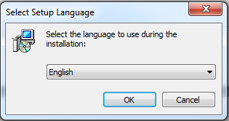

1. Click “Next” to continue the setup.

Figure 2.2. R Install Screenshot #2

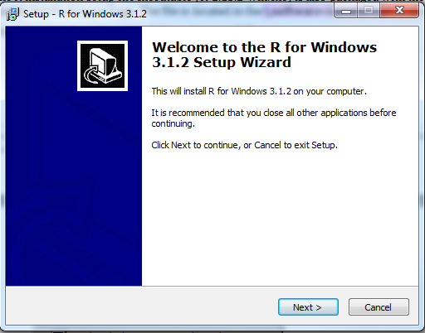

1. Click “Next” once you have read the Public Licensing information.

Figure 2.3. R Install Screenshot #3

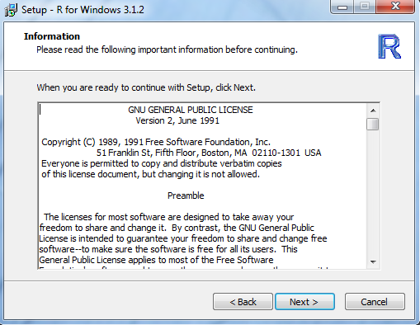

1. Select a location for the program installation (e.g. C:\ProgramFiles\R\R-3.1.2) and click “Next”.

Figure 2.4. R Install Screenshot #4

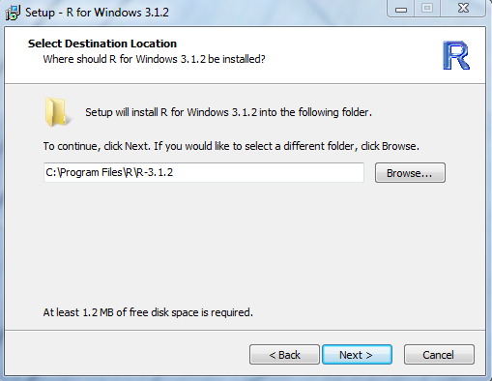

1. Select the components to be installed. All components can be selected. Then click “Next”.

Figure 2.5. R Install Screenshot #5

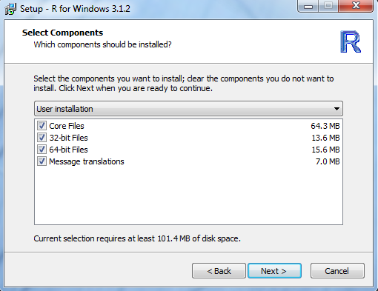

1. Click “Next” to leave the accepted defaults for the startup options.

Figure 2.6. R Install Screenshot #6

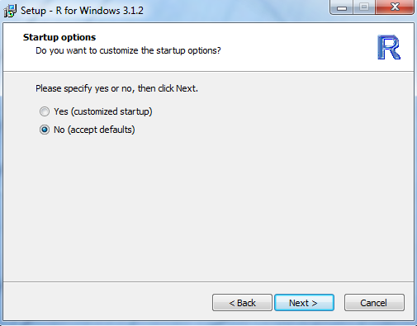

1. Specify the location where the program’s shortcut in the Start Menu folder will reside (e.g. R) and click “Next”.

Figure 2.7. R Install Screenshot #7

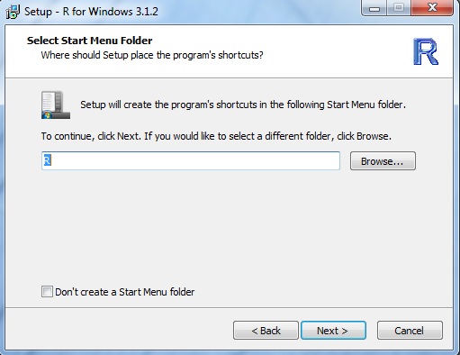

1. Select which additional tasks are desired and click “Next”.

Figure 2.8. R Install Screenshot #8

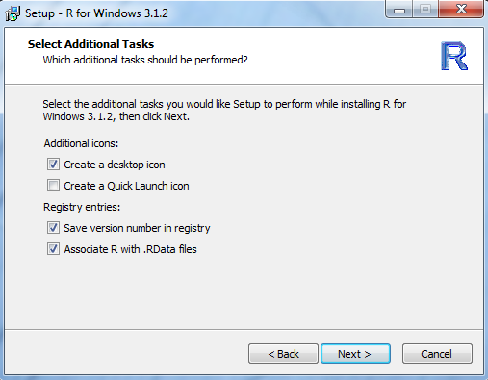

1. The installation will begin and present the following progress on-screen.

Figure 2.9. R Install Screenshot #9

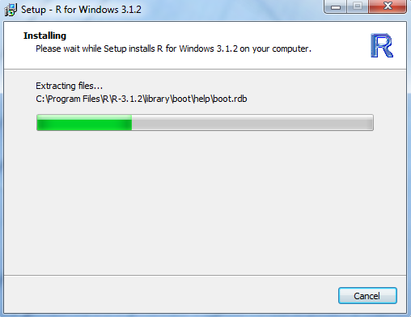

1. When the installation is complete, click “Finish”.

Figure 2.10. Install Screenshot #10

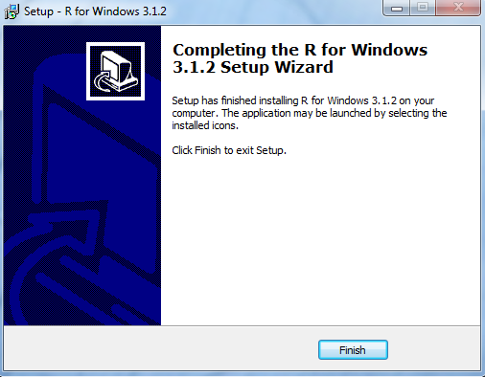

1. R will now have been successfully installed on the user’s computer. To confirm the program was installed successfully, look for and find the R shortcut which should now reside on the desktop (R x64 3.1.2). Double clicking the shortcut will open the RGui and console.

Figure 2.11. R GUI Screenshot

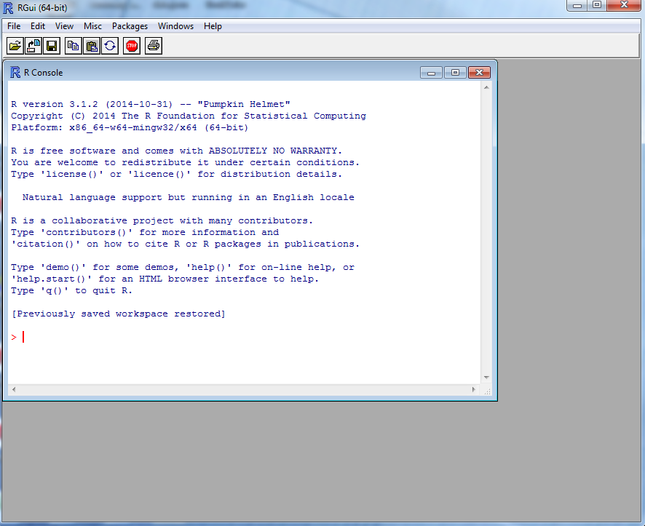

### PopSyn

#### Overview

PopSynis a tool for generating a synthetic population representing the Nashville region’s households and persons. This synthetic population is a key input to the activity-based model system. The Nashville PopSyn documentation was implemented as part of a separate development effort, and thus is not included in this activity-based model user guide.

# Model Design

## Process Flow

The Nashville activity-based model system builds upon the existing trip-based model system. The ABM employs a modified version of the same user interface that allows analysts to specify how the model system should be run. Essentially, the activity-based model system replaces the trip generation, trip distribution, and mode choice components of the trip-based model system with a more detailed set of model components that predict regional residents’ activity generation, destination, mode, and time-of-day choices, and includes additional models such as household vehicle availability. These predictions are combined with forecasts of auxiliary demand, such as airport and freight, and are assigned to roadway and transit networks to produce estimates of network performance. The model system is executed iterative with feedback in order to achieve a stable, equilibrated result. Figure 3.1 illustrates the overall model system flow.

The activity-based model system requires the preparation of some additional data that are not required by the trip-based model system, which are shown at the top of the model system flow. This additional data preparation is primarily related to the additional spatial and socioeconomic data that is used in the ABM. The model system uses “all streets” based network impedances when calculating the accessibilities used in the ABM. Network and short distance impedances are calculated and used to develop microzone-level measures of accessibilities. A synthetic population that represents the region’s households and persons and matches key demographic distributions is created and allocated to microzones, and a number of other key inputs are prepared such as the information about regional in-commuting and out-commuting, the location of regional park-and-ride facilities, and initial estimates of network performance, or “skims”.

Once all the inputs are prepared, the iterative model system run can be executed. There are two primary types of demand components in the model system: Daysim and the auxiliary models. Daysim predicts the daily activity patterns of all regional residents when they travel within the region. The auxiliary models predict other components of the overall travel demand, such as freight demand and airport demand. The Daysim-generated and auxiliary-model demand are combined and assigned to networks, and revised estimated of network impedances are generated. These revised impedances are then fed back to into Daysim and the auxiliary models to produce new demand estimates. Successive averaging is used in order to achieve a stable equilibrated result. After three system iterations, the final demand estimates are produced and all the demand is assigned to the appropriate roadway or transit networks by time of day. The final step of the model involves producing detailed reports of summarizing model outputs.

Figure 3.1 Model process flow

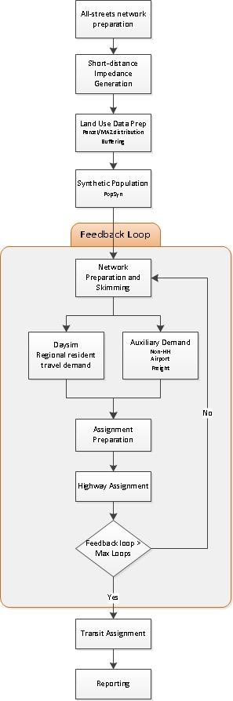

## All Streets Network Preparation

The Nashville Daysim activity-based model uses microzones as the fundamental spatial unit for predicting travel demand, which are essentially Census blocks. In order to support this more detailed geography, DaySim is designed to take advantage of more accurate distances for short distance on-street trips than are available from the TAZ-to-TAZ road network skims. These more accurate shortest-path node-to-node distances are calculated from an “All Streets Network” which is a network (as the name indicates) that consists of all the streets in the model region. A typical model network would only consist of freeways, expressways, and major and minor arterials. This coarser network cannot accurately represent the accessibility between small geographies such as microzones.

These short distance microzone-level impedances are most important for non-motorized trips such as bike and walk trips. Thus, facilities such a freeways and expressways, freeway ramps, and other facilities that are not available to non-motorized modes are excluded from the all-streets based network path building. In addition, short driveways (if present) are also typically dropped from the all-streets network in order to reduce the computation burden. The modified all streets network is then used to generate node-to-node shortest path distance as described in the next section.

## Short Distance Impedance Generation

Once the all-streets network preparation is complete, it can be used to generate short distance impedances. These short distance impedances are typically used in two ways: they are input to the microzone-level data preparation in order to provide more accurate measures of accessibilities to employment, households, schools and transit, and they can also be used directly by the Daysim choice models, in conjunction with more typical TAZ-based impedances. There is a multistep process for generating the short distance impedances. First, a list of network node pairs is generated consisting of all node pairs that are within 3 miles (Euclidean, based on node coordinates) of each other is generated using a utility program. Network shortest path distances are then calculated for each of the node pairs in the list using a roadway network pathbuilding tool called DTALite. DTALite is used because it is very fast, although other pathbuilding tools may also be used. The result is a list of node pairs with the all streets network shortest path distances between them that is a input to the microzone buffering process that is described in subsequent sections.

## Land Use Data Prep

### Microzone allocation

One of the distinguishing features of Nashville ABM is the use of microzones as the basic spatial unit for generating demand. Microzones are created by intersecting the existing trip-based model TAZs with Census blocks. In order to run the ABM, it is necessary to develop microzone level estimates of employment by industrial sector, households, and enrollment. The microzone estimates are derived from TAZ-level information used in the Nashville trip-based model.

In order to facilitate the preparation of microzone information, a microzone allocation tool has been developed. This tool requires a number of inputs such as the TAZ-level employment and household controls, the block level employment household information, school locations and enrollment by grade, and correspondences between TAZ, Census block, and microzone geographies. Note that in addition to performing spatial allocation from TAZs to microzones, the tool also performs allocates employment by industrial sector from the five employment sectors used in the Nashville trip-based model to the nine industrial sectors used in the Nashville activity-based model system. This sector allocation is performed by first disaggregating the employment for each of five broad sectors into twenty more detailed employment sectors using 2-digit NAICS code employment totals from the Census Bureau’s Longitudinal Employer-Household Dynamics (LEHD) data source, and then aggregating these twenty sectors back to the nine sectors used in the Nashville Daysim activity-based model components.

Table 3.1 summarizes the employment sectors used in the Nashville trip-based model and their corresponding 2-digiti NAICS codes, while Table 3.2 summarizes the employment sectors used in the activity-based model and their associated 20digit NAICS codes.

Table 3.1 Nashville TRip-based model employment sectors

|  |  |
| --- | --- |
| TRIP-BASED SECTOR | 2-DIGIT NAICS CODE |
| EMP_ARG | 11,99,21,23 |
| EMP_MANU | 31,32,33 |
| EMP_RET | 44,45,72 |
| EMP_TRANS | 22,48,49,42 |
| EMP_OFFICE | 51, 52,53,54,55,56,61,62,71,81,92 |

Table 3.2 Daysim activity-based model employment sectors

|  |  |
| --- | --- |
| DAYSIM SECTOR | 2-DIGIT NAICS CODE |
| Industrial | 22,31-33, 42, 48-49 |
| Retail Trade | 44-45 |
| Office | 51-56 |
| Educational Services | 61 |
| Health / Medical | 62 |
| Government | 92 |
| Food | 72 |
| Services | 71, 81 |
| Other | 11, 21, 23 |

The allocation tool allocates households from TAZ to microzone using Census block-level information on household locations. Block-level household information was derived from the 2010 Census.

In addition to allocating households and employment information to microzones, the allocation tool also attaches school enrollment information to microzones. DaySim uses following three school categories:

* STUGRD – students in kindergarten through grade 8
* STUHGH – students in grade 9 through grade 12
* STUUNI – students in universities

The allocation tool uses US Department of Education National Center for Education Statistics information on the point location of schools and their associated enrollment by grade (<http://nces.ed.gov/ccd/elsi/tableGenerator.aspx>). Post-secondary information was derived from the US Department of Education’s Integrated Postsecondary Education Data System (<http://nces.ed.gov/ipeds/datacenter/>).

The allocation tool is programmed in C# and includes some key features such as:

* A graphical user interface (GUI) that allows users to easily reconfigure the employment sector allocation scheme
* The option to use either NAICS or SIC codes
* The option to perform a “base” allocation in which exogenous TAZ level controls are used or a “forecast” allocation in exogenous growth is provide. All Nashville microzone data preparation involved the “base” allocation method as TAZ level controls were provided for both the model calibration / validation year as well as the model horizon year.
* The ability to be executed from within the GUI, or to be called as part of batch process using a prepared control file

Five inputs are required to run the tool:

* TAZ file - TAZ level totals for employment, household, and enrollment. This data is prepared by the Nashville MPO.
* Block file - Employment in 2-digit NAICS codes at block detail. The data has been prepared for Nashville based on 2010 LEHD information. Updates to the LEHD information can be downloaded from here: http://lehd.ces.census.gov/data/
* Microzone correspondence file - microzone geometry file that contains Microzone ID (MAZID), Census block ID (BLOCKID) and the model TAZ ID (TAZID). The geometry file is prepared by the intersection of block and TAZ boundaries. This file does not need to be modified unless the underlying model geography is revised.
* School file - School enrollments with MAZID. The data is provided by the agency, based on detailed point location information.
* Parking file – Parking capacity and cost with MAZID. The parking data contains following information for a microzone: hourly capacity, average hourly parking rate (in cents), daily capacity, and average daily parking rate (in cents).

First four input files are space delimited text files and the parking file is a csv file. The output file is a csv file with employment in DaySim categories, HHs, enrollments in three school types, and parking capacity and cost at parcel level.

The allocation tool performs the following sequential steps:

1. Disaggregate block data to microzone level
2. Aggregate microzone level data to TAZ level
3. Disaggregate TAZ employment categories to NAICS codes (using the aggregate TAZ level microzone data from Step 2).
4. Disaggregate TAZ data to microzone (factoring microzone data to match TAZ totals)
5. Aggregate NAICS codes to DaySim employment categories
6. Add school enrollment data to MZs.
7. Add parking data to MZs

The process is illustrated in Figure 3.2

Figure 3.2 Microzone allocation tool flow



### Buffering & Transit Access Preparation

In DaySim, it is important to have measures not only of within a particular microzone, but also what lies in the area immediately surrounding each microzone. These measures are created by defining a “buffer” area around each microzone and counting what lies inside the buffer. These variables can then be used in DaySim in a way similar to how zonal land use and density variables are used in TAZ-based models, with the advantage that the buffer is defined in exactly the same way for each microzone. The buffer variables that DaySim uses include:

* The number of households in the buffer;
* Employment (number of jobs) in the buffer in various employment sectors;
* Enrollment in schools in the buffer, segmented by grade schools and colleges;
* The number of spaces and average price of paid off-street parking in the buffer;
* The number of transit stops within the buffer (segmented by sub-mode, if relevant);
* The number of street intersections in the buffer, segmented by 1-node (dead-end or cul-de-sac), 3-node (T-junction), and 4+node intersections; and

In addition, DaySim also uses the distance from the microzone centroid to the nearest transit stop (by transit sub-mode, if relevant), as well as the distance to the nearest open space area while simulating models.

The Nashville’s traditional trip-based model uses long form TAZ ids. As DaySim cannot handle very long integers, it is required to change those to short form integers. Therefore, the output of the buffer tool is put into a R script that updates original long form taz ids to short form taz ids and sets lutype_p to 1. The output of the R script is then used as input to DaySim.

#### DaySim Buffering Tool

A tool to perform the buffer calculations has been developed, and includes a user-friendly GUI. The use of GUI is described in a subsequent chapter of this document. This tool calculates all the buffer and transit access variables that DaySim needs, using the following inputs:

* Base microzone file (obtained from employment and enrollment allocation process)
* Street intersections file
* Transit stops file
* Network nodes file (for all streets network based short trip distances)
* Node-to-node shortest path distance file (for all streets network based short trip distances)

If all streets network based short trip distances need to be used, the buffering program, in addition to the buffered file, outputs/uses following four intermediate files:

* External node file
* Parcel node file
* Intersection node file
* Stop to node correspondence

In the GUI, it is required to provide file names for these intermediate outputs. The outputs can be used to save time in the next run. However, in the present ABM setup, this functionality is disabled and the intermediate files (except parcel node file) are not produced by the tool. The parcel node file is generated because it is later used in DaySim.

Note that it is essential that the buffer measures used in application are consistent with those used for the original model estimation. Thus, when preparing new buffer measures, users should not modify the settings in the buffering tool control file.

#### Buffer Calculations

As mentioned earlier, buffer variables for a microzone are calculated by summing land use variables of all microzones within a certain buffer distance of the particular microzone. In the past, buffer calculations have used a “flat” buffer, using a certain radius, e.g. ¼ mile, and counting everything within that radius and nothing outside the radius. That approach is simple, but has the disadvantages that (a) it weights all opportunities within the buffer the same, whereas in reality the land use that is very close by will tend to have more influence on behavior than the land use at the edge of the buffer, and (b) there can be “cliff effects” if a large development is located near the edge of the buffer. In the latter case, the measures become sensitive to the somewhat arbitrary specification of the buffer size, and to the rules used to deal with microzones that straddle the buffer boundary. This tends to add random “noise” to the buffer measures.

The buffering tool can be set to use flat buffering, or a distance-decay buffer, in which each buffered item is weighted according to the distance from the origin microzone centroid. There are two options provided for the weighting function: a logistic function and a negative exponential function. The logistic form is recommended because its shape is more representative of typical behavioral models that use logistic functions.

The buffering program simultaneously calculates all the buffer variables for two different buffer sizes. The reason for this is that the DaySim choice models use smaller buffers for some variables (e.g. those that represent attractiveness of walk trips), and larger buffers for some other variables (e.g. those that represent attractiveness of bike trips, or more general neighborhood effects).

For distance decay buffering, the user specifies three parameters for each buffer: (1) the distance parameter, (2) the offset parameter, and (3) the slope parameter (the latter two are used only for logistic buffering). The parameters and equation for the logistic curves used for DaySim model estimation and calibration are listed below. It is necessary that these same parameters be used for model application.

**Parameter Buffer 1 Buffer 2**

Inflection BDIST1 = 660 (ft) BDIST2 = 1320 (ft)

Offset BOFFS1 = 2640 (ft) BOFFS2 = 2640 (ft)

Slope DECAY1 = 0.76 DECAY2 = 0.76

The equation is:

Weight = MIN(1, (1 + Exp(DECAY – 0.5 + BOFFS/5280))

/ (1 + Exp(DECAY * (Distance/BDIST – 0.5 – BOFFS/5280))))

Distance is the distance, in feet, from the origin microzone to any other microzone whose calculation is explained in the next paragraph..

Figure 3.3. Buffer1 and buffer2 distance decay weights

The buffering program also gives the user three options as to how distances are calculated within the buffering program:

1. Use crow-fly distance between the XY coordinates
2. Use interpolation with a “circuity surface” around each microzone.
3. Use shortest path distance between the nearest all street network nodes.

Note that in option 1, because the buffer distance is calculated using XY coordinates from centroid to centroid for microzones, buffering may not be very accurate for microzones that are very large compared to the size of the buffer.

Option 3 provides most accurate distances that take into account obstacles and directness in the street network and is preferable is the required data exists. The following steps are involved in buffering using distance decay weights and all streets network distances:

1. The buffering tool first associates each microzone with the nearest network node and creates a microzone-node correspondence.
2. Multiple microzones may be associated with a single node and so the base microzone file is reduced to node level by aggregating data from all microzones that are associated with the same node.
3. Other items such as open spaces/parks and transit stops are also associated with the closest network nodes.
4. At this point, buffering calculations are all done at the node level since node-to-node all street network distance are available. For node pairs that are not within 3 miles of each other, Euclidean distance calculated from XY coordinates is used. Buffer variables for a particular node are calculated by obtaining the weighted sum of land-use variables of all the nodes with the chosen buffer distance. The calculation of distance weights has been described earlier.
5. Once the buffer calculations at the node level are complete, the buffer variables are then transferred to microzones using the microzone-node correspondence created in step 1.

It should also be noted that in case of option 3, during the buffering process, two binary files that have information about node-to-node network shortest path distances are output so the DaySim can use them for simulation of short trips.

The following steps are involved in buffering using distance decay weights and XY/Euclidean distance:

1. Calculate distance weights using the logistic decay equation described earlier.
2. Calculate buffer variables for each microzone by counting land-use attributes of the surrounding microzones by getting their centroid distances (Euclidean) from that of the microzone under consideration and weighting by the corresponding distance weights.

## Synthetic Population

The synthetic population is comprised of lists of households and persons that are based on observed or forecasted distributions of socioeconomic attributes and are typically created by sampling detailed Census microdata. These lists function as the basis for all subsequent choice-making simulated in the activity-based model. The PopSyn synthetic population tool used to generate the synthetic population input to the Nashville Daysim activity-based model system was developed as part of a separate model development effort, and this is not documented in this user guide. However, prior to use in the Nashville Daysim activity-based model system, it is necessary to transform this PopSyn-generated synthetic population into the input format required by Daysim. A simple script has been developed to perform this transportation.

#### DaySim Person Types

Although person are being modeled in disaggregate form in an ABM, it is often useful to create person type categories. DaySim uses eight such person types. Person type categories may be used for various purposes:

1. As a basic segmentation for certain models, such as daily activity pattern models
2. To summarize and compare observed versus estimated data and calibrate models
3. As explanatory variables in models
4. As constraints on alternatives that are available; for example, work and school activities are only available to workers and student; and driving is restricted by age

Table 3.3. DaySim Person Types

|  |  |  |  |  |
| --- | --- | --- | --- | --- |
| No. | Person Type | Age | Work Status | School Status |
| 1 | Full-time worker | 18 or more | Full-time | None/Part-time |
| 2 | Part-time worker | 18 or more | Part-time | None/Part-time |
| 3 | Retired person | 65 or more | Unemployed |  |
| 4 | Non-working adult | Less than 65 | Unemployed | None/Part-time |
| 5 | University student | 18 or more | Unemployed/Part-time | Full-time |
| 6 | High school student | 16 or more | Unemployed/Part-time | Full-time |
| 7 | Primary school child | 5-15 | Unemployed | Full-time |
| 8 | Preschool child | 0-4 | Unemployed | None |

## DaySim Inputs

The following sections provide a brief overview of the inputs to the DaySim components of the model system.

### Microzones

The Nashville activity-based model system uses microzones as the fundamental spatial unit for generating travel demand. Use of microzones improves the sensitivity of the model system to land use, fine-grained urban form and accessibility attributes. However, use of these detailed measures necessitates the preparation of more detailed and larger model input datasets. The microzone data input file contains fields that describe the quantities of households, school enrollment by type and employment by industrial sector within quarter mile and half mile buffers. Note that these buffers are based on “all streets” based network accessibilities and employ decay functions that weight closer opportunities more than distant opportunities. In addition, the microzone file contains information about urban form and the transportation system on and close to the microzone, such as the number of dead end streets, the proximity of the microzone to transit stops, and the price and supply of nearby parking.

### Synthetic Population

The synthetic population is comprised of lists of households and persons that are based on observed or forecasted distributions of socioeconomic attributes and are typically created by sampling detailed Census microdata. These lists function as the basis for all subsequent choice-making simulated in the activity-based model. The PopSyn synthetic population tool used to generate the synthetic population input to the Nashville Daysim activity-based model system was developed as part of a separate model development effort, and this is not documented in this user guide.

### Worker IXXI Fractions

Although the modeling area is defined in such a way as to capture as much “internal” travel by regional residents as possible (that is, travel with both origins and destinations with the modeling area), a certain portion of observed regional travel involves either regional residents travelling to destinations outside the modeling area or people who are not regional residents travelling to destinations within the modeling area. As in a traditional trip-based travel demand model system, these travel markets are typically incorporated into the model through the use of internal-external trip tables, which may be either fixed or dynamic.

A distinguishing feature of the DaySim activity-based model system is that, due to the spatial and behavioral detail embedded in the model, it is sensitive to how this internal-external travel affects the choices made by regional residents. A particular focus of this detail is on ensuring that the right numbers of workers are “out-commuting” to employment locations outside the modeling area, and that the right number of regional jobs are being consumed by non-residents “in-commuting” to the region. At present, this is accomplished by using a file (worker IXXI fractions) that contains TAZ-based shares of workers who are in-commuting and out-commuting, which is provided as an external input to the DaySim model system. The shares either can be held fixed, or may be updated by deriving updates shares from the trip-based model outputs.

### TAZ Indexes

The TAZ index file enables users to flexibly define non-continuous zones numbering systems, and to identify the availability of external and other zones as destination choices, without impacting DaySim performance.

### PNR Nodes

The PNR file provides park and ride locations with corresponding capacity and parking cost. The file is prepared by extracting PNR locations from the highway network (node file). For each location, capacity is set to 100 and cost to 0.

### Coefficients

A coefficient file provides a list of variables used in the model and corresponding coefficient values and t-statistics. Each Daysim model component is associated with a coefficient file. For the Nashville ABM model, the model coefficients were borrowed from SACOG model and later calibrated to match Nashville survey data.

### Roster

A key set of inputs to any travel demand forecasting model system are the files that contain the scenario, mode, user-class, and time period-specific measures of network impedance, often referred to as network “skims.” The roster provides users with the ability to flexibly specify the skims that are associated with the different mode, time period and user classes used in the Nashville activity-based models system, without necessitating changes to the core DaySim model code. For example, a user may want to increase the number of time periods used in the model system to better reflect changes in network impedance by detailed time-of-day. In order to implement such an enhancement, a user would first revise the TransCAD-based network-processing scripts in order to generate the desired skims and would only need to revise the DaySim impedance roster to make DaySim sensitive to this additional detail.

### Roster Combinations

The "Roster Combinations" file gives the possible mode/path type combinations used in DaySim. The file has columns that enumerate the 9 modes used in the current model system (walk, bike, SOV, HOV2, HOV3, transit, park-and-ride, school-bus, other) and 7 rows that enumerate the path types currently used (full-network, no-tolls, local-bus, light-rail, premium-bus, commuter rail, ferry). The path type “ferry” is used for BRT. The cells are TRUE for valid combinations within DaySim and FALSE otherwise.

### Configuration

The configuration file is the main control file for DaySim. The configuration file informs DaySim about inputs/outputs and various model settings. These settings include input/output file names, types and locations, sample rates, DaySim pathbuilding weights, and also allow users to specify which DaySim model components should be executed.

For each feedback loop DaySim is run for three iterations. In the first two iterations, shadow prices are stabilized by running only long-term choice models - work and school location choice models. The third iteration of DaySim uses these shadow prices to run both long term and short-term choice models.

A detailed description of the configuration settings used in the Nashville ABM model is provided in **Error! Reference source not found.** in section 4.3 |.

### shadow prices

The “shadow_prices.txt” is used to constrain employment and enrollment in a parcel by it’s actual capacity. Similarly, “park_and_ride_shadow_prices.txt” is used to constrain parking at park and ride locations’ capacity. The shadow prices are intermediate outputs of a DaySim run. They are optional as inputs. However, it is advisable to have starting shadow prices in order to get stable results. Also, having fixed starting shadow prices is helpful in replicating an ABM run with same inputs.

## Network Prepartion & Skimming

As mentioned before, TransCAD GISDK scripts for network preparation and skimming are adapted directly from the Nashville trip-based model. The details of the network preparation are based on the trip-based model documentation, and are described below.

### Network Preparation

Following network attributes are calculated to prepare the model network for skimming and assignment:

* Area type
* Free-flow speed
* Default travel speed (initial congestion speed)
* Capacity

#### Area type

The area-types attributed represent the general settings for the TAZ, including:

* Central Business District (CBD),
* Urban Area,
* Suburban Area,
* Rural Area.

These area types were derived from the character area used in Nashville’s 2040 LRTP land-use model, including:

* **Urban Core (DTC)-**Nashville’s Downtown Core identified in Transects
* **Traditional Town Center (TTC)-**Six County Seat CBDs
* **Village (V)-**Towns with a CBD that are not County Seats
* **Employment Centers (EC)-**Major Industrial/Office groupings
* **Activity Centers (AC)-**Major Retail/High-Density Residential groupings
* **General Urban (GU)-**Nashville’s Urban Services District, plus the city limits of the six County Seats.
* **Suburban (SU)-**Davidson County’s Urbanized Area, plus the Urban Growth Boundaries of some surrounding jurisdictions
* **Rural (R)-**The remaining area to the County boundaries

The character areas are policy-driven boundaries; however, they reflect certain realities of the current and mid/short-term developments in the area. They were further aggregated to four different area types within the model. These area types include:

* CBD
* Urban
* Suburban
* Rural

Table 3.4 shows the correspondence between the character areas and the area types.

Table 3.4 Nashville area types

|  |  |
| --- | --- |
| Character Area | Area Type |
| Employment Center | CBD |
| Downtown Core | CBD |
| General Urban | URBAN |
| Village | URBAN |
| Employment Center | URBAN |
| Activity Center | URBAN |
| Suburban | SUBURBAN |
| Rural | RURAL |
| Conservation Area | RURAL |

#### Free-flow speed

“Free flow” is defined as travel speeds where no delays attributable to traffic congestion are experienced. This term is used when making traffic assignments that can help to determine initial travel speeds for drivers on the area roadway network.

Free-flow speeds are calculated by multiplying the posted speed by factors based upon the functional-class and area-type. These initial factors are borrowed from Chattanooga’s 2012 model update, and were adjusted during the calibration process.

Table 3.5 Free-flow speed adjustment factors

|  |  |  |  |  |
| --- | --- | --- | --- | --- |
| Functional Class | CBD | Urban | Suburban | Rural |
| Interstate | 1.15 | 1.15 | 1.15 | 1.15 |
| Freeway | 1.1 | 1.1 | 1.1 | 1.1 |
| ART>=45 | 0.97 | 1.05 | 1.05 | 1.05 |
| ART<45 | 0.9 | 0.95 | 1 | 1.15 |
| COLLECTOR | 1.1 | 1.15 | 1.15 | 1.1 |
| LOCAL | 1.1 | 1.1 | 1.35 | 1.35 |

#### Default travel speed

Initial time-of-day travel speed was used to create an initial congested speed, which was then used for initial trip distribution and mode choice models. Average rates were calculated using 2010 Inrix data; rates were then smoothed and adjusted for the modeling purpose.

Table 3.6 Initial Speed Adjustment Factors

|  |  |  |  |  |  |
| --- | --- | --- | --- | --- | --- |
|  | Functional Class | CBD | Urban | Suburban | Rural |
| AM | Interstate | 1.02 | 0.94 | 0.94 | 0.89 |
| Freeway | 1.02 | 0.94 | 0.94 | 0.89 |
| ART>=45 | 0.68 | 0.76 | 0.84 | 0.91 |
| ART<45 | 0.55 | 0.74 | 0.9 | 1.17 |
| COLLECTOR | 0.4 | 0.69 | 0.99 | 0.91 |
| LOCAL | 0.56 | 0.97 | 1.33 | 1.38 |
| CENTROID | 1 | 1 | 1 | 1 |
| MD | Interstate | 1.02 | 0.96 | 0.95 | 0.9 |
| Freeway | 1.02 | 0.96 | 0.95 | 0.9 |
| ART>=45 | 0.58 | 0.74 | 0.83 | 0.9 |
| ART<45 | 0.54 | 0.71 | 0.89 | 1.16 |
| COLLECTOR | 0.23 | 0.6 | 0.97 | 0.9 |
| LOCAL | 0.35 | 0.92 | 1.31 | 1.35 |
| CENTROID | 1 | 1 | 1 | 1 |
| PM | Interstate | 0.29 | 0.85 | 0.93 | 0.95 |
| Freeway | 0.29 | 0.85 | 0.93 | 0.95 |
| ART>=45 | 0.6 | 0.72 | 0.84 | 0.91 |
| ART<45 | 0.56 | 0.71 | 0.9 | 1.19 |
| COLLECTOR | 0.23 | 0.61 | 0.99 | 1 |
| LOCAL | 0.35 | 0.92 | 1.32 | 1.42 |
| CENTROID | 1 | 1 | 1 | 1 |
| OP | Interstate | 1 | 0.95 | 0.94 | 0.9 |
| Freeway | 1 | 0.95 | 0.94 | 0.9 |
| ART>=45 | 0.71 | 0.78 | 0.86 | 0.91 |
| ART<45 | 0.65 | 0.77 | 0.93 | 1.13 |
| COLLECTOR | 0.23 | 0.62 | 1 | 1 |
| LOCAL | 0.39 | 1.03 | 1.33 | 1.45 |
| CENTROID | 1 | 1 | 1 | 1 |

#### Capacity

The capacity calculation is based on the Chattanooga MPO’s 2012 Model, and was modified during the calibration process.

The General Form of the capacity equation is:

[3-1] $SF=c ×N ×Fw ×Fhv ×Fp ×Fe ×Fd ×Fsd ×Fsc ×Fclt ×Fpark ×Ft ×Fa ×\left(\frac{v}{c}\right)i$

|  |  |  |
| --- | --- | --- |
| SF | = | Maximum service flow for desired level of service |
| c | = | Capacity under ideal conditions (vehicles per hour per lane) |
| N | = | Number of lanes |
| Fw | = | Factor due to lane and shoulder width |
| Fhv | = | Factor due to percent heavy vehicles |
| Fp | = | Factor due to driver population |
| Fe | = | Factor due to driving environment |
| Fd | = | Factor due to directional distribution |
| Fsd | = | Factor due to signal density |
| Fsc | = | Factor due to signal coordination |
| Fclt | = | Factor for continuous left turn lane (for undivided sections) |
| Fpark | = | Factor due to on-street parking |
| Ft | = | Factor due to mountainous terrain |
| Fa | = | Factor due to the area type |
| (V/C)i | = | Rate of service flow for levels of service D or E3.2.1 Hourly Capacity |

A look-up table was created to assign the factors that determine capacity. The hourly capacity is then used to calculate time of day capacity. These factors are shown in Table 3.7.

Table 3.7 Hour-to-period capacity factors

|  |  |  |
| --- | --- | --- |
| Time Period | Capacity Factor | Period Length |
| AM Peak | 1.7 | 3 |
| Midday | 3.1 | 6 |
| PM Peak | 2.4 | 4 |
| Off-Peak | 3.8 | 11 |
| Daily | 11 | 24 |

The four travel time periods as featured in the model are detailed in Table 3.8:

Table 3.8 Time-of-Day Categories

|  |  |
| --- | --- |
| Time Period | Duration |
| AM Peak (AM) | 6am-9am |
| Midday (MD) | 9am-3pm |
| PM Peak (PM) | 3pm-7pm |
| Off-Peak (OP) | the rest |

### Highway Skimming

The highway skims are developed for two mode types: drive alone (SOV) and shared ride (HOV). In total, 9 highway skims are built: one free-flow skim and four time-period specific (am, md, pm, and op) skims for each of the two modes. The model uses TransCAD’s Pathfinder to develop highway paths. The paths are based upon shortest travel time.

### Transit Skimming

Five transit service paths (local bus, BRT , express bus, urban rail, and commuter rail) were each built for four time periods (AM, MD, PM, and OP), as well as walk and drive access modes (a total of 40 paths). Path building processes essentially follow the path hierarchy as described in Table 3.9. All local bus service modes (mode numbers 1 through 5) were allowed in the local bus path; all local bus service and BRT modes (modes 1 through 5 and 8 & 9) were allowed in the BRT path; all modes 1 through 9 were allowed in the express bus path; all modes 1 through 10 were allowed in the urban rail path; and all forms of transit service were allowed in the commuter rail path. The path threshold, which determines the number of paths that the Pathfinder will consider between an interchange, was set to 0.7. No transfer path greater than 4 was allowed. The maximum trip time, which set the limit on total generalized cost of the path, was set to 240.

Table 3.9 Transit Mode Hierarchy



The model uses TransCAD’s Pathfinder to develop transit paths. These paths are based upon the generalized cost (in dollars) for taking one or more transit option(s). The travel costs associated with these generalized cost computations are the fare, the in-vehicle time, the wait times (initial and transfer waits), the transfer penalty, walk times (walk access, walk egress, and transfer times), and drive access times (for drive access trips). These time components are converted to cost using a value of time of 0.15 $/min (i.e. 9 $/hr). The value of time is based on the values used in the travel demand models for similar sized cities across the country.

Premium transit (Express bus, BRT, and commuter rail) includes a non-included attributes constant that is calculated using the weighted share of transit sub-mode specific in-vehicle time (IVT) to total transit IVT. For example, if a path’s total IVT is 40% BRT, then the path gets 40% of the BRT non-included attributes bonus. The constant for each path was calculated using FTA’s guidance on non-included attributes workbook, which includes the variables below.

1. Guideway-like characteristics
   1. reliability of vehicle arrival
   2. branding/ visibility/ learnability
   3. schedule-free service
2. Span of good service
3. Passenger amenities
   1. stations/stops
   2. dynamic schedule information

The transit sub-mode IVT was further discounted using FTA’s guidance on IVT coefficient reduction, which includes the following variables:

* 1. ride quality
  2. vehicle amenities
  3. reliability of travel time
  4. availability of seat

The non-included attribute constants range from 6.8 to 10.6 minutes. The IVT reduction multiplier ranges from 0.78 to 0.83. Transit was further calibrated during model calibration.

## Auxiliary Demand

DaySim provides detailed predictions of the long-term and short-term travel choices of regional residents, but this travel demand does not fully represent all trips that use the regional transportation networks. Commercial and truck traffic typically comprise a significant shore of all roadway volumes. In addition, non-residents enter the region through key external gateways to access jobs, shopping or other opportunities, and similarly, the residents may leave the region to satisfy other needs. This “auxiliary demand” is derived from the existing four-step model system.

### Airport

Airport trips involve air travelers and trips related to serving them, including those who are picking up and/or dropping off passengers at the airport. Note that commute trips for airport personnel are generated by the activity-based model components. The air traveler market is generated and distributed separately from Daysim, and the resulting trip tables are classified as HBO, NHBW or NHBO trips. After trip distribution, air trips are put through the mode choice model that is borrowed from the trip-based model. Post-mode choice trips are then added to the residents travel predicted by DaySim. The airport demand is derived in the same way as the existing trip-step model system, and integrated with Daysim activity-based demand prior to network assignment.

### Freight

The Nashville ABM incorporates the existing trip-based model methods for estimating estimates of multi-unit truck trips, single-unit truck trips, and commercial vehicle trips. The regional truck model is based upon that which appears in the Nashville Area MPO’s 2035 Regional Transportation Plan, as well as Phase II of the MPO’s Regional Freight & Goods Movement Study.

The major source of data for Multi-Unit Truck Model was the 2007 commodity-movement database assembled by Global Inside. The trip-table for commodity movement was converted to all heavy-truck trips, and was then factored into external station-class counts to get the conversion factors.

The trips are classified by vehicle type, as following:

* IEMU
* EIMU
* EEMU

### Non-HH

Non household (non-hh) trips are generated and distributed separately. Three types of non-hh trips are identified in the model:

* Internal-internal (II)
* Internal-External (IE)/External-Internal (EI)
* External-External (EE)

The trips are classified by vehicle type, as following:

* IICOM
* IISU
* IIMU
* IEAUTO
* IESU
* EEAUTO
* EESU

Here, COM stands for commercial vehicles, SU for single unit trucks and MU for multi-unit trucks.

## DaySim

DaySim simulates 24-hour itineraries for regional residents including but not limited to choices of activity participation, destination, mode, and time-of-day, with spatial resolution as fine as individual microzones and temporal resolution as fine as single minutes. DaySim’s predictions in all dimensions (activity and travel generation, tours and trip-chaining, destinations, modes, and timing) are sensitive to travel times and costs that vary by mode, origin–destination (OD) path, and time-of-day, so it can, in turn, effectively use as input to network supply models. DaySim captures the effects of travel time and cost upon activity and travel choices in a way that is balanced across modes and times of day and consistent with the econometric theory of nested choice models. DaySim can be used in a distributed manner by running separate instances on different processors on different partitions of the study area population, and then merging the results.

DaySim is comprised of a number of subcomponents and structured as a series of hierarchical or nested choice models. The general hierarchy places the long term models at the top of the choice hierarchy, and the short term models at successively lower levels in the hierarchy. The detailed hierarchy and flow through the model is illustrated in Figure 3.4. Note that the general flow is down from the long term models to the short term models. Moving down from top to bottom, the choices from the long term models influence or constrain choices in lower level models. For example, household auto ownership affects both day pattern and tour (and trip) mode choice, by including auto ownership variables in those component models. In addition to these direct influences, utilities from lower level models flow upward to higher level models. “Logsums” (expected utilities) from tour destination and tour mode choice models affect other short term models, as well as the upper level, longer term models. Some of the logsums from lower level models are aggregated for use in the long term models, in order to reduce the computational load of using fully detailed disaggregate logsums in such a complex nesting structure.

Figure 3.4 Daysim Modeling Components and Linkages



## Assignment Preparation

DaySim generates a list of person trips and outputs them into a tab separated values format (_trip.tsv). The trip file is converted into time period specific TransCAD matrices to use in highway and transit assignments. Separate matrices are prepared for auto and transit trips.

Both auto and transit trips are segmented into four time periods (see Table 3.8): AM, MD, PM, and OP.

To segment trips by time-of-day, a trip time is calculated based on trip’s position in the corresponding tour chain. The DaySim trip file contains this information in variable “HALF”, which takes value as 1 or 2, indicating if a trip is in first half of the tour or in the second half respectively. If a trip happened in the first leg of the tour (HALF=1), then the trip time is set to trip’s arrival time. Otherwise (HALF=2), trip’s departure time is considered as the trip time.

### Highway

Person trips generated by the Daysim activity-based model components are converted to vehicle trips prior to assignment, and are stored in the highway trip matrices. The vehicle occupancies shown in Table 3.10 are used to perform this conversion. The Daysim mode choice models include two high occupancy alternatives, HOV 2 and HOV 3+. Because the network assignment uses only a single high occupancy vehicle class for assignment, these two alternative classes are combine prior to network assignment.

Table 3.10 Persontrip-Vehicle Trip Conversion Factors

|  |  |  |
| --- | --- | --- |
| Mode | Occupancy | |
| SOV | | 1 |
| HOV2 | | 2 |
| HOV3+ | | 3.5 |

Trips for single occupancy vehicles and high occupancy vehicles are stored in separate matrices, and are further segmented by time-of-day.

Before the traffic assignment, non-hh, freight and airport trips are converted to origin-destination (OD) vehicle trips using a TransCAD-based production-attraction (PA) to OD method. The total demand is aggregated by vehicle type: passenger, commercial, single unit truck and multi-unit truck. As internal and external demand are assigned separately, the aggregation are also performed independently. The external demand is aggregated into passenger, single unit, and multi-unit.

In each of the matrices, the trips are stored into two cores: Passenger_SOV and Passenger_HOV. Passenger_SOV containsvehicle trips for drive alone and Passenger_HOV contains vehicle trips for shared ride.

### Transit

Daysim produces transit trips across all times of day in which transit service is provided. The DaySim trip file (_trips.tsv) reports all transit trips as walk-to-transit and no separate drive-to-transit trips are reported. However, another DaySim output, tour file (_tour.tsv), details tours made by a person and provides drive-to-transit as a sub-mode for a tour. As described in Section 3.9 |, DaySim calculates trips from the tours made by a person. Therefore, if the tour corresponding to a trip is reported as drive-to-transit than the trip is a drive-to-transit too. To get the tour information to the trips, tour and trip files are joined by a common identifier (tourid). Presently, no KNR sub-mode is included in DaySim, thus, all drive-to-transit trips are reported as PNR trips.

## Assignment

### Highway

The highway assignment has two steps, a preload multimodal multi-class (MMA) assignment for all the external vehicle trips, and another MMA User Equilibrium (UE) assignment for all other trips. Both assignment procedures are applied for each of the four time periods (see Table 3.8), which yields a total of eight assignment routines for the Nashville Model.

The assignment employs a user equilibrium method that is an iterative process to achieve a convergent solution where no travelers on the roadway network can improve travel-times by shifting routes. Throughout each of these iterations, TransCAD computes network-link flows, which incorporate link-capacity restraint effects and flow-dependent travel-times. Formulation of the UE problem as a mathematical program, and the Frank-Wolfe (FW) solution method, are part of several programs deployed in TransCAD

A period specific flow table is produced as an assignment output. For example, preload assignment outputs Assignment_Preload_[period].bin and general assignment produces Assignment_[period].bin.

### Transit

Transit assignment is performed for the four time periods shown in Table 3.8. TransCAD based Pathfinder assignment is used for the transit assignment. Transit trips are assigned by period (AM, MD, PM, and OP), mode (local bus, brt, express bus, urban rail, and commuter rail), and access mode (walk and drive).

For each of the assignment, following five binary outputs are produced:

* Transit flow table (Flow.bin)
* Non-transit flow table (WalkFlow.bin)
* Aggregated flow table (AggreFlow.bin)
* Boarding/ alighting flow table (OnOffFlow.bin)
* Movement table (MOV.bin)

## Feedback

Feedback is used in two primary ways in the Nashville activity-based model system: between iterations within the highway assignment process, and between “system” iterations of the model system in which both the Daysim activity-based demand components and the TransCAD-based network supply components are executed.

The Method of Successive Averages (MSA) method is a common means of achieving overall stable model system results. The basic idea of the MSA method is to combine the link flows from the current system iteration with the best estimate of link flows from prior system iterations to produce the current best estimate of link flows. This is then used to compute congested link travel times using the volume delay function and these congested times are input to the skimming procedure.

Three modifications are made to implement the MSA method feedback loops in TransCAD:

First, MSA flow and MSA cost (time) variables are added during the highway assignment procedure. The fields are updated automatically after each feedback loop to contain the best estimate of flows from all the feedback loops and the corresponding congested link times.

Second, MSA cost is fed back into the skimming procedure as the skim field. The initial iteration uses congested travel time but the subsequent iterations feed in the MSA cost to skimming.

Third, convergence criteria (percent root mean square error) is calculated. In the trip-based model it was determined that three iterations are sufficient to achieve a stable result, the same number of iterations are retained for the ABM model as well.

## Reporting

This section describes the various reports generated by the model run. These reports can be used assess model performance, and can inform model calibration and validation, as well as other analyses.

### DaySim

The DaySim run produces multiple outputs in “DaySim” within the scenario output directory. The primary outputs are

* _household.tsv
* _household_day.tsv
* _person.tsv
* _person_day.tsv
* _tour.tsv
* _trip.tsv

These files contain information about the various activities, tours, and trips generated by the Daysim activity-based model components. To make the information more interpretable by the user and also to help in the validation of the activity-based model, these outputs are summarized in a set of Excel spreadsheets. R scripts are available that run the summary as a post-process each time the model is run and update the excel spreadsheets. The process has been set up as an application in TransCAD at the very end of the model and is called “DSReport”.

The process consists of just two steps. The first creates an R script that sets the paths of various inputs required. In the second step, R is called in the batch mode from within TransCAD to run the summary script created in the first step. The output files are set of Excel spreadsheets that have tables and charts summarizing various model simulation results. This process is described in further detail in Section 4.7 |.

### Highway Assignment

As mentioned in section 4.11, the highway assignment outputs are time period specific flow tables. The flow tables are combined into one flow table as assignment_result.bin. This flow table is used to report a few highway statistics.

Nashville MPO prepared an excel spreadsheet which after pasting the combined flow table values to one of the worksheets automatically calculates highway statistics. Following statistics are calculated:

* Daily traffic volume compared to counts
* Speed
* VMT
* Screen line and cutline volumes

### Transit Assignment

As described in section 3.11 |, the transit assignment outputs period, mode and mode access specific flow tables. A GISDK script processes the outputs and reports a summary in TrnStats.asc. The summary includes following statistics:

* Trips by time-of-day and mode
* Transit boarding by mode
* Transfer rate by time-of-day
* Transit boarding by route

# Directory & Data Structures

## Master Model Directory

The master model directory contains a subfolder for each alternative scenario, as well as a separate directory for model scripts:

* 2010
* 2040
* Script
* ParcelInputs
* Nashville User’s Guide

The 2010 and 2040 year-specific scenario directories contains inputs/output to the model. Each directory folder includes five sub-directories:

* DaySim - contains activity-based model (DaySim) related inputs and outputs.
  + Working – intermediate outputs from DaySim
  + Outputs – output generated by DaySim
  + FormatPopSyn – script to format PopSyn outputs to
* DaySimSummaries – contains reports/summaries generated from the final iteration of DaySim outputs
* Inputs – contains inputs of the model
* Outputs – contains outputs of the model
* References – contains original PB mode choice utilities, trip generation related files etc.

The “Script” sub-directory contains GISDK scripts used during the model run. It also contains a list of scripts, “2040 Model.lst”, used in the model and a model table (“nashville.bin”). The model table is critical for the user interface. It specifies scenarios, model steps, associated macros, required inputs, parameters, outputs, and other parameters.

The “ParcelInputs” directory contains two sub-directories for DaySim tools:

* Allocation Tool – contains allocation tool and related inputs for year 2010 and 2040
* Buffer Tool – contains buffer tool and related inputs for year 2010 and 2040

The master model directory also includes the current document, Nashville user’s guide.

## Network Skims

Network skims are stored in the sub-directory /outputs/.

### Highway Skims

Following are the five time period specific highway skims:

* Hwyskim_ff.mtx
* Hwyskim_am.mtx
* Hwyskim_md.mtx
* Hwyskim_pm.mtx
* Hwyskim_op.mtx

Each skim matrix contains the matrix cores shown in Table 4.1.

Table 4.1 Highway Skim Matrix Cores

|  |  |  |
| --- | --- | --- |
| Table # | Name | Units/Description |
| 1 | Shortest Path – [time_AM_AB/time_AM_BA] | Minutes |
| 2 | Length | Miles |

Iteration specific highway skims are stored as well and could be find under /outputs/Skims_Iter*.

### Transit Skims

For each transit path built into the model, a corresponding skim table was also developed. These skim tables assign a value to the path components incurred during a given transit trip. The skim matrices that go into the DaySim are [Period]_[AccesMode][Mode]Skim.mtx. “Period” refers to four time period values, including: AM, MD, PM, and OP. “AccessMode” refers to two transit access modes, including: Walk and Drive. “Mode” refers to five different transit mode values, including: Local Bus, BRT, Express Bus, Urban Rail, and Commuter Rail; hence, a total of 40 transit skim matrix files were generated. These matrices each contain 24 tables for all five transit mode paths. Names and descriptions for these 24 path-tables are shown in Table 4.2.

Table 4.2 Transit Skim Matrix Cores

| Table # | Name | Units/Description |
| --- | --- | --- |
| 1 | Generalized Cost | dollars |
| 2 | Fare | cents |
| 3 | In-Vehicle Time | minutes |
| 4 | Initial Wait Time | minutes |
| 5 | Transfer Wait Time | minutes |
| 6 | Transfer Penalty Time | minutes |
| 7 | Transfer Walk Time | minutes |
| 8 | Access Walk Time | minutes |
| 9 | Egress Walk Time | minutes |
| 10 | Access Drive Time | minutes. These are weighted drive access times. |
| 11 | Dwelling Time | minutes. These are not used in the mode choice model; the in-vehicle time already includes the dwell times. |
| 12 | Number of Transfers | transfers |
| 13 | In-Vehicle Distance | miles |
| 14 | Access Drive Distance | miles |
| 15 | In-Vehicle Time (New Local Bus) | minutes |
| 16 | In-Vehicle Time (Project Local Bus) | minutes |
| 17 | In-Vehicle Time (Express Bus) | minutes |
| 18 | In-Vehicle Time (Commuter Bus) | minutes |
| 19 | In-Vehicle Time (Existing BRT) | minutes |
| 20 | In-Vehicle Time (New BRT) | minutes |
| 21 | In-Vehicle Time (Urban Rail) | minutes |
| 22 | In-Vehicle Time (Commuter Rail) | minutes |
| 23 | In-Vehicle Time (New FG) | minutes |
| 24 | In-Vehicle Time (Project FG) | minutes |

### Non-motorized Skims & Short Distance Paths

No separate skims are generated for walk and bike trips. Instead, DaySim uses free flow shortest path distance with an average time of 20 minutes per mile for walk and 6 minutes per mile for bike.

## DaySim

### Microzone Input Preparation

As described in section 4.4, first, TAZ level household, employment and school enrollment are allocated to microzones using the distribution tool.

The allocation tool requires following four inputs:

* TAZ file
* Block file
* TAZ-Block intersect file
* School file

#### TAZ File

The TAZ file used as input to the microzone allocation tool contains TAZ-level information control totals of employment by industrial sector, households and enrollment school type, which are disaggregated down to the microzone level. This TAZ-level information is derived directly the TAZ-level information used as input to the Nashville model system. The file resides here: /ParcelInputs/AllocationTool/[year]/TAZ_nashville.txt . Table 4.3 details the fields available in the file.

Table 4.3 Microzone allocation tool taz input file

|  |  |
| --- | --- |
| FIELD | DESCRIPTION |
| TAZ | taz number |
| XCOORD | X coordinate of taz centroid – state plane feet |
| YCOORD | Y coordinate of taz centroid – state plane feet |
| AREA | taz area – square feet |
| HH10 | households in taz |
| EMP_ARG | agriculture employment in taz |
| EMP_MANU | manufacturing employment in taz |
| EMP_TRANS | transport employment in taz |
| EMP_RET | retail employment in taz |
| EMP_OFFICE | office employment in taz |
| EMP10 | total employment in taz |

#### Block File

The block file used as input to the microzone distribution tool contains key information describing employment by sector and households, which are used to inform the disaggregation of the TAZ-level controls. There are two primary sources for this block–level information: Household information the US Census Bureau’s American Community Survey, while information on employment by industrial sector is derived from US Census Bureau’s Local Employment Dynamics database. The file resides here: /ParcelInputs/AllocationTool/[year]/BLOCKS_SE_nashville.dat. Table 4.4 summarizes the contents of the block file.

Table 4.4 Microzone allocation tool Block input file

|  |  |
| --- | --- |
| FIELD | DESCRIPTION |
| blockid10 | Block id number |
| xcoord | X coordinate of block centroid – state plane feet |
| ycoord | Y coordinate of block centroid – state plane feet |
| SQFT | block area – square feet |
| IFE002 | households in block |
| CNS01 | Number of jobs in NAICS sector 11 (agriculture, forestry, fishing, and hunting) |
| CNS02 | Number of jobs in NAICS sector 21 (mining, quarrying, and oil and gas extraction) |
| CNS03 | Number of jobs in NAICS sector 22 (utilities) |
| CNS04 | Number of jobs in NAICS sector 23 (construction) |
| CNS05 | Number of jobs in NAICS sector 31-33 (manufacturing) |
| CNS06 | Number of jobs in NAICS sector 42 (wholesale trade) |
| CNS07 | Number of jobs in NAICS sector 44-45 (retail trade) |
| CNS08 | Number of jobs in NAICS sector 48-49 (transportation and warehousing) |
| CNS09 | Number of jobs in NAICS sector 51 (information) |
| CNS10 | Number of jobs in NAICS sector 52 (finance and insurance) |
| CNS11 | Number of jobs in NAICS sector 53 (real estate and rental and leasing) |
| CNS12 | Number of jobs in NAICS sector 54 (professional, scientific, and technical services) |
| CNS13 | Number of jobs in NAICS sector 55 (management of companies and enterprise) |
| CNS14 | Number of jobs in NAICS sector 56 (administrative and support and waste management and remediation services) |
| CNS15 | Number of jobs in NAICS sector 61 (educational services) |
| CNS16 | Number of jobs in NAICS sector 62 (health care and social assistance) |
| CNS17 | Number of jobs in NAICS sector 71 (arts, entertainment, and recreation) |
| CNS18 | Number of jobs in NAICS sector 72 (accommodation and food services) |
| CNS19 | Number of jobs in NAICS sector 81 (other services, except public administration) |
| CNS20 | Number of jobs in NAICS sector 92 (public administration) |
| C000 | Total number of jobs in block |

#### TAZ-Block Intersect File

The TAZ-block intersect file is the source for the microzone geography. This geography is created by intersecting the Census block geography with the TAZ geography. The file resides here: /ParcelInputs/AllocationTool/[year]/MZ_nashville.dat. The details of the fields available in the file are provided in Table 4.5.

Table 4.5 Microzone allocation tool TAZ-Block Intersect input file

|  |  |
| --- | --- |
| FIELD | DESCRIPTION |
| ID | Intersect/microzone id number |
| XCOORD | X coordinate of intersect centroid – state plane feet |
| YCOORD | Y coordinate of intersect centroid – state plane feet |
| AREA | intersect area – square feet |
| TAZID | TAZ in which intersect is located |
| BLOCKID | Block in which intersect is located |

#### School File

School location-level information on enrollment is necessary to order to ensure that the proper number of students are being attracted to each school location. Unlike employment and households, for which we must rely on block-level and TAZ-level information in order to derive microzone-level totals for these attributes, the distribution tool uses school specific information to associate enrollment with microzones. The data included information on enrollment by grade for all schools in the multi-county region. The school locations were geocoded and visually inspected using land use information and air photos to ensure that schools were being placed in their correct locations. DaySim distinguishes school enrollment into three enrollment sectors:

* Grade school enrollment (K-8)
* High school enrollment (9-12)
* University enrollment (post-secondary)

Future year school enrollment assumptions may be adjusted either by scaling the enrollment at the existing school locations consistently or by identifying new parcels as locations for schools. In either case, the amount of the scaled or additional enrollment should be consistent with the expected change in population by age, which can be derived from the trip-based model inputs.

The file resides here: /ParcelInputs/AllocationTool/[year]/SCHOOLS_nashville.txt. The file contents are provided in Table 4.6.

Table 4.6 Microzone allocation tool School input file

|  |  |
| --- | --- |
| FIELD | DESCRIPTION |
| SCHID | School ID |
| MZID | Microzone id |
| XCOORD | X coordinate of school – state plane feet |
| YCOORD | Y coordinate of school – state plane feet |
| STUGRD | grade school enrollment in taz |
| STUHGH | high school enrollment in taz |
| STUUNI | university enrollment in taz |

#### Parking File

The parking file is an input to the R script that adds parking information to the output of the allocation tool. The r-script is here:/ParcelInputs/AllocationTool/[year]/addParking.R. The parking file resides here: :/ParcelInputs/AllocationTool/[year]/ MZ_Parking_06122015_Final.csv. Table 4.7 shows the format of the file.

Table 4.7 Parking file format

|  |  |
| --- | --- |
| FIELD | DESCRIPTION |
| microzoneid | microzone id number |
| AvgHrRate | Average hourly rate (cents) |
| AvgDlRate | Average daily rate (cents) |
| HrCapacity | Hourly capacity (number of parking spaces) |
| DlCapacity | Daily capacity (number of parking spaces) |

### Short Distance Impedance Generation

This process is required to generate more accurate short distances based on an all streets network. DTALite, a dynamic traffic assignment software, is used to generate node-to-node shortest path distances using the all streets network. The executable is called “DTALite64.exe” and requires the following input files:

* Node file
* Link file
* Link type file
* Node pairs file

#### Node File

This file provides DTALite with the locations of all the nodes in the all streets network and has the format as shown in Table 4.8. It has to be named “input_node.csv” and can be found in the “AllStreets_Buffer” folder of the master model directory.

Table 4.8. DTALite Input Node FIle Format

|  |  |
| --- | --- |
| FIELD | DESCRIPTION |
| NODEID | Node id number |
| XCOORD | X coordinate of node– state plane feet |
| YCOORD | Y coordinate of node – state plane feet |

#### Link File

This file provides DTALite with information about link attributes and the nodes they connect and has the format as shown in Table 4.9. It has to be named “input_link.csv” and can be found in the “AllStreets_Buffer” folder of the master model directory. Only the first four fields are used in calculations. The remaining fields can use dummy values if that information is not readily available.

Table 4.9. DTALite Input Link FIle Format

|  |  |  |
| --- | --- | --- |
| FIELD | DESCRIPTION | REQUIRED |
| FROM_NODE_ID | A node of the link | Yes |
| TO_NODE_ID | B node of the link | Yes |
| LINK_ID | Link id number | Yes |
| LENGTH_IN_MILE | Link length in miles | Yes |
| DIRECTION | Direction of the link | No |
| NAME | Name of the link | No |
| SPEED_LIMIT_IN_MPH | Speed limit | No |
| NUMBER_OF_LANES | Number of lanes | No |
| LINK_TYPE | Type of link | No |
| LANE_CAPACITY_IN_VHC_PER_HOUR | Lane capacity | No |

#### Link Type File

This file provides DTALite with link type definitions and has the format as shown in Table 4.10. It has to be named “input_link_type.csv” and can be found in the “AllStreets_Buffer” folder of the master model directory. However, the default provided with the model setup can be used instead of creating a new file each time. This is because the input in this file is not taken into consideration for just getting shortest path distances over the network.

Table 4.10. DTALite Input Link Type FIle Format

|  |  |
| --- | --- |
| FIELD | DESCRIPTION |
| LINK_TYPE | Link type code |
| LINK_TYPE_NAME | Link type name |
| FREEEWAY_FLAG | 1 if freeway; 0 otherwise |
| RAMP_FLAG | 1 if ramp; 0 otherwise |
| ARTERIAL_FLAG | 1 if arterial; 0 otherwise |

#### Node Pairs File

This file provides DTALite with the specific node pairs for which network shortest path distance needs to calculated. As noted earlier, it is usually all nodes that are with 3-miles (Euclidean) of each other. It has to be named “input_od_pairs.csv” and can be found in the “AllStreets_Buffer” folder of the master model directory. The node pairs file needs to be in the following format.

Table 4.11. DTALite Input Node Pairs FIle Format

|  |  |
| --- | --- |
| FIELD | DESCRIPTION |
| RECORD_ID | Record id number |
| ORIGIN_NODE_ID | Origin node id |
| DEST_NODE_ID | Destination node id |

There exists a utility “Network_DataPrepv2.exe” (also in AllStreets_Buffer folder of the master model directory) that uses the node file (input_node.csv) and produces the node pairs file. The Euclidean distance threshold between the node pairs can be controlled by changing BUFRAD parameter in “netprep.ctl” file.

#### Node-to-Node Distance File

When run, DTALite outputs a comma-separated text file named “output_shortest_path.txt”. This contains the shortest path distance information for all the network node pairs provided as input. The format of the file is as follows.

Table 4.12. DTALite Output Node Distance FIle Format

|  |  |
| --- | --- |
| FIELD | DESCRIPTION |
| RECORD_ID | Record id number |
| FROM_NODE_ID | Origin node id |
| TO_NODE_ID | Destination node id |
| DISTANCE | Shortest path distance in miles |

### DaySim Buffering Tool

The Daysim buffering tool is run to prepare microzone input file for DaySim. The executable is called “DSBuffTool.exe” and can be found in the “ParcelInputs/BufferTool/[year]” folder of the master model directory. The tool is run to prepare microzone input file for DaySim.

#### Buffered Microzone File

This is a space-delimited delimited ASCII text format file (.dat) with one row of data per microzone and is the primary file used to maintain socioeconomic information. The file begins with several fields that identify the microzone, and describe the physical location and size of the microzone, and then contains fields that describe the quantity of housing, school enrollment, and employment around the microzone using logistic distance decay curves with 1/8th mile and quarter mile inflection points. These two distance decay curves with 1/8th and quarter mile inflection points result in “buffer 1” and “buffer 2” variables respectively which are referred to in the file format table below.. In addition, the microzone file contains information about urban form and the transportation system on and close to the microzone, including the proximity to transit stops and the price and supply of parking. Table 4.13 shows the fields in the buffered microzone file.

Table 4.13. Buffered Microzone File

| FIELD | DESCRIPTION |
| --- | --- |
| id | Microzone ID number |
| xcoord_p | X coordinate – state plane feet |
| ycoord_p | Y coordinate – state plane feet |
| sqft_p | Area – square feet |
| taz_p | TAZ number |
| lutype_p | land use type |
| hh_p | households on microzone |
| stugrd_p | grade school enrollment on microzone |
| stuhgh_p | high school enrollment on microzone |
| stuuni_p | university enrollment on microzone |
| empedu_p | educational employment on microzone |
| empfoo_p | food employment on microzone |
| empgov_p | government employment on microzone |
| empind_p | industrial employment on microzone |
| empmed_p | medical employment on microzone |
| empofc_p | office employment on microzone |
| empret_p | retail employment on microzone |
| empsvc_p | service employment on microzone |
| empoth_p | other employment on microzone |
| emptot_p | total employment on microzone |
| parkdy_p | offstreet daily parking on microzone |
| parkhr_p | offstreet hourly parking on microzone |
| ppricdyp | offstreet daily parking price |
| pprichrp | offstreet hourly parking price |
| hh_1 | households within buffer 1 |
| stugrd_1 | grade school enrollment within buffer 1 |
| stuhgh_1 | high school enrollment within buffer 1 |
| stuuni_1 | university enrollment within buffer 1 |
| empedu_1 | educational employment within buffer 1 |
| empfoo_1 | food employment within buffer 1 |
| empgov_1 | government employment within buffer 1 |
| empind_1 | industrial employment within buffer 1 |
| empmed_1 | medical employment within buffer 1 |
| empofc_1 | office employment within buffer 1 |
| empret_1 | retail employment within buffer 1 |
| empsvc_1 | service employment within buffer 1 |
| empoth_1 | other employment within buffer 1 |
| emptot_1 | total employment within buffer 1 |
| parkdy_1 | offstreet daily parking within buffer 1 |
| parkhr_1 | offstreet hourly parking within buffer 1 |
| ppricdy1 | average offstreet daily parking price within buffer 1 |
| pprichr1 | average offstreet hourly parking price within buffer 1 |
| nodes1_1 | number of single link street nodes (dead ends) within buffer 1 |
| nodes3_1 | number of three-link street nodes (T-intersections) within buffer 1 |
| nodes4_1 | number of 4+ link street nodes (traditional 4-way +) within buffer 1 |
| tstops_1 | number of transit stops within buffer 1 |
| nparks_1 | number of open space parks within buffer 1 |
| aparks_1 | open space area in swuare feet within buffer 1 |
| hh_2 | households within buffer 2 |
| stugrd_2 | grade school enrollment within buffer 2 |
| stuhgh_2 | high school enrollment within buffer 2 |
| stuuni_2 | university enrollment within buffer 2 |
| empedu_2 | educational employment within buffer 2 |
| empfoo_2 | food employment within buffer 2 |
| empgov_2 | government employment within buffer 2 |
| empind_2 | industrial employment within buffer 2 |
| empmed_2 | medical employment within buffer 2 |
| empofc_2 | office employment within buffer 2 |
| empret_2 | retail employment within buffer 2 |
| empsvc_2 | service employment within buffer 2 |
| empoth_2 | other employment within buffer 2 |
| emptot_2 | total employment within buffer 2 |
| parkdy_2 | offstreet daily parking within buffer 2 |
| parkhr_2 | offstreet hourly parking within buffer 2 |
| ppricdy2 | average offstreet daily parking price within buffer 2 |
| pprichr2 | average offstreet hourly parking price within buffer 2 |
| nodes1_2 | number of single link street nodes (dead ends) within buffer 2 |
| nodes3_2 | number of three-link street nodes (T-intersections) within buffer 2 |
| nodes4_2 | number of 4+ link street nodes (traditional 4-way +) within buffer 2 |
| tstops_2 | number of transit stops within buffer 2 |
| nparks_2 | number of open space parks within buffer 2 |
| aparks_2 | open space area in swuare feet within buffer 2 |
| dist_lbus | distance to nearest local bus stop from microzone |
| dist_ebus | distance to nearest express bus stop from microzone |
| dist_crt | distance to nearest commuter rail stop from microzone |
| dist_fry | distance to nearest ferry stop from microzone |
| dist_lrt | distance to nearest light rail stop from microzone |
| dist_park | distance to nearest park from microzone |

The following are the input files required for buffering process.

#### Base Microzone File

This file contains information regarding location and land-use of microzones. The buffer variable calculations pivot off of this base file. This is an output generated from the distribution tool described earlier and has the following format.

able 4.14. Base Parcel/Microzone File FOrmat

|  |  |
| --- | --- |
| FIELD | DESCRIPTION |
| parcelid | Microzone ID number |
| xcoord_p | X coordinate – state plane feet |
| ycoord_p | Y coordinate – state plane feet |
| sqft_p | microzone area – square feet |
| taz_p | corresponding TAZ number |
| lutype_p | special generator id (0-none, 1-hospital, 2-shopping, 3-recreation, 4-airport, 5-industrial, 6-other, 7-regional site) |
| hh_p | households on microzone |
| stugrd_p | grade school enrollment on microzone |
| stuhgh_p | high school enrollment on microzone |
| stuuni_p | university enrollment on microzone |
| empedu_p | educational employment on microzone |
| empfoo_p | food employment on microzone |
| empgov_p | government employment on microzone |
| empind_p | industrial employment on microzone |
| empmed_p | medical employment on microzone |
| empofc_p | office employment on microzone |
| empret_p | retail employment on microzone |
| empsvc_p | service employment on microzone |
| empoth_p | other employment on microzone |
| emptot_p | total employment on microzone |
| parkdy_p | offstreet daily parking on microzone |
| parkhr_p | offstreet hourly parking on microzone |
| ppricdyp | offstreet daily parking price |
| pprichrp | offstreet hourly parking price |

Offstreet parking location and pricing information is used in the activity-based models system to influence mode and other choices. Note that this parking information is focused on publically accessibility off-street locations and does not consider private off-street parking locations (such as those available only to workers in an office building), nor does it consider on-street parking location. Future year parking locations and costs can be easily added to the model system by simply updating the microzone_base file to identify parking capacity and costs for individual microzones. Where data is unavailable or unknown, the parking attributes should be set to 0.

#### Intersection Data File

A unique measure of urban form that DaySim incorporates is the number of intersections or nodes of different types around a microzone. These intersection types include, dead-ends (1 link), T-intersections (3-links), and tradition intersections (4+ links), and help characterize the pattern of urban development. The intersection data currently used is in a text file and has the following format.

Table 4.15. Intersection Dat File Format

|  |  |
| --- | --- |
| FIELD | DESCRIPTION |
| id | Intersection ID number |
| links | Number of links associated with node |
| xcoord_p | X coordinate – state plane feet |
| ycoord_p | Y coordinate – state plane feet |

A largely automated process has been developed to calculate these urban form measures based on detailed GIS street centerline files. This is more detailed than the modeled network, which does not include all streets. This GIS process analyses the GIS street centerline file to locate nodes and assigns an intersection type code to them based on the number of links joined to the node.

#### Transit Stops File

In addition to using zone-level information on access times to transit, DaySim also incorporates detailed microzone-level information on the distance to transit by transit sub-mode. The following table summarizes the contents of this file.

Table 4.16. Transit Stops File Format

|  |  |
| --- | --- |
| FIELD | DESCRIPTION |
| id | Transit stop ID number |
| mode | Transit submode code  1=local bus  2=express bus  3=commuter rail  4=ferry  5=light rail |
| xcoord_p | X coordinate – state plane feet |
| ycoord_p | Y coordinate – state plane feet |

When developing or updating forecast year or project alternative networks, careful consideration should be given to the location of individual bus stops. In addition to the bus tops located in urban areas of the county, it is also necessary to incorporate bus stop locations for rural transit routes into the model. This fine-grained information is used by DaySim to develop microzone-level estimates of access time to transit. Ideally, forecast year transit networks would include a similar level of detail. Forecast year travel model transit network do include information on stop locations as part of the network coding. However, these stop locations are constrained by the coarser travel model roadway networks, and thus may tend to make transit access times appear longer by not including stops that are on major roads included in the roadway network. Model users should be ensure that the future year transit stop location file used as input to the microzone preparation contains information consistent with expected future year alignments and stop spacing assumptions.

#### Parks/Open Spaces Data Stops File

A unique feature of DaySim is that it incorporates measures of access to publically accessible open space. Although open space is clearly an attractor of travel for recreational, social and other purposes, typically open space is not included in travel models because the traditional “size” measures used as input to travel models, such as employment and population, are not good indicators of the attractiveness of open space (i.e. a popular park will often have no employment and no population). The open space measures incorporated into DaySim capture the proximity of each microzone to the nearest open space, and the amount of open space present in the buffer area around the microzone. The following table describes the format of the file.

Table 4.17. Open Space Data File Format

|  |  |
| --- | --- |
| FIELD | DESCRIPTION |
| id | Open space ID number |
| xcoord_p | X coordinate – state plane feet |
| ycoord_p | Y coordinate – state plane feet |
| sqft | Open space grid cell size in sq ft |

The individual records in the open space file are based on converting a shapefile of regional, publically accessibility open spaces into a smaller set of open space grid cells.

If all streets network based short trip distances need to be used, the buffering program requires two additional input files that are described in the previous section on short distance impedance generation:

* Node file (input_node.csv)
* Node-to-node distance file (output_shortest_path.txt)

#### Parcel to TAZ Correspondece File

As mentioned in section 3.4 |, a R-script updates TAZ ids and lutype_p in the output of the buffer tool. The script converts long form TAZ ids to short form TAZ ids that are compatible with DaySim. The script is located here: ./ParcelInputs/BufferTool/[year]/taz_merge.R. The TAZ correspondence file resides here: ./ParcelInputs/BufferTool/[year]/parcel_taz.dat. Table 4.18 describes the format of the file.

Table 4.18. TAZ Correspondence File Format

|  |  |
| --- | --- |
| FIELD | DESCRIPTION |
| parcelid | Parcel/microzone Id |
| taz_p | New short form TAZ Id |

### DaySim Inputs

#### Microzones

The final microzone data input file is a tab-delimited ASCII text format file created by the project team. This file has the main land use inputs, including microzone-specific values, and buffered measures, as well as shortest-distance circuity measures. DaySim can read these variables in any order, but the variable names must remain the same as those in Table 4.13. Currently, this file is .\[year]\DaySim\Nashville_mzbuffer_allstreets_[year].dat.

#### Synthetic Population

The python script used to convert PopSyn outputs to DaySim format is .\[year]\DaySim\FormatPopSyn\FormatPopSyn.py.

The household file, an input to DaySim, contains household-level variable and is .\ [year]\DaySim\nashville_household_[year].dat. The fields in the household file are presented in Table 4.19.

Table 4.19 Synthetic population household file

|  |  |
| --- | --- |
| FIELD | DESCRIPTION |
| HHNO | Household id |
| HHSIZE | Household size |
| HHVEHS | Vehicles available |
| HHWKRS | Household workers |
| HHFTW | HH full time workers (type 1) |
| HHPTW | HH part time workers (type 2) |
| HHRET | HH retired adults (type 3) |
| HHOAD | HH other adults (type 4) |
| HHUNI | HH college students (type 5) |
| HHHSC | HH high school students (type 6) |
| HH515 | HH kids age 5-15 (type 7) |
| HHCU5 | HH kids age 0-4 (type 8) |
| HHINCOME | Household income ($) |
| HOWNRENT | Household own or rent |
| HRESTYPE | Household residence type |
| HHPARCEL | Residence microzone id |
| HHTAZ | Residence TAZ index number |
| HHEXPFAC | HH expansion factor |
| SAMPTYPE | Sample type |

The person file, an input to DaySim, contains person-level variables and is .\[year]\DaySim\nashville_person_[year].dat. The fields in the person file are presented in Table 4.20.

Table 4.20 Synthetic population person file

|  |  |
| --- | --- |
| FIELD | DESCRIPTION |
| HHNO | Household id |
| PNO | person sequential id number on file |
| PPTYP | person type |
| PAGEY | age in years |
| PGEND | gender |
| PWTYP | worker type |
| PWPCL | usual work microzone id |
| PWTAZ | usual work TAZ |
| PWAUTIME | auto time to usual work |
| PWAUDIST | auto distance to usual work |
| PSTYP | student type |
| PSPCL | usual school microzone id |
| PSTAZ | usual school TAZ |
| PSAUTIME | auto time to usual work |
| PSAUDIST | auto distance to usual work |
| PUWMODE | usual mode to work |
| PUWARRP | Usual arrival period to work |
| PUWDEPP | Usual depart period from work |
| PTPASS | 0/1 - 1 indicates an transit pass |
| PPAIDPRK | 0/1 - 1 indicates paid parking available at workplace |
| PDIARY | 0/1 - 1 indicates Person used paper diary |
| PPROXY | 0/1 - 1 indicates an proxy response |
| PSEXPFAC | Person expansion factor |

#### Worker IXXI Fraction

The IXXI fractions file, Table 4.21, has the fraction of workers in each zone who work outside the region, and the fraction of jobs filled by workers from outside the region. This file is an ASCII delimited file without header. It is .\[year]\DaySim\nashville_worker_IXXIfractions.dat.

Table 4.21 Worker IXXI Fraction File

|  |  |
| --- | --- |
| FIELD | DESCRIPTION |
| ZoneID | The TAZ number |
| Worker_IXFrac | The fraction of workers living in the zone who work outside the region |
| Jobs_XIFrac | The fraction of jobs in the zone filled by workers from outside the region |

#### TAZ Indexes

The TAZ index file assigns a continuous numbering to the zones. External zones are also identifies in the file. The file, Table 4.22, is in ASCII delimited file with header. It is .\[year]\DaySim\ nashville_taz_indexes_1.dat.

Table 4.22 TAZ Index File

|  |  |
| --- | --- |
| FIELD | DESCRIPTION |
| ZoneID | The TAZ number |
| Zone_ordinal | A zone index number, generally starting at 1, with no gaps |
| Dest_eligible | 0/1 - 1 indicates an internal zone that is eligible as a destination in Daysim |
| External | 0/1 - 1 indicates an external zone, not eligible as a destination in Daysim |

#### PNR Nodes

The PNR node file contains PNR location ids and corresponding capacity and parking cost. The file, Table 4.23, is ASCII delimited and with header. It is .\[year]\DaySim\p_r_Nodes_[year].dat.

Table 4.23 PNR Node File

|  |  |
| --- | --- |
| FIELD | DESCRIPTION |
| NodeID | The park and ride node ID (can be the same as the ZoneID) |
| ZoneID | The TAZ number |
| XCoord | The X coordinate (in length units) of the park and ride node |
| YCoord | The Y coordinate (in length units) of the park and ride node |
| Capacity | The total capacity, in spaces, of the park and ride lot |
| Cost | The daily parking cost, in hundredths of monetary units, of the park and ride lot |

#### Coefficients

Coefficient for each model is a separate text file (.F12 format) that can be edited by the user for calibration purpose. There are a total of 23 files corresponding to all the models described in section 5.9. All coefficient files are in the same directory at .\[year]\DaySim. For example, the person day pattern model coefficient is a file named IndividualPersonDayPatternCoefficients_Nash-v1.8.F12 at that directory. An example of a coefficient file is provided in Figure 4.1.

Figure 4.1 Coefficient File Example

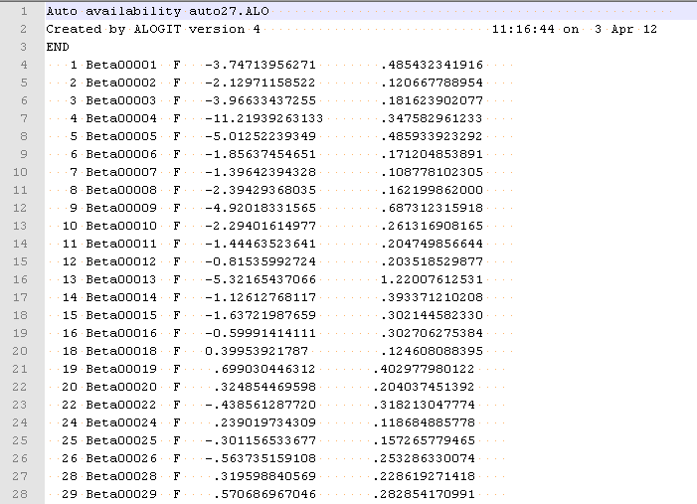

#### Roster

Skim files report the level of services on regional network. All level of service files are TransCAD matrix (mtx) files. The skims files are under the directory at .\[year]\outputs. The roster file, Table 4.24, is a CSV file that lists all the impedance skim matrices to be read and used by Daysim. It is .\[year]\DaySim\nashville-roster_matrix.csv. During a model run, the roster file is copied to the global outputs folder (.\[year]\outputs\ nashville-roster_matrix.csv). The configuration files are pointed to this location to use the skims in the same folder.

Table 4.24 RosTer File

|  |  |
| --- | --- |
| FIELD | DESCRIPTION |
| #variable | Skim variable, with string that is used in the C# code |
| mode | Skim mode, valid values are walk, bike, SOV, HOV2, HOV3, and transit |
| path-type | Path type, valid values are full-network, bus, knr-bus, pnr-bus |
| vot-group | Value of time range, valid values are very-low, low, medium, high, and very-high (currently all values are medium) |
| start-minute | First minute for which skim applies, in minutes past midnight |
| end-minute | Last minute for which skim applies, in minutes past midnight (if lower than start-minute, then period spans midnight |
| length | Size of matrix (currently all values are maxzone) |
| File-type | Type of input file, current valid values are Text_IJ, BIN and null (leave as 0) |
| name | File name (assumes same directory as roster file). Null is assumed for file type null |
| field | The field on the file (use 1 for BIN, for Text-IJ, the O and D zones are fields 1 and 2) |
| transpose | If TRUE, DaySim will use the transpose of the matrix that is read in |
| blend-variable | Variable that is used for short distance "blending" - the same mode is assumed |
| blend-path-type | Allows blending variable to be for a different path type, If null, same path type is assumed |
| factor | A factor to be applied to the matrix - e.g. 20 to turn walk distance to time. (If null, factor is 1) |
| scaling | If TRUE, matrix is scaled by 100 before being stored as a 2-byte integer. (BIN matrices are assumed to already be scaled) |

#### Roster Combination

The "Roster Combinations" file gives the possible mode/path type combinations used in DaySim. It is a CSV file at .\[year]\DaySim\nashville_roster.combinations.csv. The file, Table 4.25 , has columns that enumerate the 9 modes used in the current model system (walk, bike, SOV, HOV2, HOV3, transit, park-and-ride, school-bus, other) and 7 rows that enumerate the path types currently used (full-network, no-tolls, local-bus, light-rail, premium-bus, commuter rail, ferry). The cells are TRUE for valid combinations within DaySim and FALSE otherwise. During a model run, the roster combination file is copied to the global outputs folder (.\[year]\outputs\ nashville_roster.combinations.csv). The configuration files are pointed to this location.

Table 4.25 Roster Combination File Example

|  |  |  |  |  |  |  |  |
| --- | --- | --- | --- | --- | --- | --- | --- |
| # | walk | bike | sov | hov2 | hov3 | transit | pnr |
| full-network | TRUE | TRUE | TRUE | TRUE | TRUE | TRUE | TRUE |
| no-tolls | FALSE | FALSE | TRUE | TRUE | TRUE | FALSE | FALSE |
| local-bus | FALSE | FALSE | FALSE | FALSE | FALSE | TRUE | TRUE |

#### Configuration

The configuration file is the main user input control file for DaySim. This file is an XML format. As mentioned previously, for each feedback loop DaySim is run for three iterations. In the first two iterations only long term choice models, work and school location choice models, are run. The third iteration runs both long-term and short-term choice models. Therefore, the ABM setup uses two configuration files: “configuration_workandschool.xml” (first two iterations) and “configuration.xnl” (third iteration).

When running DaySim, the name of the configuration file and the name of the print log file can be given as command-line arguments. An example is:

Daysim – c [configuration_file_name] – p [print_file_name]

Table 4.26 Configuration File (configuration.xml)

| Setting | Value | Description |
| --- | --- | --- |
| Nashville | TRUE | Path type model |
| ChoiceModelRunner | Default | Type of choice model runner |
| DataType | Default | Identifies the presence of client-specific household input data (currently only used for Actum) |
| Settings | DefaultSettings |  |
| WorkingSubpath | ".\working" | Working directory name |
| OutputSubpath | ".\outputs" | Output directory name |
| EstimationSubpath | ".\estimation" | If estimation mode, estimation directory name |
| RandomSeed | 1234 | Initial seed value for the random number generator |
| ShouldSynchronizeRandomSeed | TRUE | If true, Daysim will use a seed for each person/tour/trip/model combination that depends only on the initial seed |
| NumberOfRandomSeeds | 1000 | Number of random seeds |
| RosterPath | .\output\nashville-roster_matrix.csv | Name of roster CSV file, including full directory path |
| RosterCombinationsPath | .\output\nashville_roster.combinations.csv | Name of valid roster combinations CSV file, including full directory path |
| SkimDelimiter | "44" | The delimiter for text_IJ (ascii text) skim input files (9=TAB, 32=space, 44=comma) |
| VotVeryLowLow | 0 | Boundary between VeryLow and Low VOT groups, in Monetary units per hour |
| VotLowMedium | 6.78 | Boundary between Low and Medium VOT groups, in Monetary units per hour |
| VotMediumHigh | 20.89 | Boundary between Medium and High VOT groups, in Monetary units per hour |
| VotHighVeryHigh | 1001 | Boundary between High and VeryHigh VOT groups, in Monetary units per hour |
| IxxiPath | .\nashville_worker_IXXIfractions.dat | The full path name for the input worker IXXI fractions file |
| IxxiDelimiter | 32 | The delimiter for the input file (9=TAB, 32=space, 44=comma) |
| IxxiFirstLineIsHeader | FALSE | If true, Daysim expects a header record for this file (all other raw data' files have headers) |
| RawParkAndRideNodePath | .\p_r_Nodes_2010.dat | The full path name for the raw park and ride node file. (If none given, the park and ride mode will not be available) |
| RawParkAndRideNodeDelimiter | 9 | The delimiter for the input file (9=TAB, 32=space, 44=comma) |
| ImportParkAndRideNodes | TRUE | If TRUE, the raw file should be imported (always TRUE if ShouldRunRawConversion=true) |
| ShouldReadParkAndRideNodeSkim | FALSE | If true, will expect a skim matrix with the best park and ride node number for each OD pair |
| RawParcelPath | .\Nashville_mzbuffer_allstreets_2010.dat | The full path name for the raw parcel or microzone input file |
| RawParcelDelimiter | 32 | The delimiter for the input file (9=TAB, 32=space, 44=comma) |
| RawZonePath | .\nashville_taz_indexes_1.dat | The full path name for the raw zone indexes input file |
| RawZoneDelimiter | 9 | The delimiter for the input file (9=TAB, 32=space, 44=comma) |
| RawHouseholdPath | .\nashville_household_2010.dat | The full path name for the raw household input file |
| RawHouseholdDelimiter | 32 | The delimiter for the input file (9=TAB, 32=space, 44=comma) |
| OutputHouseholdPath | .\_household.tsv | The full path name for the household output file |
| OutputHouseholdDelimiter | 9 | The delimiter for the output file (9=TAB, 32=space, 44=comma) |
| RawPersonPath | .\nashville_person_2010.dat | The full path name for the raw person input file |
| RawPersonDelimiter | 32 | The delimiter for the input file (9=TAB, 32=space, 44=comma) |
| OutputPersonPath | .\_person.tsv | The full path name for the person output file |
| OutputPersonDelimiter | 9 | The delimiter for the output file (9=TAB, 32=space, 44=comma) |
| OutputHouseholdDayPath | .\_household_day.tsv | The full path name for the household-day output file |
| OutputHouseholdDayDelimiter | 9 | The delimiter for the output file (9=TAB, 32=space, 44=comma) |
| OutputPersonDayPath | .\_person_day.tsv | The full path name for the person-day output file |
| OutputPersonDayDelimiter | 9 | The delimiter for the output file (9=TAB, 32=space, 44=comma) |
| OutputTourPath | .\_tour.tsv | The full path name for the tour output file |
| OutputTourDelimiter | 9 | The delimiter for the output file (9=TAB, 32=space, 44=comma) |
| OutputTripPath | .\_trip.tsv | The full path name for the trip output file |
| OutputTripDelimiter | 9 | The delimiter for the input file (9=TAB, 32=space, 44=comma) |
| ShouldRunRawConversion | TRUE | If true, DAYSIM will convert and input all of the raw data files listed below |
| MinParcelSize | 10 | The minimum microzone size variable (in units of 1/1000) to be considered available in destination sampling |
| UrbanThreshold | 500 | The minimum microzone size (based on households + employment in buffer 1) to be considered "urban" rather than "rural". (Used in auto ownership model calibration) |
| IsInEstimationMode | FALSE | TRUE if Daysim should be run in order to estimate a specific model, rather than running a simulation |
| ShouldRunChoiceModels | TRUE | A toggle switch to run all choice models (TRUE can be overridden by switches below and by individual model switches) |
| ShouldRunHouseholdModels | TRUE | A toggle switch to run household level models (used to peform partial runs, TRUE can be overridden by individual model swtiches) |
| ShouldRunPersonModels | TRUE | A toggle switch to run person level models (used to peform partial runs, TRUE can be overridden by individual model swtiches) |
| ShouldRunPersonDayModels | TRUE | A toggle switch to run person-day level models (used to peform partial runs, TRUE can be overridden by individual model swtiches) |
| ShouldRunTourModels | TRUE | A toggle switch to run tour level models (used to peform partial runs, TRUE can be overridden by individual model swtiches) |
| ShouldRunTourTripModels | TRUE | A toggle switch to run trip level models (used to peform partial runs, TRUE can be overridden by individual model swtiches) |
| ShouldRunSubtourModels | TRUE | A toggle switch to run subtour level models (used to peform partial runs, TRUE can be overridden by individual model swtiches) |
| ShouldRunSubtourTripModels | TRUE | A toggle switch to run trip level models for subtours (used to peform partial runs, TRUE can be overridden by individual model swtiches) |
| DestinationScale | 0 |  |
| EstimationModel | none | The name of the specific model to be estimated |
| ShouldOutputAlogitData | FALSE | TRUE if an Alogit data file for model estimation should be written |
| OutputAlogitDataPath | .\xxx.dat | The full pathname of the Alogit data file for model estimation |
| OutputAlogitControlPath | .\xxx.alo | The full pathname of the Alogit control (.ALO) file for model estimation |
| MaximumBlendingDistance | 3 | The maximum (network) distance for which short-distance blending should be used, in miles |
| ShowRunChoiceModelsStatus | TRUE | TRUE to show percent of households simulated on the screen during simulation |
| LargeDegreeOfParallelism | 8 | Controls the use of multiple processors for threading |
| SmallDegreeOfParallelism | 4 | Controls the use of multiple processors for threading |
| ShouldOutputTDMTripList | FALSE | TRUE to produce a separate trip list output file for use by other models |
| OutputTDMTripListPath | .\transims_trip_list.csv | The full path name of the output trip list file |
| TDMTripListDelimiter | 44 | The delimiter for the output file (9=TAB, 32=space, 44=comma) |
| UseTransimsTDMTripListFormat | TRUE | TRUE to write the output trip list file in the format to be used by Transims |
| PathImpedance_PathChoiceScaleFactor | 1.5 | A scale factor for the coefficients of the path type models (the inverse of a logsum coefficient in upper level models) |
| PathImpedance_AutoOperatingCostPerMile | 0.12 | The auto operating cost, in Monetary Units per Distance Unit |
| PathImpedance_TransitInVehicleTimeWeight | 1 | The relative weight on transit in-vehicle time in the transit and park and ride path type models |
| PathImpedance_TransitFirstWaitTimeWeight | 2 | The relative weight on transit first wait time in the transit and park and ride path type models |
| PathImpedance_TransitTransferWaitTimeWeight | 2 | The relative weight on transit transfer wait time in the transit and park and ride path type models |
| PathImpedance_TransitNumberBoardingsWeight | 4 | The relative weight on transit number of boardings in the transit and park and ride path type models |
| PathImpedance_TransitDriveAccessTimeWeight | 2 | The relative weight on transit drive access in-vehicle time in the park and ride path type models |
| PathImpedance_TransitWalkAccessTimeWeight | 2 | The relative weight on transit walk access and egress times in the transit and park and ride path type models |
| PathImpedance_WalkTimeWeight | 2 | The relative weight on walk mode time in the walk path type model |
| PathImpedance_BikeTimeWeight | 2 | The relative weight on bike mode time in the bike path type model |
| PathImpedance_WalkMinutesPerMile | 20 | The factor to convert microzone-based transit walk access/egress distance into time (in minutes per distance unit) |
| PathImpedance_TransitWalkAccessDistanceLimit | 2 | The maximum microzone-based transit walk access or egress distance allowed for available transit paths |
| PathImpedance_TransitWalkAccessDirectLimit | 1 | The maximum microzone-based transit walk access or egress distance allowed for direct transit paths to be chosen over mixed paths |
| PathImpedance_TransitSingleBoardingLimit | 1.1 | The maximum number of boardings for a transit path to be considered a "direct path" (no transfers) |
| PathImpedance_AutoTolledPathConstant | 0 | The path type constant for an auto path that includes a non-zero toll cost (reflects extra resistance to paying tolls) |
| PathImpedance_AvailablePathUpperTimeLimit | 180 | The maximum total (unweighted) path travel time for a path to be considered as an available option |
| PathImpedance_TransitLocalBusPathConstant | 0.57 | The path type constant for transit local bus only paths |
| PathImpedance_TransitPremiumBusPathConstant | 0.60 | The path type constant for transit premium bus (possibly plus feeder) paths |
| PathImpedance_TransitLightRailPathConstant | 0 | The path type constant for transit light rail (possibly plus feeder) paths |
| PathImpedance_TransitCommuterRailPathConstant | 1.50 | The path type constant for transit commuter rail (possibly plus feeder) paths |
| PathImpedance_TransitFerryPathConstant | 0.40 | The path type constant for transit passenger ferry (possibly plus feeder) paths |
| PathImpedance_TransitUsePathTypeSpecificTime | TRUE | A switch to use additional skims and weights to reflect transit submode-specific in-vehicle times (SACOG-specific) |
| PathImpedance_TransitPremiumBusTimeAdditiveWeight | -0.204 | An additive weight on premium bus submode-specific in-vehicle time (adds to TransitInVehicleTimeWeight) |
| PathImpedance_TransitLightRailTimeAdditiveWeight | 0.0 | An additive weight on light rail submode-specific in-vehicle time (adds to TransitInVehicleTimeWeight) |
| PathImpedance_TransitCommuterRailTimeAdditiveWeight | -0.273 | An additive weight on commuter rail submode-specific in-vehicle time (adds to TransitInVehicleTimeWeight) |
| PathImpedance_TransitFerryTimeAdditiveWeight | -0.318 | An additive weight on passenger ferry submode-specific in-vehicle time (adds to TransitInVehicleTimeWeight) |
| PathImpedance_TransitPremiumBusInVehicleTimeWeight | 0.95 | A weight applied to premium bus sub-mode specific in-vehicle time |
| PathImpedance_TransitLightRailInVehicleTimeWeight | 1.0 | A weight applied to light rail sub-mode specific in-vehicle time |
| PathImpedance_TransitCommuterRailInVehicleTimeWeight | 0.78 | A weight applied to commuter rail sub-mode specific in-vehicle time |
| PathImpedance_TransitFerryInVehicleTimeWeight | 0.80 | A weight applied to ferry (BRT) sub-mode specific in-vehicle time |
| PathImpedance_BikeUseTypeSpecificDistanceFractions | FALSE | A switch to use additional skims and weights to reflect bicycle distances on specific facility types (SACOG-specific) |
| PathImpedance_BikeType1DistanceFractionAdditiveWeight | 0 | An additive weight on bike distance on Class 1 bike paths (adds to BikeTimeWeight, distance is converted to time) |
| PathImpedance_BikeType2DistanceFractionAdditiveWeight | 0 | An additive weight on bike distance on Class 1 bike paths (adds to BikeTimeWeight, distance is converted to time) |
| PathImpedance_BikeType3DistanceFractionAdditiveWeight | 0 | An additive weight on bike distance on Class 1 bike paths (adds to BikeTimeWeight, distance is converted to time) |
| PathImpedance_BikeType4DistanceFractionAdditiveWeight | 0 | An additive weight on bike distance on Class 1 bike paths (adds to BikeTimeWeight, distance is converted to time) |
| PathImpedance_TransitUseFareDiscountFractions | TRUE | A switch to use transit fare discount fractions based on person type and age |
| PathImpedance_TransitFareDiscountFractionChildUnder5 | 0.8 | Transit fare discount fraction for children under age 5 |
| PathImpedance_TransitFareDiscountFractionChild5To15 | 0.5 | Transit fare discount fraction for children age 5 to 15 |
| PathImpedance_TransitFareDiscountFractionHighSchoolStudent | 0.5 | Transit fare discount fraction for high school students (children age 16+) |
| PathImpedance_TransitFareDiscountFractionUniverityStudent | 0.5 | Transit fare discount fraction for college students |
| PathImpedance_TransitFareDiscountFractionAge65Up | 0.5 | Transit fare discount fraction for adults age 65+ |
| PathImpedance_TransitPassCostPercentChangeVersusBase | 0 | Policy input variable to change the cost of transit passes with respect to the base year |
| Coefficients_BaseCostCoefficientPerDollar | -0.15 | A base cost coefficient (per monetary unit), when income = BaseCostCoefficientIncomeLevel |
| Coefficients_BaseCostCoefficientIncomeLevel | 30000 | The household income level (monetary units per year) where the cost coefficient is the BaseCostCoefficient |
| Coefficients_CostCoefficientIncomePower_Work | 0.6 | The power function exponent to use for adjusting the cost coefficient for income, for work tours |
| Coefficients_CostCoefficientIncomePower_Other | 0.5 | The power function exponent to use for adjusting the cost coefficient for income, for non-work tours |
| Coefficients_MeanTimeCoefficient_Work | -0.03 | The mean time coefficient (/minute) for work tours |
| Coefficients_MeanTimeCoefficient_Other | -0.015 | The mean time coefficient (/minute) for non-work tours |
| Coefficients_StdDeviationTimeCoefficient_Work | 0.24 | The standard deviation of the time coefficient (/minute) for work tours, when using random VOT distribution |
| Coefficients_StdDeviationTimeCoefficient_Other | 0.15 | The standard deviation of the time coefficient (/minute) for non-work tours, when using random VOT distribution |
| Coefficients_HOV2CostDivisor_Work | 1.741 | The divisor for the cost coefficient for the HOV2 mode for work tours (to reflect cost-sharing) |
| Coefficients_HOV2CostDivisor_Other | 1.625 | The divisor for the cost coefficient for the HOV2 mode for non-work tours (to reflect cost-sharing) |
| Coefficients_HOV3CostDivisor_Work | 2.408 | The divisor for the cost coefficient for the HOV3+ mode for work tours (to reflect cost-sharing) |
| Coefficients_HOV3CostDivisor_Other | 2.158 | The divisor for the cost coefficient for the HOV3+ mode for non-work tours (to reflect cost-sharing) |
| UseRandomVotDistribution | TRUE | TRUE to randomly simulate a time coefficient for each tour, using a log-normal distribution |
| ShouldRunTrace | FALSE | TRUE to trace the details of the simulation for a specific household (for diagnostics/debugging) |
| TracePath | .\trace.txt | The full path name for the trace output file |
| HouseholdIdForTrace | 1 | The household ID for the trace |
| ShouldLoadAggregateLogsumsFromFile | FALSE | TRUE to read the aggregate logsums from a file generated by a previous run (otherwise they are re-calculated) |
| ShouldOutputAggregateLogsums | TRUE | TRUE to write the aggregate logsums to a file for a subsequent run |
| OutputAggregateLogsumsPath | .\aggregate_logsums.dat | The full path name for the file where the aggregate logsums are written |
| ShouldLoadSamplingWeightsFromFile | FALSE | TRUE to read the pre-calculated sampling weights from a file generated by a previous run (otherwise they are re-calculated) |
| ShouldOutputSamplingWeights | FALSE | TRUE to write the pre-calculated sampling weights to a file for a subsequent run |
| OutputSamplingWeightsPath | .\sampling_weights.dat | The full path name for the file where the sampling weights are written |
| WorkLocationModelSampleSize | 50 | The maximum number of destinations to be sampled for this model |
| WorkLocationModelCoefficients | .\WorkLocationCoefficients_nashville-v1.5.f12 | The full path name for the coefficient file for this model |
| ShouldRunWorkLocationModel | TRUE | A toggle switch to run this model (can be used for partial runs, TRUE can be overridden by more general switches above) |
| ShouldTraceWorkLocationModel | FALSE | TRUE to trace the calculations for this model (if ShouldRunTrace is also TRUE) |
| IncludeWorkLocationModel | TRUE | FALSE to always exclude this model from the set of models to be run (not sure how this is different from ShouldRun?) |
| SchoolLocationModelSampleSize | 50 | The maximum number of destinations to be sampled for this model |
| SchoolLocationModelCoefficients | .\SchoolLocationCoefficients_nashville-v1.8.f12 | The full path name for the coefficient file for this model |
| ShouldRunSchoolLocationModel | TRUE | A toggle switch to run this model (can be used for partial runs, TRUE can be overridden by more general switches above) |
| ShouldTraceSchoolLocationModel | FALSE | TRUE to trace the calculations for this model (if ShouldRunTrace is also TRUE) |
| IncludeSchoolLocationModel | TRUE | FALSE to always exclude this model from the set of models to be run (not sure how this is different from ShouldRun?) |
| PayToParkAtWorkplaceModelCoefficients | .\PayToParkAtWorkplaceCoefficients_nashville-v1.5.F12 | The full path name for the coefficient file for this model |
| ShouldRunPayToParkAtWorkplaceModel | TRUE | A toggle switch to run this model (can be used for partial runs, TRUE can be overridden by more general switches above) |
| ShouldTracePayToParkAtWorkplaceModel | FALSE | TRUE to trace the calculations for this model (if ShouldRunTrace is also TRUE) |
| IncludePayToParkAtWorkplaceModel | TRUE | FALSE to always exclude this model from the set of models to be run (not sure how this is different from ShouldRun?) |
| TransitPassOwnershipModelCoefficients | .\TransitPassOwnershipCoefficients_nashville-v1.5.f12 | The full path name for the coefficient file for this model |
| ShouldRunTransitPassOwnershipModel | TRUE | A toggle switch to run this model (can be used for partial runs, TRUE can be overridden by more general switches above) |
| ShouldTraceTransitPassOwnershipModel | FALSE | TRUE to trace the calculations for this model (if ShouldRunTrace is also TRUE) |
| IncludeTransitPassOwnershipModel | TRUE | FALSE to always exclude this model from the set of models to be run (not sure how this is different from ShouldRun?) |
| AutoOwnershipModelCoefficients | .\AutoOwnershipCoefficients_nashville-v1.5.f12 | The full path name for the coefficient file for this model |
| ShouldRunAutoOwnershipModel | TRUE | A toggle switch to run this model (can be used for partial runs, TRUE can be overridden by more general switches above) |
| ShouldTraceAutoOwnershipModel | FALSE | TRUE to trace the calculations for this model (if ShouldRunTrace is also TRUE) |
| IndividualPersonDayPatternModelCoefficients | .\IndividualPersonDayPatternCoefficients_nashville-v1.8.f12 | The full path name for the coefficient file for this model |
| ShouldRunIndividualPersonDayPatternModel | TRUE | A toggle switch to run this model (can be used for partial runs, TRUE can be overridden by more general switches above) |
| ShouldTraceIndividualPersonDayPatternModel | FALSE | TRUE to trace the calculations for this model (if ShouldRunTrace is also TRUE) |
| PersonExactNumberOfToursModelCoefficients | .\PersonExactNumberOfToursCoefficients_nashville-v1.5.F12 | The full path name for the coefficient file for this model |
| ShouldRunPersonExactNumberOfToursModel | TRUE | A toggle switch to run this model (can be used for partial runs, TRUE can be overridden by more general switches above) |
| ShouldTracePersonExactNumberOfToursModel | FALSE | TRUE to trace the calculations for this model (if ShouldRunTrace is also TRUE) |
| WorkTourDestinationModelSampleSize | 25 | The maximum number of destinations to be sampled for this model |
| WorkTourDestinationModelCoefficients | .\WorkTourDestinationCoefficients_nashville-v1.8.F12 | The full path name for the coefficient file for this model |
| ShouldRunWorkTourDestinationModel | TRUE | A toggle switch to run this model (can be used for partial runs, TRUE can be overridden by more general switches above) |
| ShouldTraceWorkTourDestinationModel | FALSE | TRUE to trace the calculations for this model (if ShouldRunTrace is also TRUE) |
| OtherTourDestinationModelSampleSize | 25 | The maximum number of destinations to be sampled for this model |
| OtherTourDestinationModelCoefficients | .\OtherTourDestinationCoefficients_nashville-v1.8.F12 | The full path name for the coefficient file for this model |
| ShouldRunOtherTourDestinationModel | TRUE | A toggle switch to run this model (can be used for partial runs, TRUE can be overridden by more general switches above) |
| ShouldTraceOtherTourDestinationModel | FALSE | TRUE to trace the calculations for this model (if ShouldRunTrace is also TRUE) |
| WorkBasedSubtourGenerationModelCoefficients | .\WorkbasedSubtourGenerationCoefficients_nashville-v1.5.F12 | The full path name for the coefficient file for this model |
| ShouldRunWorkBasedSubtourGenerationModel | TRUE | A toggle switch to run this model (can be used for partial runs, TRUE can be overridden by more general switches above) |
| ShouldTraceWorkBasedSubtourGenerationModel | FALSE | TRUE to trace the calculations for this model (if ShouldRunTrace is also TRUE) |
| WorkTourModeModelCoefficients | .\WorkTourModeCoefficients_nashville-v1.5.F12 | The full path name for the coefficient file for this model |
| ShouldRunWorkTourModeModel | TRUE | A toggle switch to run this model (can be used for partial runs, TRUE can be overridden by more general switches above) |
| ShouldTraceWorkTourModeModel | FALSE | TRUE to trace the calculations for this model (if ShouldRunTrace is also TRUE) |
| SchoolTourModeModelCoefficients | .\SchoolTourModeCoefficients_nashville-v1.5.F12 | The full path name for the coefficient file for this model |
| ShouldRunSchoolTourModeModel | TRUE | A toggle switch to run this model (can be used for partial runs, TRUE can be overridden by more general switches above) |
| ShouldTraceSchoolTourModeModel | FALSE | TRUE to trace the calculations for this model (if ShouldRunTrace is also TRUE) |
| WorkBasedSubtourModeModelCoefficients | .\WorkBasedSubtourModeCoefficients_nashville-v1.5.F12 | The full path name for the coefficient file for this model |
| ShouldRunWorkBasedSubtourModeModel | TRUE | A toggle switch to run this model (can be used for partial runs, TRUE can be overridden by more general switches above) |
| ShouldTraceWorkBasedSubtourModeModel | FALSE | TRUE to trace the calculations for this model (if ShouldRunTrace is also TRUE) |
| EscortTourModeModelCoefficients | .\EscortTourModeCoefficients_nashville-v1.5.F12 | The full path name for the coefficient file for this model |
| ShouldRunEscortTourModeModel | TRUE | A toggle switch to run this model (can be used for partial runs, TRUE can be overridden by more general switches above) |
| ShouldTraceEscortTourModeModel | FALSE | TRUE to trace the calculations for this model (if ShouldRunTrace is also TRUE) |
| OtherHomeBasedTourModeModelCoefficients | .\OtherHomeBasedTourModeCoefficients_nashville-v1.5.F12 | The full path name for the coefficient file for this model |
| ShouldRunOtherHomeBasedTourModeModel | TRUE | A toggle switch to run this model (can be used for partial runs, TRUE can be overridden by more general switches above) |
| ShouldTraceOtherHomeBasedTourModeModel | FALSE | TRUE to trace the calculations for this model (if ShouldRunTrace is also TRUE) |
| WorkTourTimeModelCoefficients | .\WorkTourTimeCoefficients_nashville-v1.5.F12 | The full path name for the coefficient file for this model |
| ShouldRunWorkTourTimeModel | TRUE | A toggle switch to run this model (can be used for partial runs, TRUE can be overridden by more general switches above) |
| ShouldTraceWorkTourTimeModel | FALSE | TRUE to trace the calculations for this model (if ShouldRunTrace is also TRUE) |
| SchoolTourTimeModelCoefficients | .\SchoolTourTimeCoefficients_nashville-v1.5.F12 | The full path name for the coefficient file for this model |
| ShouldRunSchoolTourTimeModel | TRUE | A toggle switch to run this model (can be used for partial runs, TRUE can be overridden by more general switches above) |
| ShouldTraceSchoolTourTimeModel | FALSE | TRUE to trace the calculations for this model (if ShouldRunTrace is also TRUE) |
| OtherHomeBasedTourTimeModelCoefficients | .\OtherHomeBasedTourTimeCoefficients_nashville-v1.5.F12 | The full path name for the coefficient file for this model |
| ShouldRunOtherHomeBasedTourTimeModel | TRUE | A toggle switch to run this model (can be used for partial runs, TRUE can be overridden by more general switches above) |
| ShouldTraceOtherHomeBasedTourTimeModel | FALSE | TRUE to trace the calculations for this model (if ShouldRunTrace is also TRUE) |
| WorkBasedSubtourTimeModelCoefficients | .\WorkbasedSubtourTimeCoefficients_nashville-v1.5.F12 | The full path name for the coefficient file for this model |
| ShouldRunWorkBasedSubtourTimeModel | TRUE | A toggle switch to run this model (can be used for partial runs, TRUE can be overridden by more general switches above) |
| ShouldTraceWorkBasedSubtourTimeModel | FALSE | TRUE to trace the calculations for this model (if ShouldRunTrace is also TRUE) |
| IntermediateStopGenerationModelCoefficients | .\IntermediateStopGenerationCoefficients_nashville-v1.5.F12 | The full path name for the coefficient file for this model |
| ShouldRunIntermediateStopGenerationModel | TRUE | A toggle switch to run this model (can be used for partial runs, TRUE can be overridden by more general switches above) |
| ShouldTraceIntermediateStopGenerationModel | FALSE | TRUE to trace the calculations for this model (if ShouldRunTrace is also TRUE) |
| IntermediateStopLocationModelSampleSize | 50 | The maximum number of destinations to be sampled for this model |
| IntermediateStopLocationModelCoefficients | .\IntermediateStopLocationCoefficients_nashville-v1.8.F12 | The full path name for the coefficient file for this model |
| ShouldRunIntermediateStopLocationModel | TRUE | A toggle switch to run this model (can be used for partial runs, TRUE can be overridden by more general switches above) |
| ShouldTraceIntermediateStopLocationModel | FALSE | TRUE to trace the calculations for this model (if ShouldRunTrace is also TRUE) |
| TripModeModelCoefficients | .\TripModeCoefficients_nashville-v1.5.f12 | The full path name for the coefficient file for this model |
| ShouldRunTripModeModel | TRUE | A toggle switch to run this model (can be used for partial runs, TRUE can be overridden by more general switches above) |
| ShouldTraceTripModeModel | FALSE | TRUE to trace the calculations for this model (if ShouldRunTrace is also TRUE) |
| TripTimeModelCoefficients | .\TripTimeCoefficients_nashville-v1.5.f12 | The full path name for the coefficient file for this model |
| ShouldRunTripTimeModel | TRUE | A toggle switch to run this model (can be used for partial runs, TRUE can be overridden by more general switches above) |
| ShouldTraceTripTimeModel | FALSE | TRUE to trace the calculations for this model (if ShouldRunTrace is also TRUE) |
| UseShortDistanceNodeToNodeMeasures | TRUE | TRUE to use node-to-node distance in accessibility measures calculations |
| RawParcelNodePath | .\mz_node_2010.dat | The full path name for the file providing the nearest node id for a microzone |
| RawParcelNodeDelimiter | 32 | The delimiter for the input file (9=TAB, 32=space, 44=comma) |
| NodeIndexPath | .\node_node_index.dat | The full path name for the file providing, for every node id, starting and end record indices in node short distance file (NodeDistancePath). |
| NodeIndexDelimiter | 32 | The delimiter for the input file (9=TAB, 32=space, 44=comma) |
| NodeDistancesPath | .\ node_node_distances.dat | The full path name for the file providing short distances for node pairs |
| NodeDistancesDelimiter | 32 | Delimiter for the node distance file (9=TAB, 32=space, 44=comma) |
| AllowNodeDistanceAsymmetry | TRUE | TRUE to allow node distance asymmetry |
| UseShortDistanceCircuityMeasures | FALSE | TRUE to read in and use microzone-specific circuity factors in the short distance blending calculations |
| HouseholdSamplingRateOneInX | 1 | The denominator of the fraction of households in the input sample to be simulated (e.g. 100 is for 1 / 100) |
| HouseholdSamplingStartWithY | 1 | The household number to simulate first (e.g. 2, in combination with 100 above would simulate HH 2, 102, 202, etc.) |
| ShouldUseShadowPricing | TRUE | TRUE to apply shadow pricing for the WorkLocation and SchoolLocation models |
| UsualWorkMicrozoneThreshold | 5 | Microzone-specific threshold used in the shadow price calculations |
| UsualSchoolMicrozoneThreshold | 5 | Microzone-specific threshold used in the shadow price calculations |
| UsualUniversityMicrozoneThreshold | 5 | Microzone-specific threshold used in the shadow price calculations |
| NumberOfMicrozonesInReportDiffs | 10 | Control for printing out reporting on shadow price calculations |
| UsualWorkPercentTolerance | 0 | Percentage tolerance to trigger work microzone shadow price adjustment |
| UsualWorkAbsoluteTolerance | 0 | Absolute tolerance to trigger work microzone shadow price adjustment |
| UsualSchoolPercentTolerance | 0 | Percentage tolerance to trigger school microzone shadow price adjustment |
| UsualSchoolAbsoluteTolerance | 0 | Absolute tolerance to trigger school microzone shadow price adjustment |
| UsualUniversityPercentTolerance | 0 | Percentage tolerance to trigger university microzone shadow price adjustment |
| UsualUniversityAbsoluteTolerance | 0 | Absolute tolerance to trigger university microzone shadow price adjustment |
| ShadowPriceDelimiter | 9 | The delimiter for the shadow price files (9=TAB, 32=space, 44=comma) |
| NBatches | 16 |  |
| NProcessors | 12 | Number of processors to be used |
| ShouldUseParkAndRideShadowPricing | TRUE | If, True park and ride shadow pricing would be used in the model |
| ParkAndRideShadowPriceDelimiter | 9 | The delimiter for the park and ride shadow pricing file (9=TAB, 32=space, 44=comma) |
| ParkAndRideShadowPriceMaximumPenalty | -20 |  |
| ParkAndRideShadowPriceTimeSpread | 5 |  |

### DaySim Outputs

The person, tour and trip level output files contain all of the variables predicted by DaySim, plus ID variables to cross-reference each other and the input data files in order to append more information if necessary. These output files are under the scenario directory .\[year]\DaySim\Output\.

#### Household and household day files

The DaySim household and household day output files append the model predicted information into the household input files. Household output file is _household.tsv and is in the exact same format as the input file in Table 4.19.

The household day output file is household_day.tsv. The format of the file is shown in Table 4.27.

Table 4.27 Household Day File

|  |  |
| --- | --- |
| FIELD | DESCRIPTION |
| ID | internal DaySim record ID |
| HHNO | Household id |
| DAY | Diary / simulation day ID |
| DOW | Day of week |
| JTTOURS | HH fully joint tours in day |
| PHTOURS | HH partially joint half tours |
| FHTOURS | HH fully joint half tours |
| HDEXPFAC | HH day expansion factor |

#### Person and person day files

The person output file is _person.tsv and is in the exact same format as the input file in Table 4.20

The person-day output file has the person-day-level variables from a previous run. It is person_day.tsv. The format of the file is shown in Table 4.28.

Table 4.28 Person Day File

| FIELD | DESCRIPTION |
| --- | --- |
| ID | internal DaySim record ID |
| PERSON_ID | internal DaySim record ID |
| HOUSEHOLD_DAY_ID | internal DaySim record ID |
| HHNO | Household id |
| PNO | person sequential number on file |
| DAY | Diary / simulation day ID |
| BEGHOM | Dairy day begins at home? |
| ENDHOM | Dairy day ends at home? |
| HBTOURS | home based tours in day |
| WBTOURS | work based tours in day |
| UWTOURS | tours to usual workplace in day |
| WKTOURS | work tours |
| SCTOURS | school tours |
| ESTOURS | escort tours |
| PBTOURS | personal business Tours |
| SHTOURS | shopping tours |
| MLTOURS | meal tours |
| SOTOURS | social tours |
| RETOURS | recreation tours |
| METOURS | medical tours |
| WKSTOPS | work stops in day |
| SCSTOPS | school stops in day |
| ESSTOPS | escort stops in day |
| PBSTOPS | personal bus stops in day |
| SHSTOPS | shopping stops in day |
| MLSTOPS | meal stops in day |
| SOSTOPS | social stops in day |
| RESTOPS | recreation stops in day |
| MESTOPS | medical stops in day |
| WKATHOME | Minutes worked at home in day |
| PDEXPFAC | Person-day expansion factor |

#### Tour File

This file has tour-level variables based by all persons predicted by a previous DaySim run. It is _tour.tsv. Table 4.29 summarizes the contents of this file.

Table 4.29 Tour File

| FIELD | DESCRIPTION |
| --- | --- |
| ID | internal DaySim record ID |
| PERSON_ID | internal DaySim record ID |
| PERSON_DAY_ID | internal DaySim record ID |
| HHNO | Household ID |
| PNO | person sequential number on file |
| DAY | Diary / simulation day ID |
| TOUR | tour ID |
| JTINDEX | household joint tour index |
| PARENT | parent tour ID |
| SUBTRS | number of sub-tours |
| PDPURP | primary destination purpose |
| TLVORIG | time leave tour origin |
| TARDEST | time arrive tour destination |
| TLVDEST | time leave tour destination |
| TARORIG | time arrive tour origin |
| TOADTYP | tour origin address type |
| TDADTYP | tour destination address type |
| TOPCL | tour origin microzone |
| TOTAZ | tour origin TAZ |
| TDPCL | tour destination microzone |
| TDTAZ | tour destination TAZ |
| TMODETP | tour main mode type |
| TPATHTP | tour main mode path type |
| TAUTOTIME | tour 1-way auto time |
| TAUTOCOST | tour 1-way auto distance |
| TAUTODIST | tour 1-way auto cost |
| TRIPSH1 | 1st half tour number of trips |
| TRIPSH2 | 2nd half tour number of trips |
| PHTINDX1 | 1st half-partial joint half tour index |
| PHTINDX2 | 2nd half-partial joint half tour index |
| FHTINDX1 | 1s half- fully joint half tour index |
| FHTINDX2 | 2nd half- fully joint half tour index |
| TOEXPFAC | trip expansion factor |

#### Trip File

This file has trip-level variables for all trips predicted from a previous DaySim run. It is _trip.tsv.

Table 4.30 Trip File

| FIELD | DESCRIPTION |
| --- | --- |
| ID | internal DaySim record ID |
| TOUR_ID | internal DaySim record ID |
| HHNO | household ID |
| PNO | person sequence number on file |
| DAY | diary / simulation day ID |
| TOUR | tour ID |
| HALF | tour half |
| TSEG | trip segment number within half tour |
| TSVID | original survey trip ID number |
| OPURP | trip origin purpose |
| DPURP | trip destination purpose |
| OADTYP | trip origin address type |
| DADTYP | trip destination address type |
| OPCL | trip origin microzone |
| OTAZ | trip origin zone |
| DPCL | trip destination microzone |
| DTAZ | trip destination zone |
| MODE | trip mode |
| PATHTYPE | transit sub-mode |
| DORP | trip driver or passenger |
| DEPTM | trip departure time (min after 3 am) |
| ARRTM | trip arrival time (min after 3 am) |
| ENDACTTM | trip destination activity end time |
| TRAVTIME | network travel time, min (by SOV) |
| TRAVCOST | network travel time, min (by SOV) |
| TRAVDIST | network travel distance, miles (by SOV) |
| VOT | trip value of time (cents/minute) |
| TREXPFAC | trip expansion factor |

## DaySim-TransCAD Linkage

TransCAD GISDK scripts produce highway and transit skims in matrix (.mtx) format. The skims are input to DaySim, which simulates person trips and outputs them into .tsv list format. The trips are transformed into time-of-day specific highway and transit matrices for assignment. The matrices are under the directory: .\[year]\outputs\

Highway trips are saved into four time-of-day specific matrices:

* temp_AMOD.mtx
* temp_MDOD.mtx
* temp_PMOD.mtx
* temp_OPOD.mtx

Each matrix contains following cores:

Table 4.31 Highway Assignment Matrices

| Core | Description |
| --- | --- |
| IICOM | Internal-internal commercial vehicle trips |
| IISU | Internal-internal single unit truck trips |
| IIMU | Internal-internal multi-unit truck trips |
| IEAUTO | Internal-external auto trips |
| IESU | Internal-external single unit truck trips |
| EEAUTO | External-external auto trips |
| EESU | External-external single unit truck trips |
| Passenger | Residents auto trips |
| Commercial | Residents commercial trips |
| Single unit | Residents single unit truck trips |
| MU | Residents multi-unit truck trips |
| Preload_MU | Multi-unit truck trips for preload assignment |
| Preload_SU | Single unit truck trips for preload assignment |
| Preload_Pass | Auto trips for preload assignment |

Transit trips are saved into four time-of-day two matrices used for assignment:

* AMTripsByMode.mtx
* MDTripsByMode.mtx
* PMTripsByMode.mtx
* OPTripsByMode.mtx

Table 4.32 Transit Assignment Matrices

| Core | Description |
| --- | --- |
| WLKLOCBUS | Walk trips to local bus |
| WLKURBRAIL | Walk trips to urban rail |
| WLKEXPBUS | Walk trips to express bus |
| WLKCOMRAIL | Walk trips to commuter rail |
| WLKBRT | Walk trips to BRT |
| PNRLOCBUS | Park and ride trips to local bus |
| PNRBRT | Park and ride trips to urban rail |
| PNREXPBUS | Park and ride trips to express bus |
| PNRURBRAIL | Park and ride trips to commuter rail |
| PNRCOMRAIL | Park and ride trips to BRT |
| KNRLOCBUS | kiss and ride trips to local bus |
| KNRBRT | kiss and ride trips to urban rail |
| KNREXPBUS | kiss and ride trips to express bus |
| KNRURBRAIL | kiss and ride trips to commuter rail |
| KNRCOMRAIL | kiss and ride trips to BRT |

## Auxiliary Demand

#### Airport

In order to run the airport model, it is necessary to have the household production-attraction table produced by the original trip-based model generation component. This output generation file can be found in .\[year]\outputs\householdPA.bin and is an input to the airport model.

Table 4.33 Household PA Table

| Field | Description |
| --- | --- |
| ID | TAZ Id |
| HBW1 | Home-based work trips 1 |
| HBW2 | Home-based work trips 2 |
| HBW3 | Home-based work trips 3 |
| HBPD1 | Home-based |
| HBShp1 | Home-based shopping trips 1 |
| HBShp2 | Home-based shopping trips 2 |
| HBShp3 | Home-based shopping trips 3 |
| HBSch1 | Home-based school trips |
| HBO1 | Home-based other trips 1 |
| HBO2 | Home-based other trips 2 |
| HBO3 | Home-based other trips 3 |
| NHBW1 | Non-home based work trips |
| NHBO1 | Non-home based other trips |

The output form the airport model is the balanced airport PA table l, which can be found here .\[year]\outputs\airportPA.bin.

Table 4.34 Airport Generation File

|  |  |
| --- | --- |
| Field | Description |
| ID1 | TAZ Id |
| AIR_HBO_P | Home-based other airport production |
| AIR_HBO_A | Home-based other airport attraction |
| AIR_NHBW_P | Non-home-based work airport production |
| AIR_NHBW_A | Non-home-based work airport attraction |
| AIR_VISIT_P | Visitors airport production |
| AIR_VISIT_A | Visitors airport attraction |

Another output, the airport trip distribution matrix, can be found in .\[year]\outputs\airportTD.bin.

Table 4.35 Airport Distribution File

|  |  |
| --- | --- |
| Field | Description |
| ORIG | Origin zone |
| DEST | Destination zone |
| AIR_HBO | Home-based other airport trips |
| AIR_NHBW | Non-home-based work airport trips |
| AIR_VISIT | Visitors airport trips |

Subsequently, mode choice is run for airport trips, and three purpose specific outputs are produced. The outputs are .\[year]\outputs\mc_hbo.mtx, mc_nhbo.mtx, mc_nhbw.mtx.

Table 4.36 Airport Mode Choice File

|  |  |
| --- | --- |
| Core | Description |
| DA | Drive alone airport trips |
| SR2 | 2 person shared ride airport trips |
| SR3 | 3 or more persons shared ride airport trips |
| WALKLOCBUS | Walk to local bus airport trips |
| WALKBRT | Walk to BRT airport trips |
| WALKEXPBUS | Walk to express bus airport trips |
| WALKURBRAIL | Walk to urban rail airport trips |
| WALKCOMRAIL | Walk to commuter rail airport trips |
| PNRLOCBUS | Park and Ride to local bus airport trips |
| PNRBRT | Park and Ride to BRT airport trips |
| PNREXPBUS | Park and Ride to express bus airport trips |
| PNRURBRAIL | Park and Ride to urban rail airport trips |
| PNRCOMRAIL | Park and Ride to commuter rail airport trips |
| KNRLOCBUS | Kiss and Ride to local bus airport trips |
| KNRBRT | Kiss and Ride to BRT airport trips |
| KNREXPBUS | Kiss and Ride to express bus airport trips |
| KNRURBRAIL | Kiss and Ride to urban rail airport trips |
| KNRCOMRAIL | Kiss and Ride to commuter rail airport trips |

#### Freight

Freight model district table (.\[year]\Inputs\2010 district sub OD factored.mtx) is an input to the freight model.

Table 4.37 Freight District Table

|  |  |
| --- | --- |
| Core | Description |
| Demand (Through) | Through demand |
| Demand (Inbound) | Inbound demand |
| Demand (Outbound) | Outbound demand |

The multi-unit OD matrix (.\[year]\outputs\FREIGHT_DISTRICT_update.mtx) and the Freight OD matrix (.\[year]\outputs\OD_Freight.mtx) are outputs of the freight model.

Table 4.38 Multi-unit OD MAtrix

|  |  |
| --- | --- |
| Core | Description |
| Weight_O | Weight for origin |
| Weight_D | Weight for destination |
| Demand (Through) | Through demand |
| Demand (Inbound) | Inbound demand |
| Demand (Outbound) | Outbound demand |

Table 4.39 Freight OD MAtrix

| Core | Description |
| --- | --- |
| MUEE_AM | Drive alone airport trips |
| MUEE_MD | 2 person shared ride airport trips |
| MUEE_PM | 3 or more persons shared ride airport trips |
| MUEE_OP | Walk to local bus airport trips |
| MUEI_AM | Walk to BRT airport trips |
| MUEI_MD | Walk to express bus airport trips |
| MUEI_PM | Walk to urban rail airport trips |
| MUEI_OP | Walk to commuter rail airport trips |
| MUIE_AM | Park and Ride to local bus airport trips |
| MUIE_MD | Park and Ride to BRT airport trips |
| MUIE_PM | Park and Ride to express bus airport trips |
| MUIE_OP | Park and Ride to urban rail airport trips |

#### Non-HH

Friction factors (.\[year]\Inputs\Friction Factors.bin) and county adjustment factors for non-hh trip generation (.\[year]\Inputs\Non-Household Adj.bin) are inputs in generating the non-hh demand.

Table 4.40 Non-HH Friction Factor File

|  |  |
| --- | --- |
| Field | Description |
| Time | Time |
| IICOM | Friction factor for an internal-internal commercial vehicle trip |
| IISU | Friction factor for an internal-internal Single Unit vehicle trips |
| IIMU | Friction factor for an internal-internal Multi Unit vehicle trips |
| IEAUTO | Friction factor for an internal-external auto trips |
| IESU | Friction factor for an internal-external Single Unit vehicle trips |

Table 4.41 Non-HH County Adjustment Factor File

|  |  |
| --- | --- |
| Field | Description |
| County | County Id |
| COM | commercial vehicle |
| SU | Single Unit vehicle |
| MU | Multi-Unit vehicle |

Non-HH demand is stored in .\[year]\outputs\PA.mtx.

Table 4.42 Non-HH Demand File

| Matrix Core | Description |
| --- | --- |
| IICOM | Internal-internal commercial |
| IISU | Internal-internal single-unit |
| IIMU | Internal-internal multi-unit |
| IEAUTO | Internal-external auto |
| IESU | Internal-external single unit |
| EEAUTO | External-external auto |
| EESU | External-external single unit |
| HBO_DA | Drive alone home based other |
| HBO_SR2 | Shared ride home based other |
| HBO_SR3 | Shared ride (3 or more people) home based other |
| HBSch_DA | Drive alone home based school |
| HBSch_SR2 | Shared ride home based school |
| HBSch_SR3 | Shared ride (3 or more people) home based school |
| HBShp_DA | Drive alone home based shopping |
| HBShp_SR2 | Shared ride home based shopping |
| HBShp_SR3 | Shared ride (3 or more people) home based shopping |
| HBW_DA | Drive alone home based work |
| HBW _SR2 | Shared ride home based work |
| HBW _SR3 | Shared ride (3 or more people) home based work |
| NHBO_DA | Drive alone non-home based other |
| NHBO_SR2 | Shared ride non-home based other |
| NHBO_SR3 | Shared ride (3 or more people) non-home based other |
| NHBW_DA | Drive alone non-home based work |
| NHBW_SR2 | Shared ride non-home based work |
| NHBW_SR3 | Shared ride (3 or more people) non-home based work |

## Network Assignment

### Assignment Inputs

#### Highway Assignment

Before the highway assignment step, and assignment preparation step is performed in which time-of-day specific matrices are prepared by putting all highway demand (airport, auxiliary, and freight) are into one matrix. The matrices are .\[year]\outputs\[Period]OD.mtx

Table 4.43 Highway Assignment Input Matrix

| Core | Description |
| --- | --- |
| IICOM | Internal-internal commercial vehicle trips |
| IISU | Internal-internal single unit truck trips |
| IIMU | Internal-internal multi-unit truck trips |
| IEAUTO | Internal-external auto trips |
| IESU | Internal-external single unit truck trips |
| EEAUTO | External-external auto trips |
| EESU | External-external single unit truck trips |
| Passenger | Residents auto trips |
| Commercial | Residents commercial trips |
| Single unit | Residents single unit truck trips |
| MU | Residents multi-unit truck trips |
| Preload_MU | Multi-unit truck trips for preload assignment |
| Preload_SU | Single unit truck trips for preload assignment |
| Preload_Pass | Auto trips for preload assignment |

Hourly factors (.\[year]\Inputs\NashvilleHourly.bin) are also input to the assignment.

Table 4.44 Highway Assignment Hourly Factors

| Field | Description |
| --- | --- |
| HOUR | Hour |
| TOD | Time of day |
| DEP_IICOM | Departure factor for internal-internal commercial vehicle |
| RET_IICOM | Return factor for internal-internal commercial vehicle |
| DEP_IISU | Departure factor for internal-internal single-unit trucks |
| RET_IISU | Return factor for internal-internal single-unit trucks |
| DEP_IIMU | Departure factor for internal-internal multi-unit trucks |
| RET_IIMU | Return factor for internal-internal multi-unit trucks |
| DEP_IESU | Departure factor for internal-external single-unit trucks |
| RET_IESU | Return factor for internal-external single-unit trucks |
| DEP_IEAUTO | Departure factor for internal-external auto trips |
| RET_IEAUTO | Return factor for internal-external auto trips |
| DEP_IEMU | Departure factor for internal-external multi-unit trucks |
| RET_IEMU | Return factor for internal-external multi-unit trucks |
| DEP_EEAUTO | Departure factor for external-external auto trips |
| RET_EEAUTO | Return factor for external-external auto trips |
| DEP_EESU | Departure factor for external-external single-unit trucks |
| RET_EESU | Return factor for external-external single-unit trucks |
| DEP_EEMU | Departure factor for external-external multi-unit trucks |
| RET_EEMU | Return factor for external-external multi-unit trucks |
| DEP_HBO | Departure factor for home-based other trips |
| RET_HBO | Return factor for home-based other trips |
| DEP_HBPD | Departure factor for home-based pick-up/drop-off |
| RET_HBPD | Return factor for home-based pick-up/drop-off |
| DEP_HBSch | Departure factor for home-based school trips |
| RET_HBSch | Return factor for home-based school trips |
| DEP_HBShp | Departure factor for home-based shopping trips |
| RET_HBShp | Return factor for home-based shopping trips |
| DEP_HBW | Departure factor for home-based work trips |
| RET_HBW | Return factor for home-based work trips |
| DEP_NHBO | Departure factor for non-home-based school trips |
| RET_NHBO | Return factor for non-home-based school trips |
| DEP_NHBW | Departure factor for non-home-based work trips |
| RET_NHBW | Return factor for non-home-based work trips |

#### Transit Assignment

To prepare transit demand for assignment, the transit trips produced by Daysim are first combined with transit trips produced by the airport models. Four time-period-specific matrix files are produced for input to the transit network assignment model:

* AMTripsByMode.mtx
* MDTripsByMode.mtx
* PMTripsByMode.mtx
* OPTripsByMode.mtx

The contents of the matrices is summarized in Table 4.32.

In addition, the mode table (.\[year]\Inputs\MODES.DBF), mode transfer table (.\[year]\Inputs\MODEXFER.DBF) and movement table (.\[year]\Inputs\MovementTable.bin) are also used in the transit assignment process.

Table 4.45 TRansit Assignment Mode Table

| Field | Description |
| --- | --- |
| MODE_NAME | Mode name |
| MODE_ID | Mode Id |
| MODE_USED | Flag for using the mode |
| MODE_ACC | Flag for mode access |
| MODE_EGR | Flag for mode egress |
| FARE | Fare |
| AM_IMP | Impedance in AM peak period |
| MD_IMP | Impedance in MD period |
| PM_IMP | Impedance in PM peak period |
| OP_IMP | Impedance in off-peak period |
| AM_LNKIMP | Link impedance in AM peak period |
| MD_LNKIMP | Link impedance in MD period |
| PM_LINKIMP | Link impedance in PM period |
| OP_LNKIMP | Link impedance in off-peak period |
| DWELL_FACT | Dwell time factor (in mins/mile) |
| DWELL_W | Dwell weight |
| WAIT_IW | Initial wait time |
| WAIT_XW | Transfer wait time |
| MIN_WAIT | Minimum wait time for the mode |
| MAX_WAIT | Maximum wait time for the mode |
| MAX_ACCESS | Maximum access time for the mode |
| MAX_EGRESS | Maximum egress time for the mode |
| MAX_XFER | Maximum transfer for the mode |
| MAX_TIME | Total maximum time allowed |

Table 4.46 Transit Assignment Mode Transfer Table

| Field | Description |
| --- | --- |
| FROM | From mode |
| TO | To mode |
| STOP | Stop id |
| XFER_PEN | Transfer penalty |
| XFER_FARE | Transfer fare |

Table 4.47 Transit Assignment Movement Table

|  |  |
| --- | --- |
| Field | Description |
| FROM_LINE | From line |
| ALIGHT_STOP | Alight stop |
| BOARD_STOP | Board stop |
| TO_LINE | To line |

### Assignment Outputs

Period specific flow tables are produced as outputs from the highway assignment process. Both preload assignment outputs (.\[year]\outputs\Assignment_Preload_[Period].bin) and general assignment outputs (.\[year]\outputs\Assignment_[Period].bin )are produced. Four time-of-day periods are used: AM, MD, PM and OP.

Table 4.48 Highway Assignment preload flow table

| Field | Description |
| --- | --- |
| ID1 | Link Id |
| AB_Flow_PCE | Link AB Flow |
| BA_Flow_PCE | Link BA Flow |
| Tot_Flow_PCE | Link Total Flow |
| AB_Time | AB Loaded Travel Time |
| BA_Time | BA Loaded Travel Time |
| Max_Time | Maximum Loaded Time |
| AB_VOC | AB Volume to Capacity Ratio |
| BA_VOC | BA Volume to Capacity Ratio |
| Max_VOC | Maximum Volume to Capacity Ratio |
| AB_VMT | AB vehicle miles or km of travel |
| BA_VMT | BA vehicle miles or km of travel |
| Tot_VMT | Total vehicle miles or km of travel |
| AB_VHT | AB vehicle hours of travel |
| BA_VHT | BA vehicle hours of travel |
| Tot_VHT | Total vehicle hours of travel |
| AB_Speed | AB Loaded Speed |
| BA_Speed | BA Loaded Speed |
| AB_VDF | Link AB Volume Delay Function |
| BA_VDF | Link BA Volume Delay Function |
| Max_VDF | Maximum Link Volume Delay Function Value |
| AB_Flow_Preload_MU | AB Flow for Preload_MU |
| BA_Flow_Preload_MU | BA Flow for Preload_MU |
| AB_Flow_Preload_SU | AB Flow for Preload_SU |
| BA_Flow_Preload_SU | BA Flow for Preload_SU |
| AB_Flow_Preload_Pass | AB Flow for Preload_Pass |
| BA_Flow_Preload_Pass | BA Flow for Preload_Pass |
| AB_Flow | Link AB Veh Flow |
| BA_Flow | Link BA Veh Flow |
| Tot_Flow | Link Total Veh Flow |

Table 4.49 Highway Assignment Flow Table

| Field | Description |
| --- | --- |
| ID1 | Link Id |
| AB_Flow_PCE | Link AB Flow |
| BA_Flow_PCE | Link BA Flow |
| Tot_Flow_PCE | Link Total Flow |
| AB_Time | AB Loaded Travel Time |
| BA_Time | BA Loaded Travel Time |
| Max_Time | Maximum Loaded Time |
| AB_VOC | AB Volume to Capacity Ratio |
| BA_VOC | BA Volume to Capacity Ratio |
| Max_VOC | Maximum Volume to Capacity Ratio |
| AB_VMT | AB vehicle miles or km of travel |
| BA_VMT | BA vehicle miles or km of travel |
| Tot_VMT | Total vehicle miles or km of travel |
| AB_VHT | AB vehicle hours of travel |
| BA_VHT | BA vehicle hours of travel |
| Tot_VHT | Total vehicle hours of travel |
| AB_Speed | AB Loaded Speed |
| BA_Speed | BA Loaded Speed |
| AB_VDF | Link AB Volume Delay Function |
| BA_VDF | Link BA Volume Delay Function |
| Max_VDF | Maximum Link Volume Delay Function Value |
| AB_MSA_Flow | Link AB MSA Flow |
| BA_MSA_Flow | Link BA MSA Flow |
| AB_MSA_Cost | Link AB MSA VDF Value |
| BA_MSA_Cost | Link BA MSA VDF Value |
| AB_MSA_Time | Link AB MSA VDF Time Value |
| BA_MSA_Time | Link BA MSA VDF Time Value |
| AB_Flow_Passenger | AB Flow for Passenger |
| BA_Flow_Passenger | BA Flow for Passenger |
| AB_Flow_Commercial | AB Flow for Commercial |
| BA_Flow_Commercial | BA Flow for Commercial |
| AB_Flow_SingleUnit | AB Flow for SingleUnit |
| BA_Flow_SingleUnit | BA Flow for SingleUnit |
| AB_Flow_MU | AB Flow for MU |
| BA_Flow_MU | BA Flow for MU |
| AB_Flow | Link AB Veh Flow |
| BA_Flow | Link BA Veh Flow |
| Tot_Flow | Link Total Veh Flow |

#### Transit Assignment

The output of the transit assignment in .\[year]\outputs. For each of the transit assignment (by time period, assignment access mode, and transit submode), following five binary outputs are produced:

* Transit flow table ([Period][AccessMode][Mode]Flow.bin)
* Non-transit flow table ([Period][AccessMode][Mode]WalkFlow.bin)
* Aggregated flow table ([Period][AccessMode][Mode]AggreFlow.bin)
* Boarding/ alighting flow table ([Period][AccessMode][Mode]OnOffFlow.bin)
* Movement table ([Period][AccessMode][Mode]MOV.bin)

Four time periods (AM, MD, PM, and OP), three assignment access modes (walk, PNR, and KNR) and five transit submodes (local bus, BRT, express bus, urban rail, and commuter rail) are used.

Table 4.50 Transit Assignment Flow Table

| Field | Description |
| --- | --- |
| Route | Transit route id |
| From_Stop | From stop id |
| To_Stop | To stop id |
| Centroid | Centroid |
| From_MP | From mile post |
| To_MP | To mile post |
| TransitFlow | Total transit flow |
| Peak_Flow | Peak flow |
| BaseIVTT | Base in-vehicle travel time |
| Cost | Cost |
| VOC | Volume over capacity ratio |
| PH | Peak hour flow |
| PM | Peak period flow |

Table 4.51 Transit Assignment Non-transit Flow Table

| Field | Description |
| --- | --- |
| ID1 | Link id |
| AB_NonTransitFlow | AB non-transit flow |
| BA_NonTransitFlow | BA non-transit flow |
| TOT_NonTransitFlow | Total non-transit flow |
| AB_Access_Walk_Flow | AB walk access flow |
| BA_Access_Walk_Flow | BA walk access flow |
| AB_Xfer_Walk_Flow | AB walk transfer flow |
| BA_Xfer_Walk_Flow | BA walk transfer flow |
| AB_Egress_Walk_Flow | AB walk egress flow |
| BA_Egress_Walk_Flow | BA walk egress flow |

Table 4.52 Transit Assignment Aggregated Flow Table

|  |  |
| --- | --- |
| Field | Description |
| ID1 | Link id? |
| AB_TransitFlow | AB transit flow |
| BA_TransitFlow | BA transit flow |
| AB_NonTransit | AB non-transit flow |
| BA_NonTransit | BA non-transit flow |
| AB_TotalFlow | AB total flow |
| BA_TotalFlow | BA total flow |
| AB_Access_Walk_Flow | AB walk access flow |
| BA_Access_Walk_Flow | BA)walk access flow |
| AB_Xfer_Walk_Flow | AB walk transfer flow |
| BA_Xfer_Walk_Flow | BA walk transfer flow |
| AB_Egress_Walk_Flow | AB walk egress flow |
| BA_Egress_Walk_Flow | BA walk egress flow |

Table 4.53 Transit Assignment Boarding / Alighting Table

|  |  |
| --- | --- |
| Field | Description |
| STOP | Stop Id |
| ROUTE | Route Id |
| On | Number of boarding |
| Off | Number of alighting |
| WalkAccessOn | Number of boarding with walk access |
| DirectTransferOn | Number of boarding with direct transfer |
| WalkTransferOn | Number of boarding with walk transfer |
| DirectTransferOff | Number of alighting with direct transfer |
| WalkTransferOff | Number of alighting with walk transfer |
| EgressOff | Number of alighting that egressed |

Table 4.54 Transit Assignment Movement Table

|  |  |
| --- | --- |
| Field | Description |
| FROM LINE | From line |
| TO LINE | To line |
| ALIGHT STOP | Number of alighting at all stops |
| BOARD STOP | Number of boarding at all stops |
| VOLUME | Total volume |

## Post-Processing

Subsequent to the execution of a model run, the model system automatically generates a number of standard reports. These reports distill key model output metrics and provide summaries of both the Daysim travel demand model components as well as the TransCAD network supply model procedures. The following sections describe the post-processing procedures and reports.

### Post-processing Inputs & Outputs

The primary inputs to the post-processing procedures are the output files described in the preceding sections of this document. Some additional processing of the highway network assignment outputs is performed in order to combine the time period estimates of network performance from each system iteration into a single file. The iteration-specific flow table is: .\[year]\outputs\assignment_result_[iteration].bin. After the final iteration, the combined flow table is copied as .\[year]\outputs\assignment_result.bin. Note that no post-processing is performed on transit assignment outputs. The outputs are directly used to generate transit reports (see next section on reports).

Table 4.55 Highway Assignment Combined Flow Table

| Field | Description |
| --- | --- |
| ID | Link Id |
| CNT | County Id |
| FCLASS | Functional Class |
| NAME | Road name |
| Leng | Road length |
| COUNT | Observed count |
| COUNT_PASS | Observed count of passenger vehicles |
| COUNT_SU | Observed count of single unit trucks |
| COUNT_MU | Observed count of multi-unit trucks |
| COUNT_COM | Observed count of commercial vehicles |
| VOL_TOT | Total link volume |
| VOL_AB | AB volume |
| VOL_BA | BA volume |
| VOL_AM | Total link volume in AM period |
| VOL_AMAB | AB volume in AM period |
| VOL_AMBA | BA volume in AM period |
| VOL_MD | Total link volume in MD period |
| VOL_MDAB | AB volume in MD period |
| VOL_MDBA | BA volume in MD period |
| VOL_PM | Total link volume in PM period |
| VOL_PMAB | AB volume in PM period |
| VOL_PMBA | BA volume in PM period |
| VOL_OP | Total link volume in OP period |
| VOL_OPAB | AB volume in OP period |
| VOL_OPBA | BA volume in OP period |
| VOL_PASS | Total passenger vehicles flow on the link |
| VOL_PASSAB | AB passenger vehicle volume |
| VOL_PASSBA | BA passenger vehicle volume |
| VOL_PASSAM | Total passenger vehicle volume in AM period |
| VOL_PASSAMAB | AB passenger vehicle volume in AM period |
| VOL_PASSAMBA | BA passenger vehicle volume in AM period |
| VOL_PASSMD | Total passenger vehicle volume in MD period |
| VOL_PASSMDAB | AB passenger vehicle volume in MD period |
| VOL_PASSMDBA | BA passenger vehicle volume in MD period |
| VOL_PASSPM | Total passenger vehicle volume in PM period |
| VOL_PASSPMAB | AB passenger vehicle volume in PM period |
| VOL_PASSPMBA | BA passenger vehicle volume in PM period |
| VOL_PASSOP | Total passenger vehicle volume in OP period |
| VOL_PASSOPAB | AB passenger vehicle volume in OP period |
| VOL_PASSOPBA | BA passenger vehicle volume in OP period |
| VOL_COM | Total commercial vehicle volume on the link |
| VOL_COMAB | AB commercial vehicle volume |
| VOL_COMBA | BA commercial vehicle volume |
| VOL_COMAM | Total commercial vehicle volume in AM |
| VOL_COMAMAB | AB commercial vehicle volume in AM |
| VOL_COMAMBA | BA commercial vehicle volume in AM |
| VOL_COMMD | Total commercial vehicle volume in MD |
| VOL_COMMDAB | AB commercial vehicle volume in MD |
| VOL_COMMDBA | BA commercial vehicle volume in MD |
| VOL_COMPM | Total commercial vehicle volume in PM |
| VOL_COMPMAB | AB commercial vehicle volume in PM |
| VOL_COMPMBA | BA commercial vehicle volume in PM |
| VOL_COMOP | Total commercial vehicle volume in OP |
| VOL_COMOPAB | AB commercial vehicle volume in OP |
| VOL_COMOPBA | BA commercial vehicle volume in OP |
| VOL_SU | Total single unit trucks volume on the link |
| VOL_SUAB | AB single-unit trucks volume |
| VOL_SUBA | BA single-unit trucks volume |
| VOL_SUAM | Total single-unit trucks volume in AM |
| VOL_SUAMAB | AB single-unit trucks volume in AM |
| VOL_SUAMBA | BA single-unit trucks volume in AM |
| VOL_SUMD | Total single-unit trucks volume in MD |
| VOL_SUMDAB | AB single-unit trucks volume in MD |
| VOL_SUMDBA | BA single-unit trucks volume in MD |
| VOL_SUPM | Total single-unit trucks volume in PM |
| VOL_SUPMAB | AB single-unit trucks volume in PM |
| VOL_SUPMBA | BA single-unit trucks volume in PM |
| VOL_SUOP | Total single-unit trucks volume in OP |
| VOL_SUOPAB | AB single-unit trucks volume in OP |
| VOL_SUOPBA | BA single-unit trucks volume in OP |
| VOL_MU | Total multi-unit trucks volume on the link |
| VOL_MUAB | AB multi-unit trucks volume |
| VOL_MUBA | BA multi-unit trucks volume |
| VOL_MUAM | Total multi-unit trucks volume in AM |
| VOL_MUAMAB | AB multi-unit trucks volume in AM |
| VOL_MUAMBA | BA multi-unit trucks volume in AM |
| VOL_MUMD | Total multi-unit trucks volume in AMD |
| VOL_MUMDAB | AB multi-unit trucks volume in MD |
| VOL_MUMDBA | BA multi-unit trucks volume in MD |
| VOL_MUPM | Total multi-unit trucks volume in PM |
| VOL_MUPMAB | AB multi-unit trucks volume in PM |
| VOL_MUPMBA | BA multi-unit trucks volume in PM |
| VOL_MUOP | Total multi-unit trucks volume in OP |
| VOL_MUOPAB | AB multi-unit trucks volume in OP |
| VOL_MUOPBA | BA multi-unit trucks volume in OP |
| SPD_AMAB | AB speed in AM period |
| SPD_AMBA | BA speed in AM period |
| SPD_MDAB | AB speed in MD period |
| SPD_MDBA | BA speed in MD period |
| SPD_PMAB | AB speed in PM period |
| SPD_PMBA | BA speed in PM period |
| SPD_OPAB | AB speed in OP period |
| SPD_OPBA | BA speed in OP period |
| VMT_TOT | Total vehicle miles travel |
| VMT_AB | AB vehicle miles travel |
| VMT_BA | BA vehicle miles travel |
| VMT_AM | Total vehicle miles travel during AM period |
| VMT_AMAB | AB vehicle miles travel in AM period |
| VMT_AMBA | BA vehicle miles travel in AM period |
| VMT_MD | Total vehicle miles travel during MD period |
| VMT_MDAB | AB vehicle miles travel in MD period |
| VMT_MDBA | BA vehicle miles travel in MD period |
| VMT_PM | Total vehicle miles travel during PM period |
| VMT_PMAB | AB vehicle miles travel in PM period |
| VMT_PMBA | BA vehicle miles travel in PM period |
| VMT_OP | Total vehicle miles travel during OP period |
| VMT_OPAB | AB vehicle miles travel in OP period |
| VMT_OPBA | BA vehicle miles travel in OP period |
| SPD_INRIXAM_AB | AB speed in AM period (INRIX data) |
| SPD_INRIXAM_BA | BA speed in AM period (INRIX data) |
| SPD_INRIXMD_AB | AB speed in MD period (INRIX data) |
| SPD_INRIXMD_BA | BA speed in MD period (INRIX data) |
| SPD_INRIXPM_AB | AB speed in PM period (INRIX data) |
| SPD_INRIXPM_BA | BA speed in PM period (INRIX data) |
| SPD_INRIXOP_AB | AB speed in OP period (INRIX data) |
| SPD_INRIXOP_BA | BA speed in OP period (INRIX data) |
| MODAREA | Link area type |
| MODCLASS | Link classification |
| Pct_FF_min1 | AB direction minimum ratio of congested speed to free-flow speed in all periods |
| Pct_FF_min2 | BA direction minimum ratio of congested speed to free-flow speed in all periods |
| Pct_FF_min | Min ratio of congested speed to free-flow speed in all periods |
| Pct_FF_AMAB | AB ratio of congested speed to free-flow speed in AM period |
| Pct_FF_AMBA | BA ratio of congested speed to free-flow speed in AM period |
| Pct_FF_AM | Ratio of congested speed to free-flow speed in AM period |
| Pct_FF_MDAB | AB direction ratio of congested speed to free-flow speed in MD period |
| Pct_FF_MDBA | BA direction ratio of congested speed to free-flow speed in MD period |
| Pct_FF_MD | Ratio of congested speed to free-flow speed in MD period |
| Pct_FF_PMAB | AB direction ratio of congested speed to free-flow speed in PM period |
| Pct_FF_PMBA | BA direction ratio of congested to free-flow speed in PM period |
| Pct_FF_PM | Ratio of congested speed to free-flow speed in PM period |
| Pct_FF_OPAB | AB direction ratio of congested speed to free-flow speed in OP period |
| Pct_FF_OPBA | BA direction ratio of congested speed to free-flow speed in OP period |
| Pct_FF_OP | Ratio of congested speed to free-flow speed in OP period |
| MU_VHT_AMAB | AB direction vehicle hours travelled (VHT) by multi-unit trucks in AM period |
| MU_VHT_AMBA | BA direction vehicle hours travelled (VHT) by multi-unit trucks in AM period |
| MU_VHT_MDAB | AB direction vehicle hours travelled (VHT) by multi-unit trucks in MD period |
| MU_VHT_MDBA | BA direction vehicle hours travelled (VHT) by multi-units trucks in MD period |
| MU_VHT_PMAB | AB direction vehicle hours travelled (VHT) by multi-unit trucks in PM period |
| MU_VHT_PMBA | BA direction vehicle hours travelled (VHT) by multi-unit trucks in PM period |
| MU_VHT_OPAB | AB direction vehicle hours travelled (VHT) by multi-unit trucks in OP period |
| MU_VHT_OPBA | BA direction vehicle hours travelled (VHT) by multi-unit trucks in OP period |
| MU_VHT_TOT | Total vehicle hours travelled (VHT) by multi-unit trucks |

### Reports

#### Highway Assignment Report

The report of highway report network assignment is embedded with an Excel spreadsheet (.\[year]\calibration v2.xlsx ). The aggregated flow table “assignment_result.bin” is exported by the user and copied into this spreadsheet (into the tab “assignment_result). This flow table is then used to report a number of key highway statistics in the spreadsheet (prepared by Nashville MPO staff). Note that these metrics were defined by, and the spreadsheet created by, the Nashville MPO staff. Key highway network assignment summaries include:

* Daily traffic volume compared to counts
* Speed
* VMT

#### Transit Assignment Report

The transit assignment report file can be found here .\[year]\outputs\TrnStat.asc. Four primary summaries are reported in this file.

Table 4.56 Transit Assignment summary by time-of-day and mode

| Field | Description |
| --- | --- |
| Per | Time of day period |
| DriveAlo | Drive alone trips |
| ShrRide 2 | 2 person shared ride trips |
| ShrRide 3+ | 3 or more persons shared ride trips |
| WalkLocal | Walk to local bus trips |
| WalkBrt | Walk to BRT trips |
| WalkExpBus | Walk to express bus trips |
| WalkUrbRail | Walk to urban rail trips |
| WalkComRail | Walk to commuter rail trips |
| PnRLocal | Park and Ride to local bus trips |
| PnRBrt | Park and Ride to BRT trips |
| PnRExpBus | Park and Ride to express bus trips |
| PnRUrbRail | Park and Ride to urban rail trips |
| PnRComRail | Park and Ride to commuter rail trips |
| KnRLocal | Kiss and Ride to local bus trips |
| KnRBrt | Kiss and Ride to BRT trips |
| KnRExpBus | Kiss and Ride to express bus trips |
| KnRUrbRail | Kiss and Ride to urban rail trips |
| KnRComRail | Kiss and Ride to commuter rail trips |
| Total Trips | Total trips |

Table 4.57 Transit Assignment summary by mode

|  |  |
| --- | --- |
| Field | Description |
| Mode | Mode number |
| Mode Name | Mode name |
| Dwell Time | Dwelling time |
| AM | Boarding in AM Peak period |
| MD | Boarding in MD period |
| PM | Boarding in PM peak period |
| OP | Boarding in OP period |
| Total | Total boarding for the mode |

Table 4.58 Transit Assignment summary transfer rates by time-of-day

|  |  |
| --- | --- |
| Field | Description |
| Period | Time of day |
| Transfers | Number of transfers |
| Rate | Transfer rate |

Table 4.59 Transit assignment summary boardings by route (Aggregate)

|  |  |
| --- | --- |
| Field | Description |
| Route | Transit route number |
| Mode | Mode number |
| Route Name | Route name |
| AM | Boarding during AM peak period |
| MD | Boarding during MD period |
| PM | Boarding during PM peak period |
| OP | Boarding during off-peak period |
| Total | Total boarding for the route |

Table 4.60 Transit assignment summary boardings by route (Disaggregate)

| Field | Description |
| --- | --- |
| RTE_ID | Route id |
| RTE_NAME | Route name |
| MODE | Transit mode |
| HDAM | Headway during AM period |
| HDMD | Headway during MD period |
| HDPM | Headway during PM peak period |
| HDOP | Headway during OP period |
| RTE | Route |
| PK_MILES | Miles travelled in peak period |
| PK_TIME | Time in peak period |
| OP_MILES | Miles travelled in off-peak period |
| OP_TIME | Time in off-peak period |
| TOT_ON | Total boarding |
| 1_WL | First reported route |
| … | … |
| 7_KC | Last reported route |
| TOT_PH | Total passenger hours |
| TOT_PM | Total passenger miles |

#### Daysim Reports

An established R process is used to automatically execute the summary R scripts and populate the DaySim summary spreadsheets. This process is executed at the end of the model system run. All these files can all be found in “.\[year]\DaySimSummaries\output” folder. The summary script is called “runDSValidation.R”. The Daysim reports include spreadsheets summarizing the following:

* Usual work location
* Usual school location
* Vehicle availability
* Day Pattern
* Escort tour destination
* Personal business tour destination
* Shop tour destination
* Meal tour destination
* Social / recreational tour destination
* Work-based tour destination
* Tour mode
* Tour time-of-day
* Trip destination
* Trip mode
* Trip time-of-day

If the user wishes to execute this process manually, please note that before it is run in R batch mode in step 2, a visual basic (VB) script is used to replace all backward slash (“\”)to forward slash (“/”)since R only recognizes either forward slash or double-backward slash (“\\”) as path separators. The VB script is “User.prg\DaySim_Summaries\summary_scripts\_text_replace.vbs” in the catalog directory. The user should also ensure that “R_PATH” key in the catalog is set correctly before running the model. For example, if R 2.15.2 is installed on the system R_PATH should be set to “C:\Program Files\R\R-2.15.2\bin\x64\R.exe”. It is recommended that the 64-bit version of R executable be used since it can then use all the memory available on the system. Otherwise, R is restricted to using a maximum of 4 GB of RAM. The R script run produces a log file called “DSValidationLog.txt” in the same directory that could be looked at to detect any errors encountered during the run.

The DaySim summaries are also output in “.\[year]\ DaySimSummaries\output” folder and graphs in them are updated automatically each time they are opened. The summaries range from work place distance distribution to tour/trip generation rates to modal shares.

Prior to the running of R summary script, all the spreadsheet templates are copied over to “Output\DaySim\Reporting\R_Summary” in the scenario directory from “\User.prg\DaySim_Summaries\summaries” in the catalog directory. The copy step is executed at the beginning of a model run in the “Prepare DaySim” step. The spreadsheets here have already been updated with summaries from NHTS. These help in the validation of DaySim outputs. The R script for generating NHTS summaries is “User.prg\DaySim_Summaries\runDSValidation_NHTS_jax.R” in the catalog directory. This needs to be run only once before the model run. The NHTS summary R script uses files from NHTS that have been processed in the same format as DaySim output files. The processed NHTS files for Florida that include the add-on survey can be found in “User.prg\DaySim_Summaries\NHTS”.

# User Interface & Running the Model

## DaySim Input Preparation

This section describes the process of running programs and scripts to prepare various inputs required by DaySim, as well as the process of executing a model run. Flow chart in Figure 5.1 shows different DaySim tools and dependencies among them.

Figure 5.1 DaySim Tools

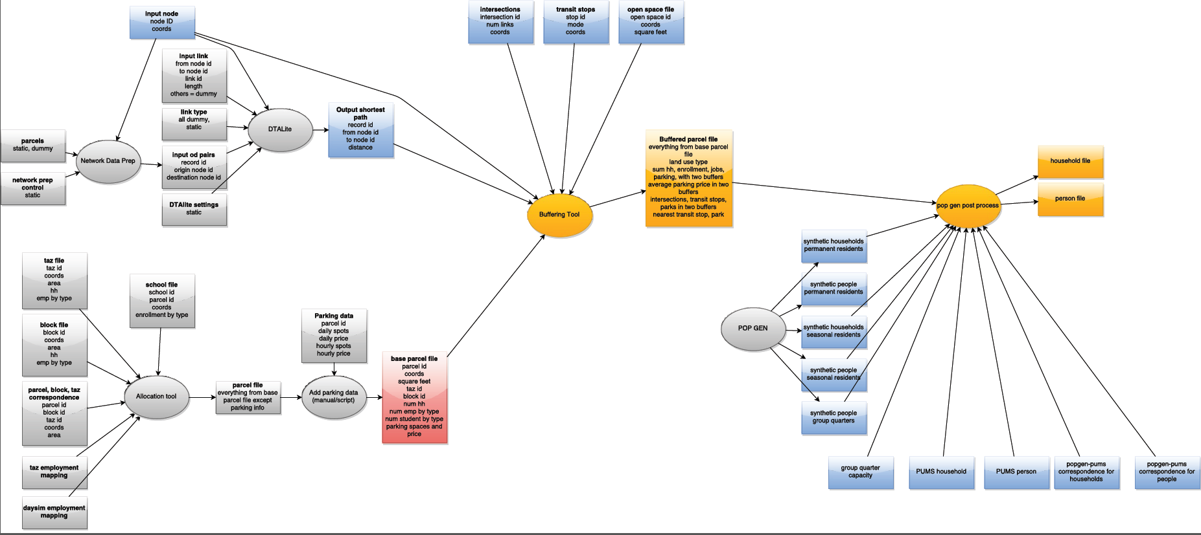

1. Network

Data Prep

2. DTA Lite

3. Allocation Tool

4. Buffer Tool

5. PopGen Post Process

There are five primary tools that are used to prepare DaySim inputs. First, Network data preparation program prepares a list of OD pairs in the network (see section 3.2 |). Then, DTA Lite finds shortest path distances between them (see section 3.3 |). The allocation tool prepares a base parcel file by allocating TAZ level land use variables to a finer geometry (microzone/parcel). The output parcel file and the shortest path distances from DTA Lite go into the buffer tool and a buffered parcel file is created. This buffered parcel file is an input to DaySim. The PopGen tool is not used to generate synthetic population inputs to the Nashville DaySim activity-based model system. The PopSyn synthetic population tool is used and was developed as part of a separate model development effort.

### Allocate TAZ data to Microzones

A key data preparation step involved allocating TAZ-level controls to the microzones. A flexible tool has been developed in order to allow users to systematically and easily perform this allocation. The allocation tool resides here: .\ParcelInputs\AllocationTool\mz_disaggregationtool.exe

The figure below illustrates the allocation tool user interface.

Figure 5.2 DaySim Allocation Tool GUI

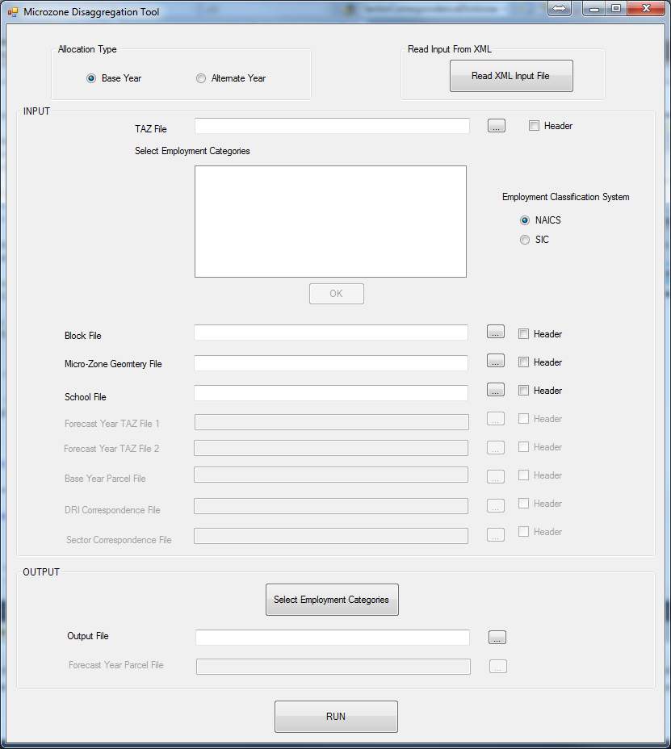

If the user has a pre-generated xml input file, that can be used to populate inputs to the tool. To read an xml file, click on “Read XML Input File” button:

Figure 5.3 Read XML Input File

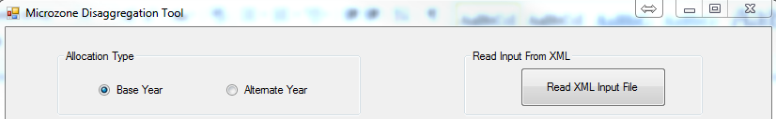

And navigate to the file:

Figure 5.4 Open Input XML File

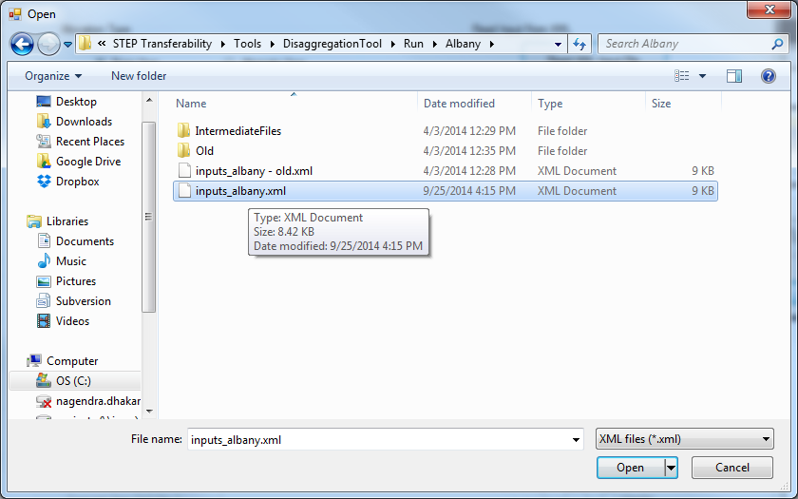

After choosing a file, click “Open” and the input fields will be populated automatically. The inputs can be changed if required.

Figure 5.5 DaySim Allocation Tool GUI with Inputs Populated

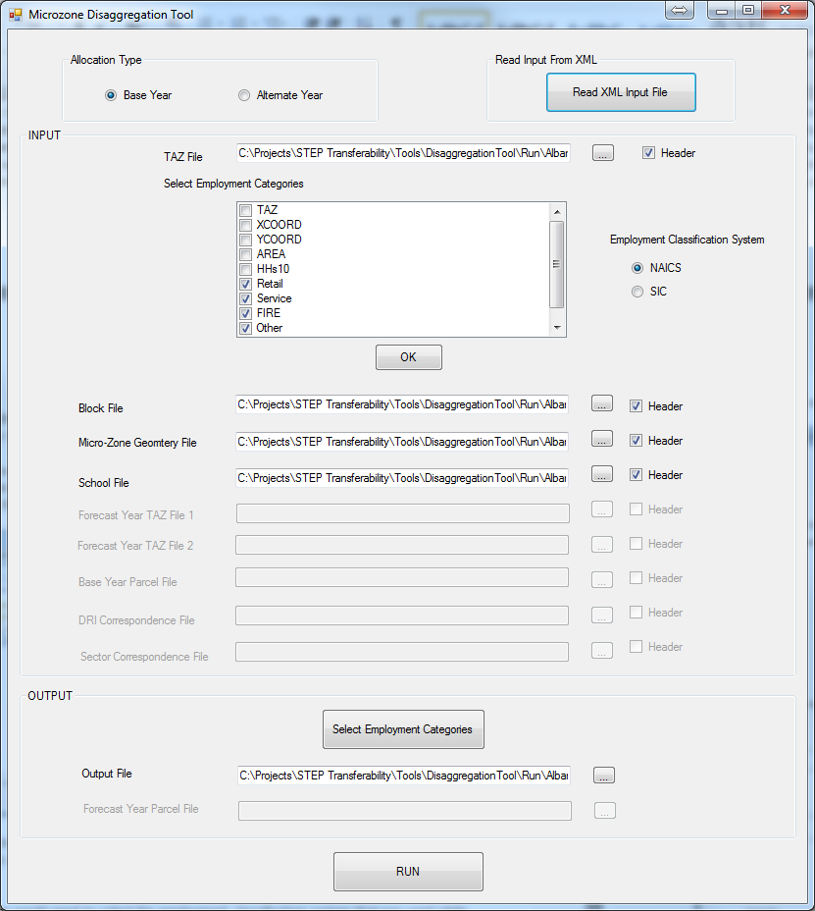

ALTERNATIVELY, the inputs can be entered manually as following:

First, choose a TAZ file:

Figure 5.6 Open tAZ file

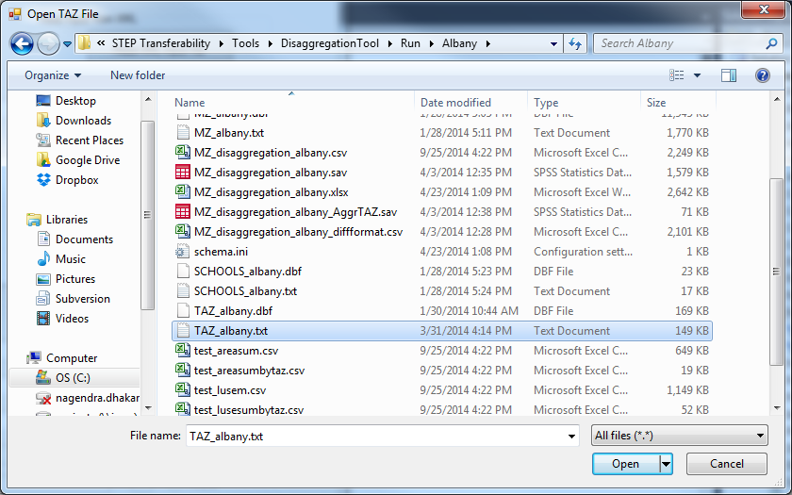

Once a TAZ file is chosen, data fields (columns) in the file would be displayed in the check box.

Figure 5.7 Display Employment Categories

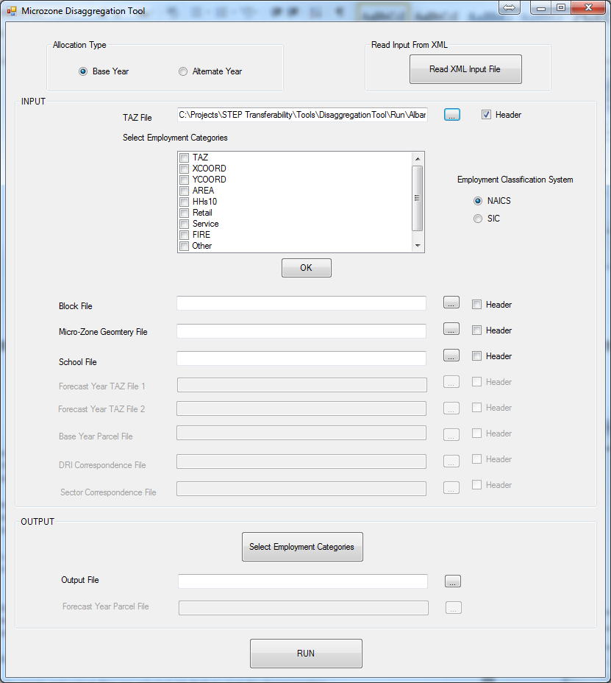

The user then checks the boxes for the employment categories. In addition, the user selects the employment classification system that was used while creating the employment categories. The default is set to NAICS.

Figure 5.8 Select Employment Categories

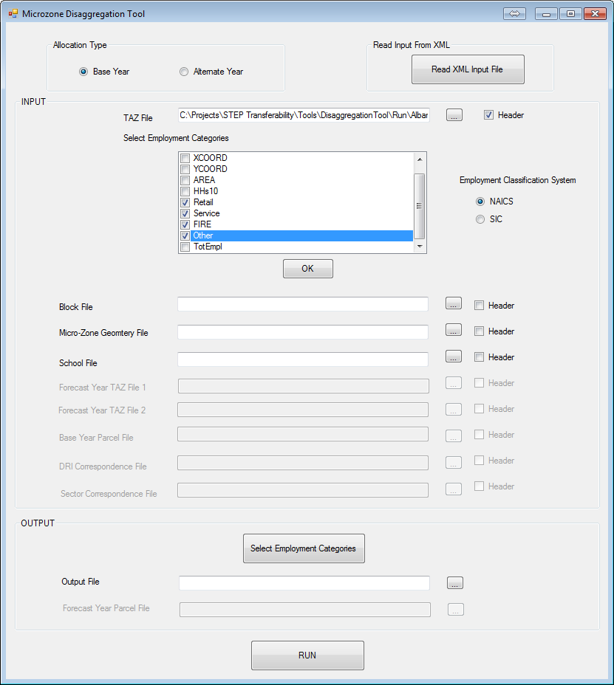

Once done, click OK button. This would open a new form asking the user to select associated NAICS/SIC codes (whichever is chosen before).

Figure 5.9 Select NAICS Codes

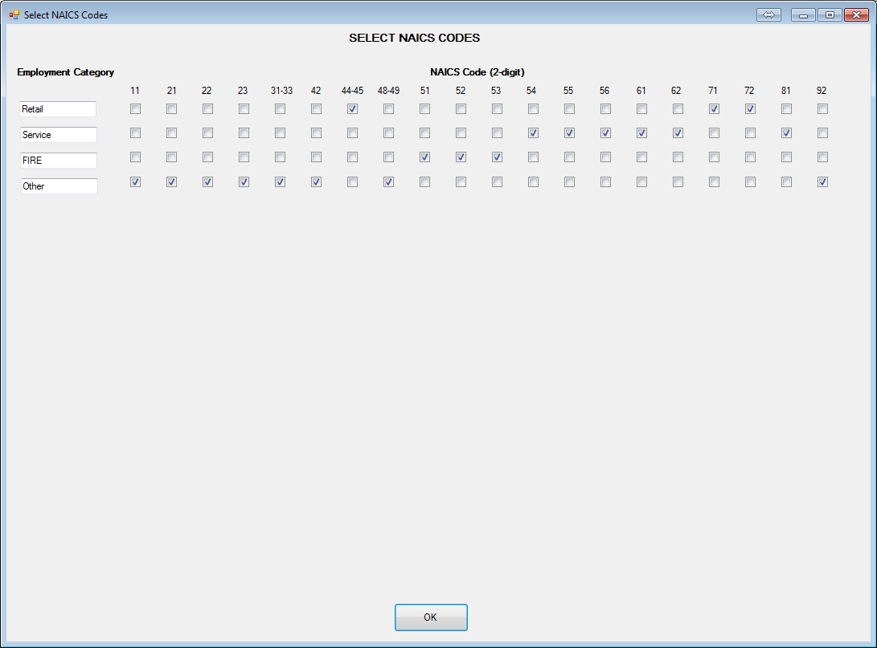

After this, choose other input files (block file, MAZ geometry file, school file, and parking file) appropriately. All four input files are space delimited text files.

Figure 5.10 Other Inputs

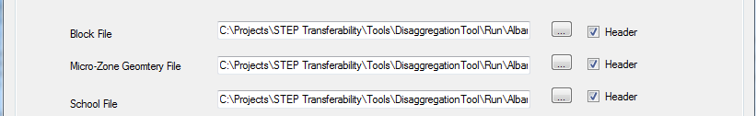

In the output section, in addition to pointing to output file, the user can also provide output employment categories and indicate associated NAICS codes.

Figure 5.11 Select DaySim Employment Categories

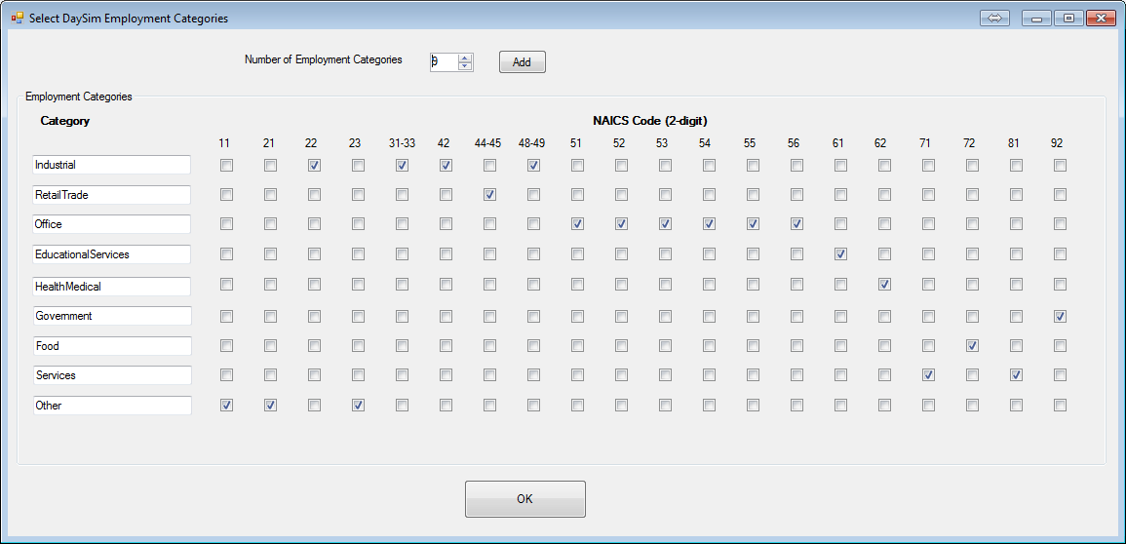

By default, it is assumed that an input file has a header. If not then uncheck the header option. Once, the input and output files are selected, hit RUN to start the distribution/ allocation process.

### Prepare Buffered Microzone File

As mentioned previously, the executable for bringing up the buffering tool is “DSBuffTool.exe” and can be found in the “.\ParcelInputs\BufferTool” folder of the master model directory. Double-clicking the executable will bring up a GUI as shown in the following figure. The use of this tool is straightforward. The user just needs to specify all the inputs and click on the “Run” button at the bottom of the GUI.

Figure 5.12 DaySim Buffering Tool GUI

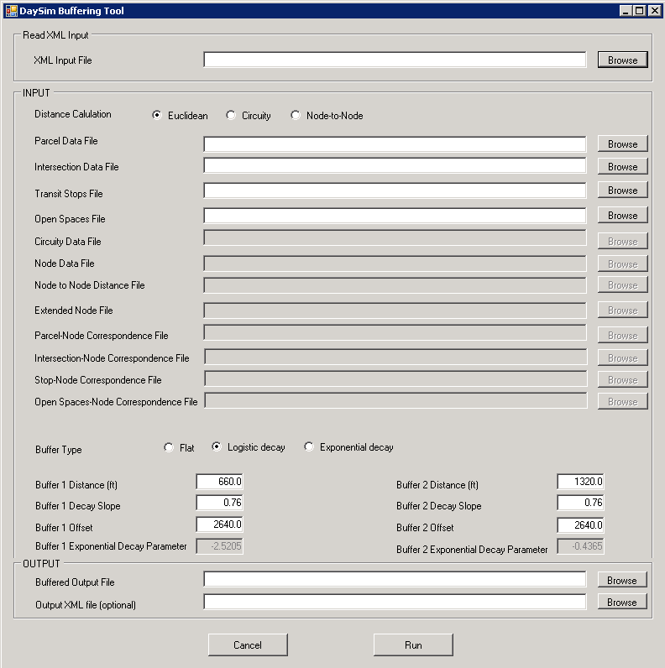

In the “INPUT” section of the GUI, distance calculation and buffer type are set to “Euclidean” and “Logistic decay” respectively. These are the recommended settings for running this tool. If node-to-node distances obtained from an all streets network are available, distance calculation may be set to “Node-to-Node”. The default recommended parameters for logistic decay weights (described in the model design chapter) such as buffer decay slope, offset etc., are also automatically populated in the appropriate fields in the GUI.

All other inputs are to specify file paths that can be done by clicking on the “Browse” button. This pops a file dialog as show in the figure below. The user may also enter full file paths manually using keyboard.

Figure 5.13. Buffer TooL File Selection Dialog

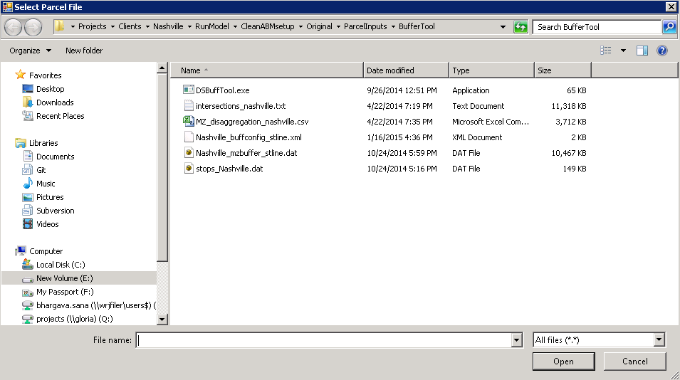

All file specification fields for the tool are described below. Details about formats for the input files can be found in the directory and data structures chapter.

* **Microzone Data File:** This is the base microzone file. It is obtained by running the disaggregation tool.
* **Intersection Data File:** This file has the coordinates of intersections and the number of links intersecting at each one of them.
* **Transit Stops File:** This file has the transit stop location coordinates by transit sub-mode.
* **Open Spaces File:** This file has the locations and area of parks/open spaces in the model region.
* **Circuity Data File:** This is only required for “Circuity” distance calculation that is now an obsolete method.

The following files are only needed for “Node-to-Node” distance calculation method.

* **Node Data File:** This file contains the coordinates of node from an all streets network.
* **Node to Node Distance File:** This file contains the network shortest path distances between a list of node pairs that are within 3 miles of each other. It is output from DTALite.
* **Extended Node File:** This is an intermediate file created during the buffering process and contains base microzone data aggregated to the network node level. This is created after each microzone/microzone has been associated with the nearest network node.
* **Microzone-Node Correspondence File:** This is an intermediate file created during the buffering process and contains the correspondence between microzones and nodes.
* **Intersection-Node Correspondence File:** This is an intermediate file created during the buffering process and contains the correspondence between intersections and nodes.
* **Stop-Node Correspondence File:** This is an intermediate file created during the buffering process and contains the correspondence between transit stops and nodes.
* **Open spaces-Node Correspondence File:** This is an intermediate file created during the buffering process and contains the correspondence between open spaces and nodes.
* Specification of the following XML files is optional. However, they store the input configuration of a buffering tool run and make it convenient to use the tool.

**Output XML File:** If a file is specified in this field, an XML file containing all the input information specified by the user is stored upon clicking on “Run” button that initiated the buffer process.

**XML Input File:** Once an XML file has been stored as described above, it can be selected to automatically populate all the input fields required for a buffer run. This can be used to re-run a buffer process with the same inputs or modify a few inputs to generate a different buffered microzone file.

Finally, **Buffered Output File** field is used to specify the location and name of the buffered microzone/microzone output file that needs to go into DaySim inputs folder.

### Update TAZ Id and Lutype

The R script that updates TAZ ids and lutyp_p in the output of the buffered tool is here: .\ParcelInputs\BufferTool\[year]\taz_merge.R. The following figure shows the content of the script:

Figure 5.14 R Script to Fields in the Buffered File

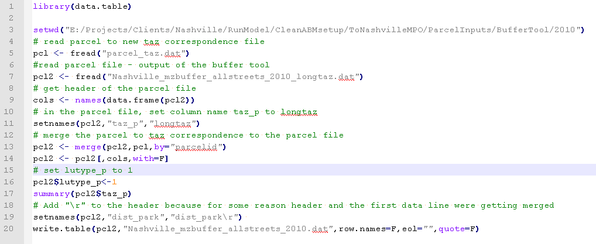

First, update the working directory path at line 3 in the script to match your setup. After that make sure that the working directory contains parcel to taz correspondence file (line 5) and the buffered parcel file (line 7). With this, you are all set to run the R script. .Open the script in R Studio, select all lines in the script and hit run. The script generates the following file: “Nashville_mzbuffer_allstreets_[year].dat”

## Running the Model

### Model Setup

To setup the Nashville ABM on a machine, follow the sequential steps as below:

1. Open TransCAD

If TransCAD is used on the machine before, go to start button (far left corner), in OS lower than windows 8.

Figure 5.15 Open TransCAD

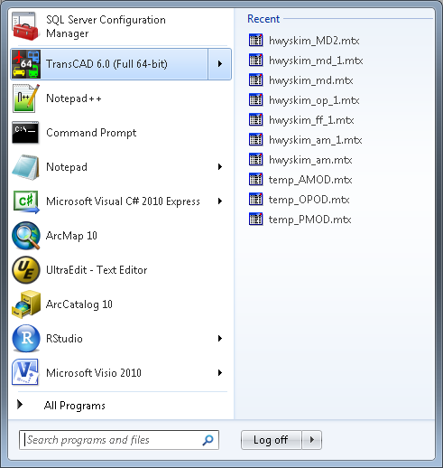

1. Add GIS Developer’s Kit tool

After opening up TransCAD, go to menu bar and click on “GIS developer’s Kit” under “Tools”

Figure 5.16 Add GIS Developer’s kit

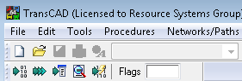

1. On the “GIS Developer’s Kit” click on compile (first icon) :

Figure 5.17 Compile

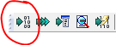

1. This will bring up a browse window asking for a resource file. Navigate to Script folder under your project directory and select the list file “2040 Model.lst”. The file lists all GSIDK scripts that are used in the model.

Figure 5.18 Open Model List File

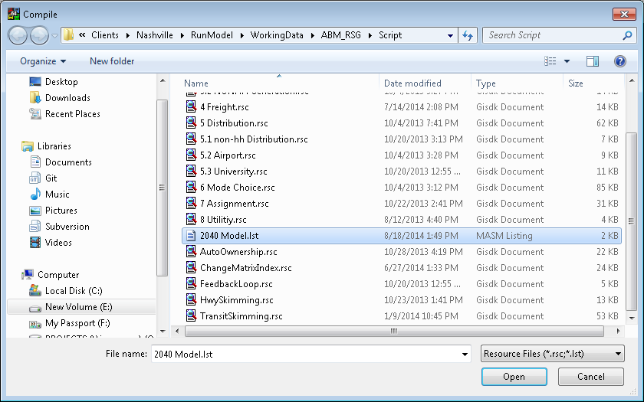

1. After all scripts are compiled and verified by TransCAD, click on Test (second icon):

Figure 5.19 Test Icon



1. This will open a window asking for an add-in name. Select “Macro” as type of add-in and enter “Model” as name.

Figure 5.20 Run model

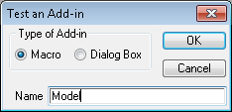

After hitting OK, a browse window will ask for a model table. Navigate to “Script” folder and select “Nashville4.bin”.

Figure 5.21 Open Model Table

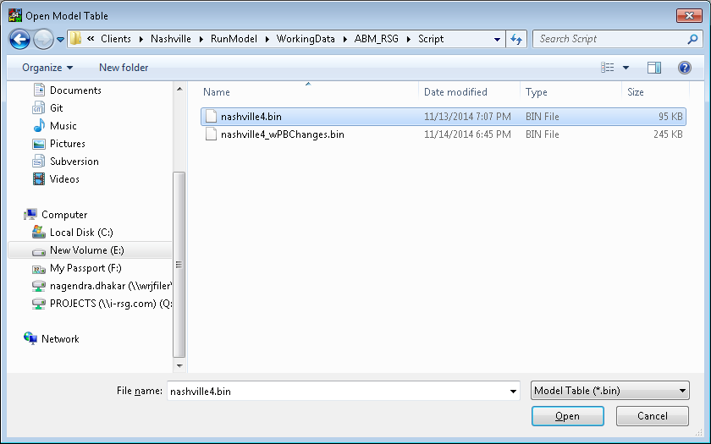

TransCAD stores the model table in memory, so TransCAD will only ask for the model table if it cannot find the table used in the last run or the model is run on the machine for the first time.

After hitting “Open”, the model GUI will appear on the TransCAD background:

Figure 5.22 TransCAD with Model GUI

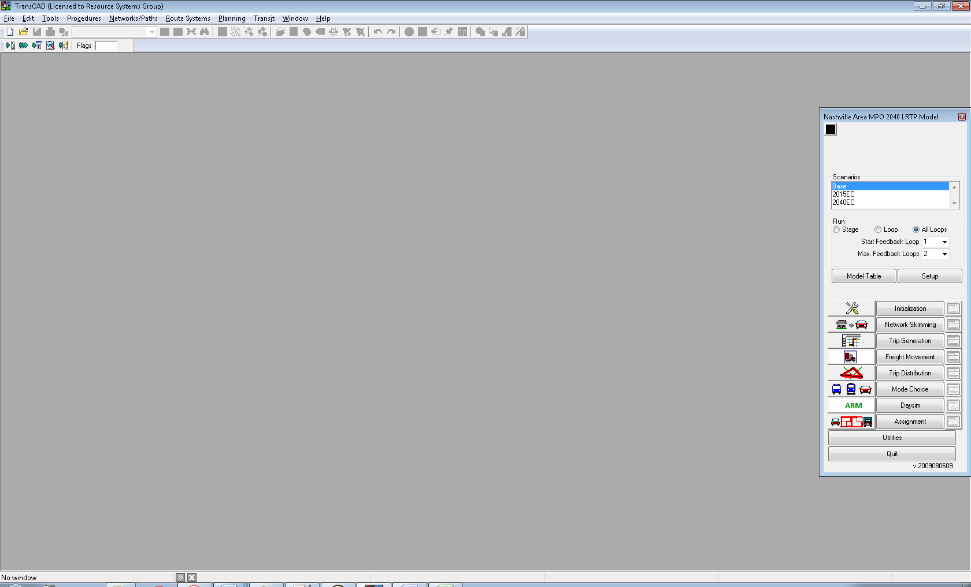

### User Interface

The following is the Nashville ABM user interface:

Figure 5.23 Model User Interface

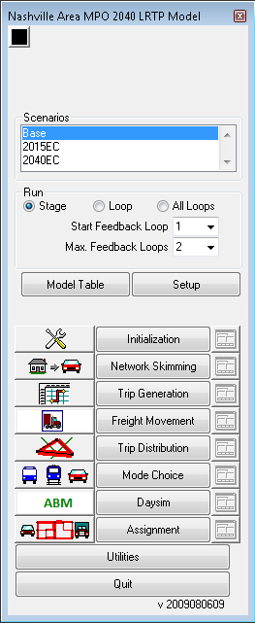

The user interface includes the following components:

* Model Scenario
* Model Run Settings
* Model Setup
* Model Stages
* Utilities

#### Model Scenario

First, the user is required to choose a scenario in “Scenarios” text box.

Figure 5.24 Model Scenarios

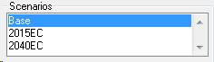

The following scenarios are available:

* Base
* 2015C
* 2040EC

Presently, only “Base” and “2040EC” are configured to run. The “2015C” does not have desired inputs available. By default, the last run scenario is selected.

#### Model Run Settings

Below the “Scenarios”, a group box “Run” provides general model run settings:

Figure 5.25 Model Run Settings

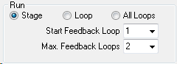

Three types of settings are available:

* Stage – runs a stage – such as Daysim – of the model. This setting requires the user to specify “Start Feedback Loop”. The corresponding stage would be run by the model.
* Loop – runs all models for a specified feedback loop. This setting requires the user to specify “Start Feedback Loop”.
* All loops – runs all models for all feedback loops from the “Start Feedback Loop”. This setting requires the users to specify “Start Feedback Loop” and “Max. Feedback Loops”

#### Model Setup

A model table is a key input to the user interface. The model table contains model setup information including macros, inputs files, output files, and parameters. This table is specified ahead of time in order to populate the user interface. If required, a new table can be specified using the “Model Table” command button.



The setup settings can be viewed through the interface using the command button “Setup”.



The command button opens up “Model Scenario Manager” as below:

Figure 5.26 Model Scenario Manager

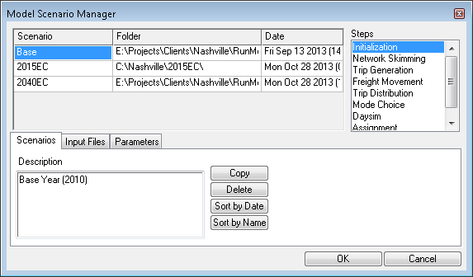

The scenario manager window displays inputs, outputs, and parameters used in every stage (step) of the model.

Figure 5.27 Model Scenario Manager - Inputs

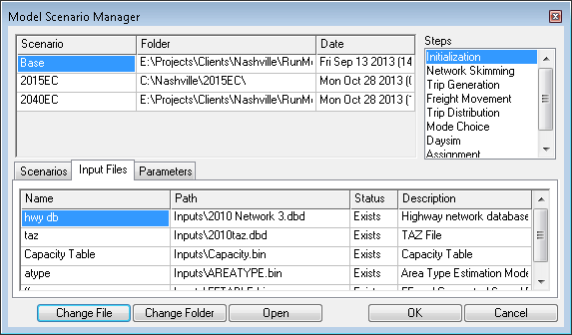

Files and parameters can be changed/edited by using the appropriate buttons at the bottom of the window. For example, to change a file name, click on the file name and click “Change File”.

#### Model Stages

The model user interface also includes command buttons for every stage (step) of the model. The command buttons are helpful if a particular stage is to be run.

Figure 5.28 Model Run Stages

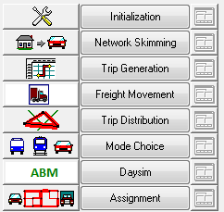

The sub-steps involved in a stage can be viewed/modified by clicking the icon next to the stage name. For example, in the “initialization” stage, the following sub-steps are involved:

Figure 5.29 Model Stage Step Settings

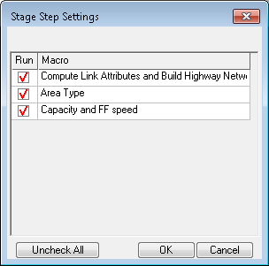

If a sub-step is not needed to be run, un-check (double click) the sub-step on the “Run” column. For example, the following settings would not run the last sub-step “Capacity and FF speed” in the “Initialization” step.

Figure 5.30 Model Stage Step Settings – How to Update

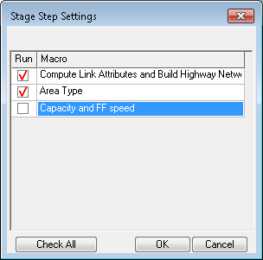

The sub-steps that will be run (check mark in the “Run” column) depend on the “Start Feedback Loop” setting. For example, if “Start Feedback Loop” is set to 2 then the settings would be checked for the sub-steps (macros) that are run in the second feedback loop. Therefore, the user can set the sub-step settings for any of the three feedback loops.

#### Utilities

The GUI also provides a few useful tools in “Utilities”.



The “Utilities” button brings up a window with various tools helpful in setting up a model run:

Figure 5.31 utilities

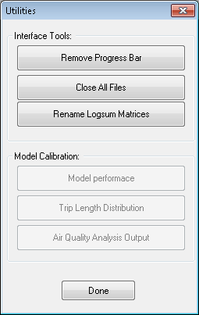

The window provides the following tools:

* Remove Progress Bar
* Close All Files
* Rename Logsum Matrices

The window also includes a section on Model Calibration, but the tools are not yet constructed and therefore are greyed out.

At the bottom of the GUI, a quit command button is available to exit the model through the interface.

### A Model Run

If a full model run is desired, check “All Loops” in “Run” group box, as following:

Figure 5.32 Select All Feedback Loops

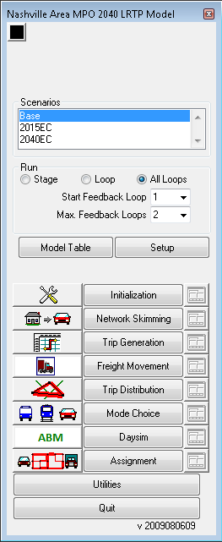

And then click “Initialization” to start a full model run:

Figure 5.33 Start a Full model Run

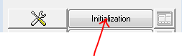

A full model run takes about 11 hours to finish.

1. If only one loop/iteration is desired, check “Loop” and select “Start Feedback Loop” as necessary. For example, if the user wants to run only the last (final) iterations, select “Final” from the dropdown:

Figure 5.34 Seelct Start Feedback Loop

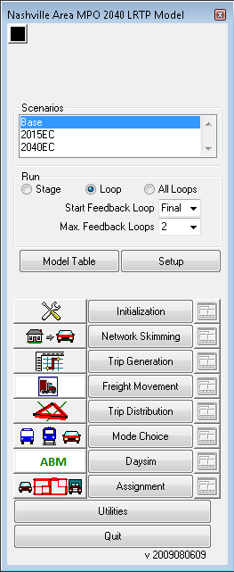

And then click “Initialization” to start a full model run:

Figure 5.35 Start a Full Model Run



1. If a particular stage is to be run, check “Stage” and select “Start Feedback Loop” as desired. Before running the stage, verify the steps within the stage by clicking the icon next to the stage. Now, click on the command button to run the stage.

Figure 5.36 Run A Stage



### Sensitivity Tests

Table 5.1 presents the sensitivity tests defined by the MPO. Sensitivity test #1 and #2 are in the process of being tested.

Table 5.1 List of Sensitivity Tests

|  |  |  |
| --- | --- | --- |
| # | Sensitivity Test | Test Description |
| 1 | Truck Trip Regulation | Test impact of long-haul trucks (EESU & EEMU) on the area by limiting access for certain times of day (Daily, AM, MD, PM, or OP) |
| 2 | Designated Truck Network | Test impact of the newly designated freight network by a freight assignment on the new fright network only |
| 3 | Land Use Change | Test GSP’s Land Use change scenario (both population and employment) |
| 4 | Local New Projects of 2040N RTP | Compare 2040L(base) with 2040N (new 2040 base w/all proposed projects) |
| 5 | Transit Supply Change | Compare 2040L(base) with 2040TRN (Transit vision) |
| 6 | Sensitivity of Transit Fare | Test different fare structure for different person ages or time of days (i.e. Free transit ride for highschoolers in AM peak or MD) |
| 7 | Transit Supply Change to Low Income Neighbors | Change the current transit supply to the low income neighbors by changing routes, headways, and/or stops |
| 8 | Parking | Test mode choice by parking cost change in CBD |

#### Sensitivity Test 1 – Truck Trip Regulation

This test studies the impact of long-haul trucks (single unit (SU) and multi-unit (MU)) on the area by limiting access for certain times of day. Seven new assignment classes were created for the long-haul truck demand: IISU, IESU, EESU, IIMU, EIMU, IEMU, and EEMU. In addition, the model GUI was modified to provide user the flexibility to control truck demand by time of day without having to changing the GISDK scripts. The Pre_Assignment and PostProcessor macros in the assignment 8.1 HwyAssignment.rsc file were revised. The GUI change was made in the model table - nashville4.bin.

To see the new controls, in the model user interface, go to “Setup”.

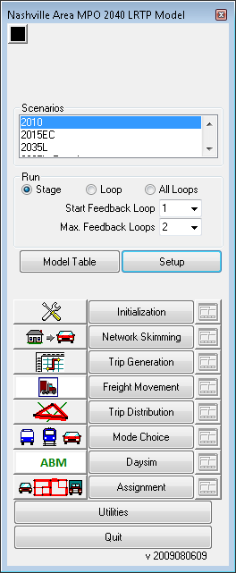

This will open up the “Model Scenario Manager”. Now click on “Assignment” and go to “Parameters”.

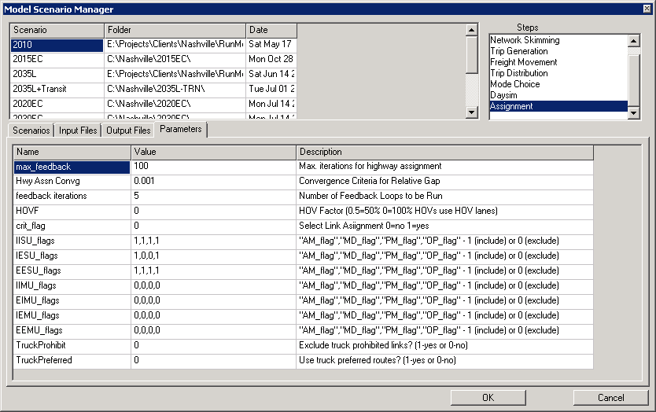

There seven new variables (as shown below) are added to the list: IISU_flags, IESU_flags, EESU_flags, IIMU_flags, EIMU_flags, IEMU_flags, and EEMU_flags

For each truck class, an array of four time of day specific flags (1 - include or 0- exclude) is provided.  The flags are in following order (also see “Description” in the model scenario manager): AM_flag ,MD_flag, PM_flag, OP_flag.

For example:

To exclude (restrict) EE SU in MD period, set EESU_flags = 1,0,1,1.

Similarly, to restrict EE MU in AM and OP period, set EEMU_flags = 0,1,1,0.

#### Sensitivity Test 2 – Designated Truck Network

The second sensitivity test studies the impact of the newly designed freight network on the traffic assignment. A new field [TRUCKNET] was created to identify the freight network type in the network. The field contains three values:

1. Regular – cars and trucks allowed
2. Preferred – cars and trucks allowed, trucks encouraged to use this route instead
3. Restricted – cars only

To give more preference to the preferred links during the truck assignment, a link toll cost was used. First, based on the paper by Bernardin et al.[1], all network links were assigned a per mile toll cost of 126.1 sec/mi and then the toll cost of the preferred links was reduced by 10% for trucks only to make them more attractive. Restricted links were excluded during the assignment by providing an exclusion set consisting of the restricted links. Finally, the user is allowed to control the freight network type through the model GUI as well.

To see the controls, in the model user interface, go to “Setup”.



This will open up the “Model Scenario Manager”. Now click on “Assignment” and go to “Parameters”.

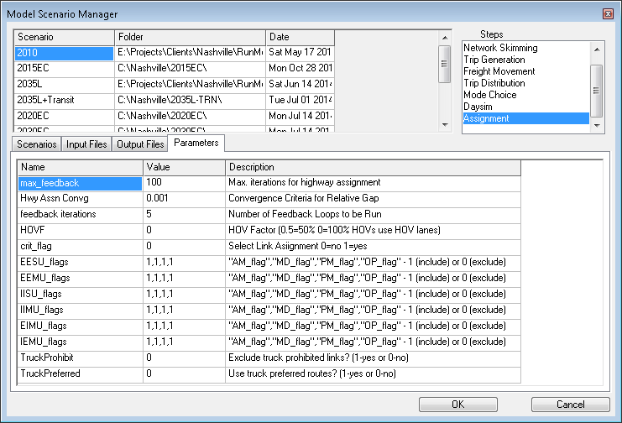

There two new variables (as shown above) are added to the list: TruckProhibit and TruckPreferred. Presently, both variables are set to 0, suggesting a regular scenario (both cars and trucks are allowed ). To run either a restricted truck scenario or a preferred truck scenario, set the respective variable to 1.

For example:

To restrict trucks on restricted links in the network, set TruckProhibit to 1 and keep TruckPreferred to 0.

To encourage trucks to use preferred links in the network, keep TruckProhibit to 0 and set TruckPreferred to 1.

To restrict trucks on restricted links and also encourage trucks to use preferred links set both variables to 1 ( TruckProhibit to 1 and TruckPreferred to 1).

## Batch File

The ABM outputs directory contains several intermediate outputs that are not being used for any analysis purpose. In addition, some outputs are rarely used. Therefore, to preserve space, a batch file that zips useful files and deletes unnecessary files is created. The batch file is named as “ZipAndDelete.bat” and takes two inputs:

filesToZip.txt = list of files to be zipped (irrespective of subfolders)

filesToKeep.txt = list of files to keep (only in “outputs” folder), the rests will be deleted

SETUP:

Keep the batch file (“ZipAndDelete.bat”) and “filesToZip.txt” in the project directory (ex. \2010\). “filesTokeep.txt” should be placed in “outputs” folder under the project directory (ex. \2010\outputs\).

INPUTS:

filesToZip.txt

filesToKeep.txt

HOW TO RUN:

Open command prompt --> navigate to your project directory --> type: ZipAndDelete.bat [ZIP_FILE]

Here, [ZIP_FILE] is the output file. If no output file is provided, by default it is assigned as “SaveData.zip”. The output zipped folder is saved in the project directory.

The default output name can be modified by opening up the batch file in a text editor (edit line 23):

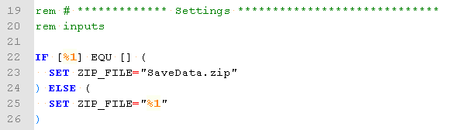

Beginning of the batch file provides information on inputs, output, and how to run the batch file.

# Configuring a Scenario

This section provides guidance on steps necessary to perform in order to reflect the changes in existing model conditions such as transportation infrastructure, land use, or household/person socio-economics. Following are a few such scenarios:

## Network changes

In the instances where there are new highway or transit network developments, the changes can be reflected by editing the networks in TransCAD environment. Highway network could see addition/deletion of roads, or change in road attributes such as number of lanes, speed, HOV lanes etc. To update the highway network open /2010/Inputs/ 2010 Network 3.dbd in TransCAD.

To update the transit network open /2010/Inputs/ 2010 transit routes.rts in TransCAD.

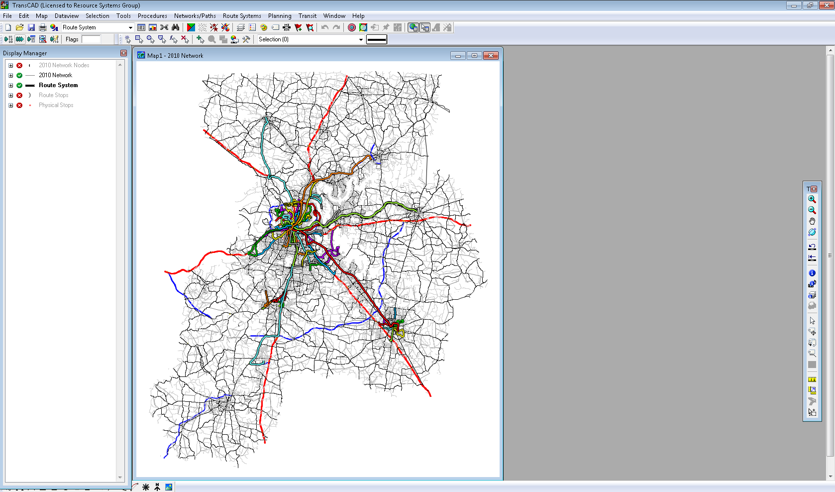

Following are the layers in the transit routes layer:

* 2010 network nodes
* 2010 network
* Route System
* Route Stops
* Physical Stops

In the instances where transit service attributes such as fare or headway have changed, multiple input files needs to be updated.

|  |  |
| --- | --- |
| File | Variable |
| 2010 transit routesR.bin | FARE |
| MODEXFER.DBF | XFER_FARE |
| MODES.DBF | FARE |

The following steps describe how to edit a table in TransCAD:

Step 1: Open /2010/Inputs/2010 transit routesR.bin in TransCAD. That can be done either by dragging the file into TransCAD window or open the file through in the user interface.

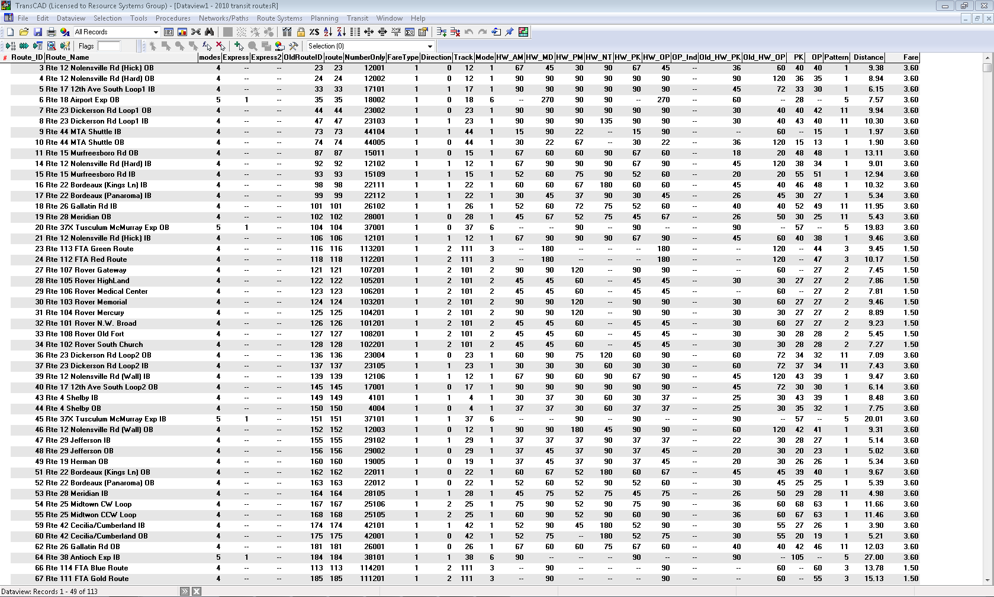

Step 2: If only selected records (a particular mode) need to be modified, go to Selection in the menu bar and select “Select by Condition”:

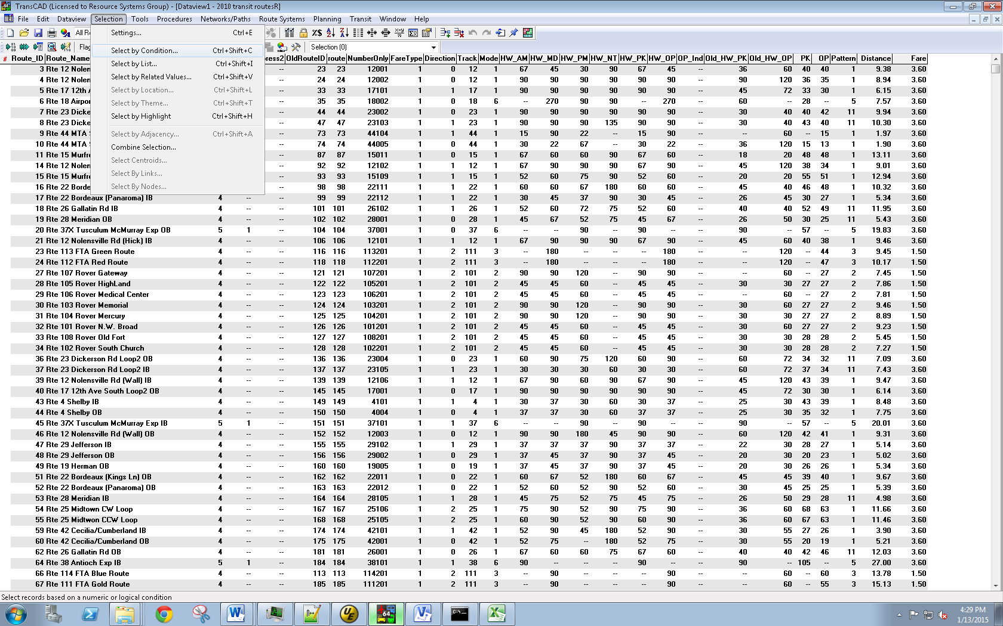

For example, select records related to modes=4:

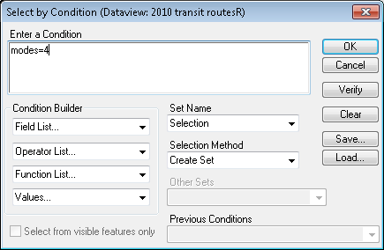

Hit OK and the selected records will be displayed with red hash on the left.

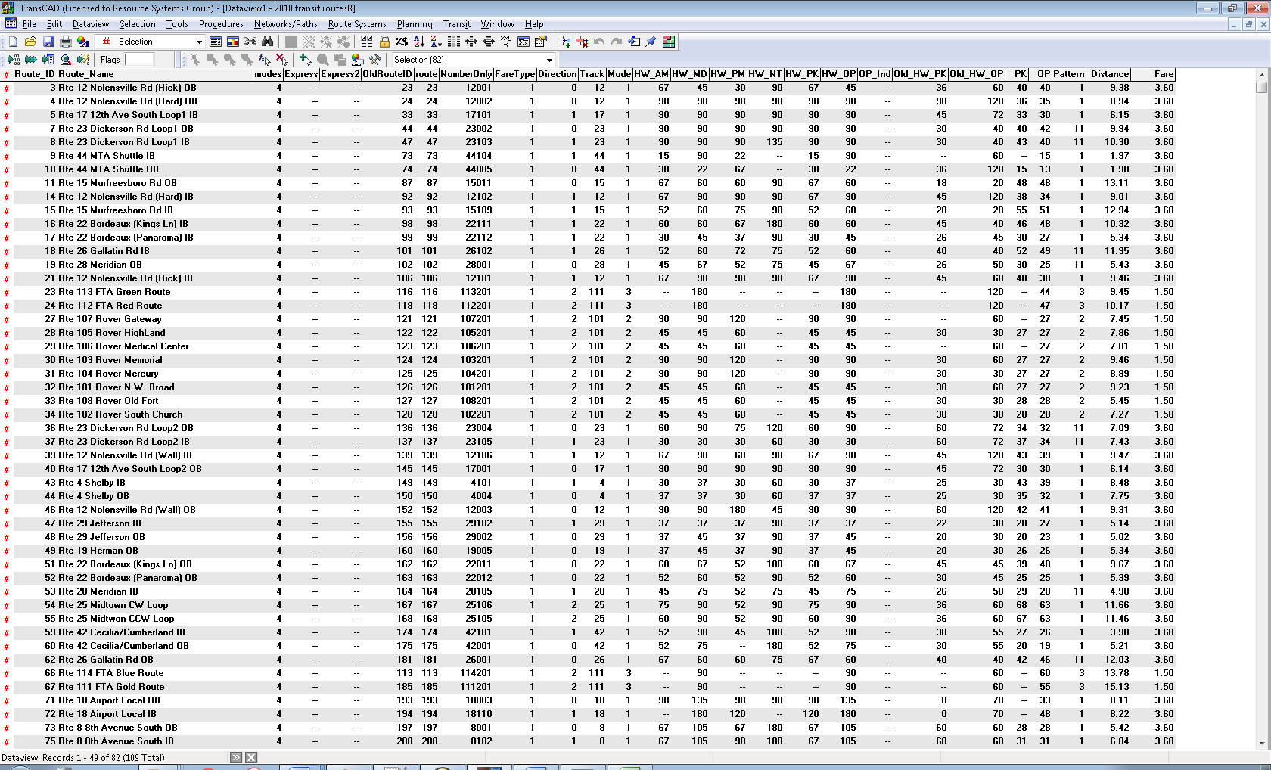

Step 4: Right click on “FARE” and select “Fill…”:

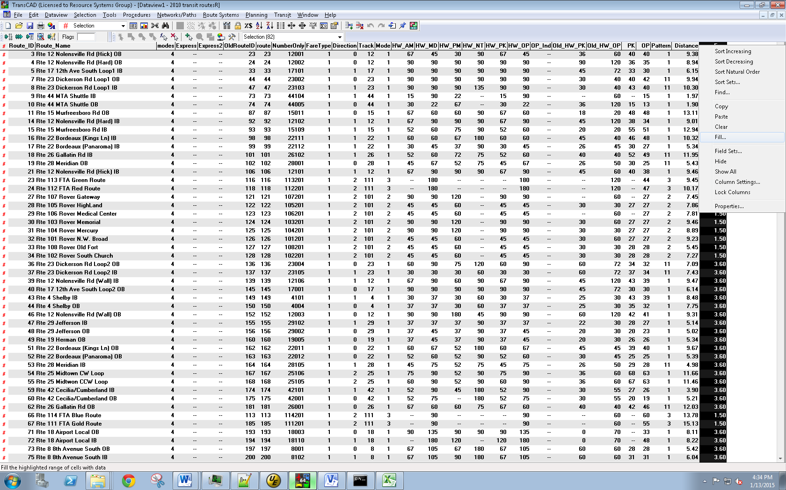

The Following window will pop-up:

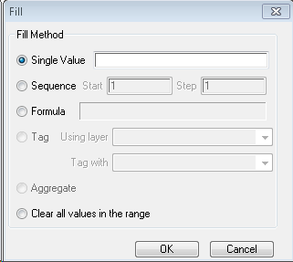

Step 5: Check “Formula”. In the window below, build a formula by select a field from Field List

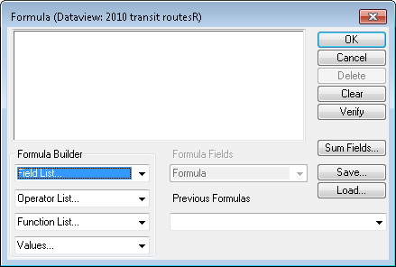

For example, if fare for mode=4 needs to be increased by 50%, then put “1.5*Fare” in the formula box:

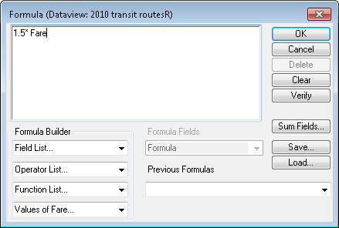

Hit Ok and the original window will look like this:

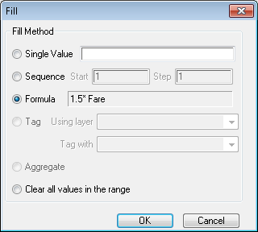

Hit OK and the new values will be calculated in the “FARE”column.

Similarly, attributes in other tables can be edited.

To reflect headway (frequency) change, following files and variables should be updated:

|  |  |
| --- | --- |
| File | Variable(s) |
| 2010 transit routesR.bin | AM_HW, PM_HW, MD_HW, OP_HW |
| MODES.DBF | MAX_WAIT |

## Employment change

In future, some areas may see growth/decline in employment due to increase/decrease in business establishments or some other reasons. In addition, the distribution of different employment types could change over the years.

In order to reflect those changes in the model, following DaySim input file needs to be updated: .\[year]\DaySim\Nashville_mzbuffer_allstreets_[year].dat

To update the file, perform following sequential steps:

First step is to update the microzone file. The microzone file can be updated as following:

* If employment at a TAZ is same, including in different sectors, but distribution of employment in microzones within the TAZ have changed then either of the two should be undertaken:
* Edit the microzone file manually.
* Get a new block level controls (with employment in 2-digit NAICS categories) and run the allocation tool (see section 5.1 |) to obtain an updated microzone file.
* If employment (or/and distribution of employment sectors) at a TAZ is different, the TAZ file (2010TAZ.bin) in the input folder should be updated first. Afterwards, this TAZ file should be used to run the allocation tool (see section 5.1 |). The tool will produce an updated microzone file.

As second step, the new microzone file is put through the buffer tool (see section 5.1 | ) to generate a new buffered microzone file (Nashville_mzbuffer_allstreets_[year]_longtaz.dat). This file contains old TAZ indices (long form) and would need to convert to a short form TAZ indices to avoid a DaySim run error. For that, run the R Script (see section 5.1 |) that assigns new TAZ ids. In addition, the script sets land use type variable (lutype_p) to 1.

This output file of the R process should then be replaced in the DaySim folder.

In summary, here are the directions to update DaySim parcel file (year = 2010 or 2040):

(**Note**: please change paths in xml inputs and R scripts to match the setup on your machine)

Allocation Tool:

STEP 1: Run “mz_disaggregationtool.exe” using inputs_nashvile_[year].xml (output: MZ_disaggregation_nashville_[year].csv)

STEP 2: Copy the output to the year specific buffer tool folder

Buffer Tool:

STEP 1: Run DSBuffTool.exe using Nashville_buffconfig_allstreets_[year].xml (output: Nashville_mzbuffer_allstreets_[year]_longtaz.dat)

STEP 2: Run taz_merge.R to convert longtaz to new tazs and also to set lutype_p to 1. (output: Nashville_mzbuffer_allstreets_[year].dat)

STEP 3: Copy the output (Nashville_mzbuffer_allstreets_[year].dat) to DaySim folder.

Now, the setup is updated with the new parcel file.

## Population change

Population is likely to increase in future, however, it may not increase proportionately geographically. A change in employment may also alter the existing geographic distribution of the population. To accommodate a change in population following three input files need to be updated:

* Buffered microzone file (.\[year]\DaySim\Nashville_mzbuffer_allstreets_[year].dat)
* Household file (.\[year]\DaySim\nashville_household_[year].dat)
* Person file (.\[year]\DaySim\nashville_person_[year].dat)

To update the buffered microzone file, the similar steps as employment change accommodation needs to be performed. First, the microzone file (output of the distribution tool and adding parking data) is updated and then it is used in the buffer tool to generate a new buffered microzone file. After assigning new TAZ ids and updating lutype_p, the output file is replaced in the DaySim folder.

Synthetic population data (household and person files) would also need updates. As previously described, the synthetic population is generated using POPSYN III developed by Parson and Brinkerhoff (PB). RSG converted the PopSyn outputs into a format that are compatible with DaySim requirement. Therefore, to update the household and person file, POPSYN III would need to be rerun and then using the python script (see Section 4.3 |) generate a new set of household and person files.

# Mini Model Runs & Input Checks

This section provides guidance on steps necessary to perform in order to reflect the changes in existing model conditions such as transportation infrastructure, land use, or household/person socio-economics. Following are a few such scenarios:

## Mini Model Runs

Table 7.1 presents types of model runs available in the Nashville ABM GUI. A few examples of where and how to use these are presented at the end.

Table 7.1 – List of Model Run Types

|  |  |  |
| --- | --- | --- |
| # | Run Type | Description |
| 1 | Run a feedback loop | Running one feedback loop without doing a full model run |
| 2 | Run a stage | Running a particular model step (ex. skimming or assignment) |
| 3 | Run selected stages in a feedback loop | Run only a few model steps in a feedback loop. Also, within a model step, run selected sub-steps. |

### Run A Feedback Loop

This scenario runs only one feedback loop in the model.

Check “Loop” in Run group box and select “Start Feedback Loop” which denotes the feedback loop you want to run. Once done, click on “Initialization”. This will trigger the “Start Feedback Loop” from the beginning stage. If you want to skip the first few stages then click on the stage you want to start your feedback loop from. For example, to run stages DaySim onwards, click on “DaySim” and it will run only “DaySim” and “Assignment”.

As an example, the following settings will run the second feedback loop (“Start Feedback Loop”=2) for the 2010 scenario.

Figure 7.1 Run a Feedback Loop

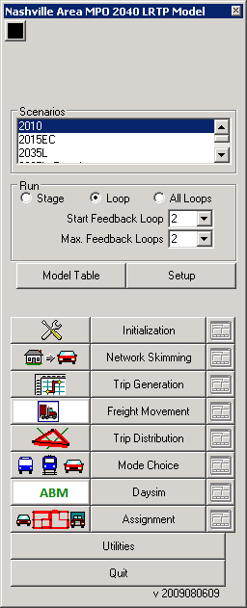

### Run A Stage

If you want to run only a particular step in the model, select “Stage” in “Run” group box and also select the appropriate “Select Feedback Loop”. Now, click on any of the stages you want to run.

Figure 7.2 Run a Stage

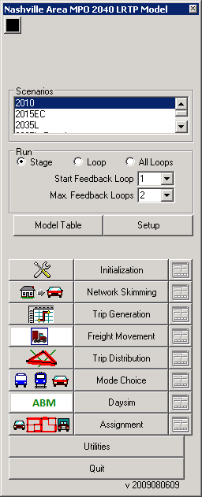

### Run Selected Stages in a Feedback Loop

The model user interface also includes command buttons for every stage (step) of the model. The command buttons are helpful if a particular stage is to be run.

Figure 7.3 Model Run Stages



The sub-steps involved in a stage can be viewed/modified by clicking the icon next to a stage name. For example, in the “initialization” stage, the following sub-steps are involved:

Figure 7.4 Model Stage Step Settings



If a sub-step is not needed to be run, un-check (double click) the sub-step on the “Run” column. For example, the following settings would not run the last sub-step “Capacity and FF speed” in the “Initialization” step.

Figure 7.5 Model Stage Step Settings – How to Update



The sub-steps that are checked depend on the “Start Feedback Loop”. For example, if “Start Feedback Loop” is set to 2 then the stage step settings would show check marks on the sub-steps (macros) that are run in the second feedback loop. The user can modify the sub-step settings for a feedback loop by selecting the appropriate “Start Feedback Loop”. The stages that are run in each of the feedback loops can be viewed in the model table (nashville4.bin).

## Mini Model Runs Input Checks

Before running a full model run (with three feedback loops), it is helpful to run only the final feedback loop with selected components (stages) to see if the new inputs are error free and the results are reasonable. **Error! Reference source not found.** lists two such data check scenarios.

Table 7.2 – List of Model Run Scenarios

|  |  |  |
| --- | --- | --- |
| # | Run Scenario | Description |
| 1 | Network change | Run selected model steps after making highway/transit network changes |
| 2 | DaySim input change | Run selected model steps after making DaySim input changes (ex. parcel updates) |

### Network Change

After some minor network updates, it may be useful to run the final feedback loop with only Skimming, DaySim, and Assignment model components. In order to do so, select “Start Feedback Loop” as “Final” and disable the following stages by unselecting all sub-steps in stage step settings:

* Freight Movement
* Trip Distribution
* Mode Choice

Note that the “Trip Generation” step is already disabled in the “Final” feedback loop. Then click on the “Skimming” stage to run only the three stages in the final feedback loop.

To do a quick assignment, fewer assignment iterations or a loose convergence criteria can be set. To make these changes, open “Model Scenario Manager” and go to step “Assignment” and click on “Parameters”.

Figure 7.6 Assignment Parameters

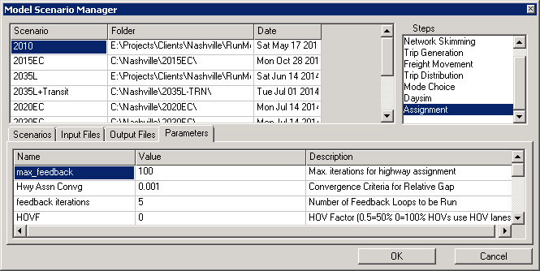

### DaySim Input Change

If any of the DaySim inputs are updated then running only DaySim and Assignment steps would help quickly see if the effects are as expected. In order to do so, select “Start Feedback Loop” as “Final” and click on “DaySim”. This will run the final feedback loop with only DaySim and Assignment stages.

## Model Input Checks

Table 7.3 presents a list of scenarios related to updating model inputs. For each, some basic checks are described in order to quickly validate the updates before starting a full model run. The checks can be helpful in saving time by identifying errors beforehand.

Table 7.3 – List of Model Input Checks

|  |  |  |
| --- | --- | --- |
| # | Scenario | Description |
| 1 | Highway network edits | Basic checks to validate highway network edits |
| 2 | Transit network edits | Basic checks to validate transit network edits |
| 3 | DaySim input updates | Basic checks to validate DaySim input updates. |

### Highway Network Edits

Often a new model scenario requires highway network updates such as the addition/deletion of roadway links or updating roadway attributes. Once updates have been made in the network, it is useful to ascertain beforehand that the edits did not introduce any errors.

The following checks may be useful in validating the updated network:

1. Link Attributes

If a new link is been added then make sure that appropriate attributes are populated for the link. Primarily, set link attribute “Assignment_LOC” to 1 if the new link needs to be included in the model run.

1. To and From Node

Once link modifications are made, it is useful to verify that “To_Node” and “From_Node” fields are correct.

To update and view the two node fields in the attribute table, first open the attribute table. Now right click on any column except “ID” and select “Fill”.

Figure 7.7 Fill

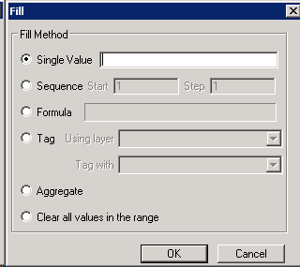

Choose Formula to bring up the following window:

Figure 7.8 Formula

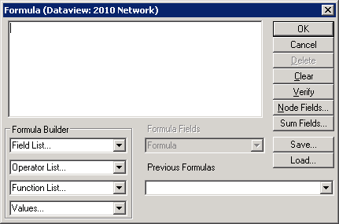

Click on “Node Fields…” on the right side.

Figure 7.9 Node Formula Fields

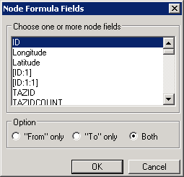

This will add “From ID” and “To ID” fields to the attribute table. Then check the two fields for updated links to make sure they look correct.

1. Network routeability

After link/node edits are made, it is useful to select a few OD pairs in the edited network area and run the shortest path routine in TransCAD to verify that there is a path between the OD pairs. To make sure that the newly added links are part of the network, select the OD pairs in such a way that the shortest path would go through the link. Then run the shortest path routine for the OD pairs and see if the results as expected.

Below are the steps to run the shortest path routine in TransCAD:

* First, open the highway network database in TransCAD
* In TransCAD menu bar go to “Network/Paths 🡪 Shortest Path” to bring up shortest path toolbox window (Figure 7.10).

Figure 7.10 Shortest path Toolbox

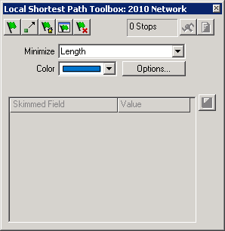

* The settings in the above window minimize the cost attribute “Length”. Click on the drop down to choose the cost field to use for calculating shortest path.
* Click on the first green flag to “Add a stop” and then click on two different locations on your map to choose an origin and a destination. Once the locations are added, TransCAD will give you a route with total cost (Figure 7.11).

Figure 7.11 Shortest Path in TransCAD

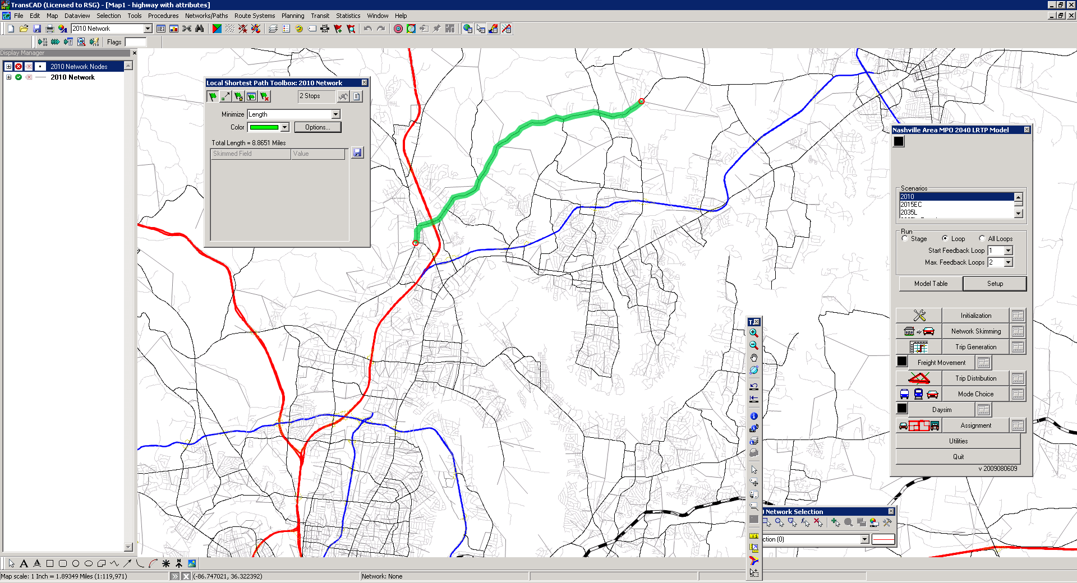

* Zoom-in to the route to see if the route contains links as expected.
* To clear all stops and routes on the map, click on the last green flag ().

### Transit Network Edits

Similar to the highway network, the transit route system may also require updates to reflect a new model scenario. For example, a new scenario may have new transit service and/or a new route may have been added. Unlike the highway network, the transit network has several components, which demand extra attention while making edits.

The transit route system in TransCAD contains three transit layers (in addition to highway link and node layers):

* Route System – routes and their attributes such as headway by time of day.
* Route Stops – stops for each route
* Physical Stops – physical stops. One physical stop can be used by multiple routes.

In addition, there are two database files that are an integral part of the transit network:

* MODES.DBF – list of modes in the model. This table includes mode specific attributes such as fare, thresholds for walk time, wait time etc.
* MODEXFER.DBF – information on penalty and fare for transfers from one mode to other. All mode pairs are included in the table.

Below are a few scenarios and corresponding checks to minimize network editing errors:

New Transit Service

If a new transit service is added, make sure that appropriate stops are added to the physical stops and route stops layer. Attributes for the new service should also be added in the “Route System” attribute table.

If the new transit service is assigned as a new mode then “MODES.DBF” and “MODEXFER.DBF” should also be updated accordingly. All modes must be defined in Daysim as well.

New Route for Existing Transit Service

While modifying an existing transit service, take extra care when dealing with route stops. Move/delete only the stops that are associated with the transit service. If a route stop of the existing route is deleted then it may result in a corrupted route system file.

Highway Network Edits

Sometimes edits made in the highway network may impact the transit route system. Network node related edits may require updates in the transit route system as well. For example, if a node is added as part of increasing transit accessibility, make sure to update the “NearNode” field in the “Route Stops” table so that the new node is seen by the transit route system. Other scenarios may need “NearField” updates as well, including deletion of a node and renumbering of node IDs.

### DaySim Input Updates

#### Parcel File

Following scenarios may require to update the parcel file:

* Revised land-use socio-economic data
* Updates in transit route system layer that resulted in addition/deletion of transit stops

Refer to Chapter 6 above for how to update the parcel file.

Once the parcel file is updated, the user should map the employment/household/ enrollment, buffer measures, and distances to transit sub-modes in order to verify the parcel input data. Figure 7.12 shows a map of distances to commuter rail. The map below makes it easy to see that distances are higher (darker color) as zones move

Figure 7.12 Distance to Commuter Rail in Nashville

away from commuter rail stops. Zones close to the stops have shorter distances (lighter color). Similar maps should be created for any variable in the parcel file.

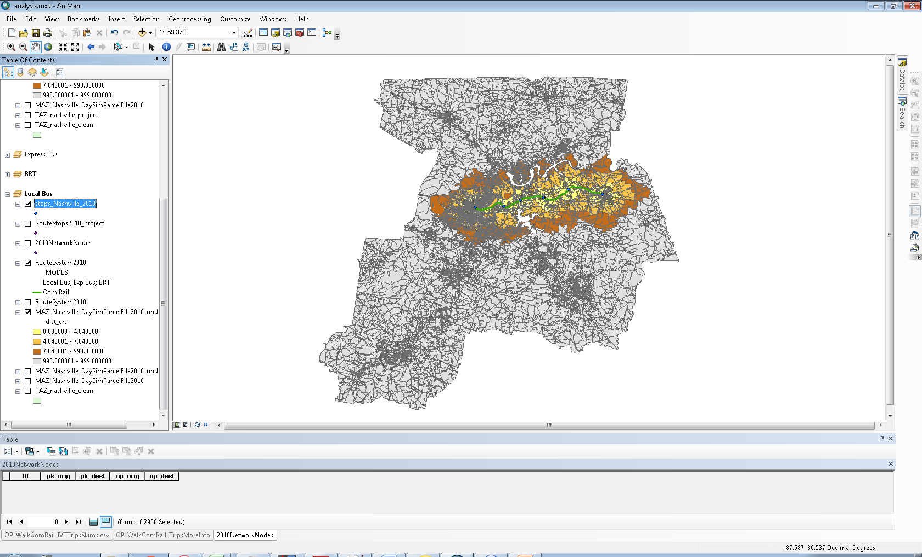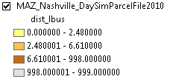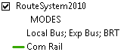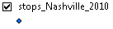

#### PNR Nodes

If the highway database file has updated PNR nodes, then the PNR nodes should also be updated in the DaySim inputs file as well. The DaySim/p_r_Nodes_[year].dat file contains PNR id, corresponding TAZ id, parking capacity and parking cost.

1. Improving Static Assignments Using Genetic Algorithms to Estimate Parameters for Complex Generalized Costs. Vince Bernardin, Jr, PhD & Steven Trevino Bernardin, Lochmueller & Associates, Inc., Seyed Shokouhzadeh Evansville Metropolitan Planning Organization, Mike Conger, PE Knoxville Regional Transportation Planning Organization. Presented at the 2012 Innovations in Travel Modeling Conference.